Activating Computer Architecture with Classroom Presenter

Beth Simon† Richard Anderson* Steven Wolfman*

*Computer Science & Engineering, U. of Washington
Seattle, WA 98195-2350
{anderson,wolf}@cs.washington.edu
†Math & Computer Science, U. of San Diego
San Diego, CA 92110
bsimon@sandiego.edu

Abstract
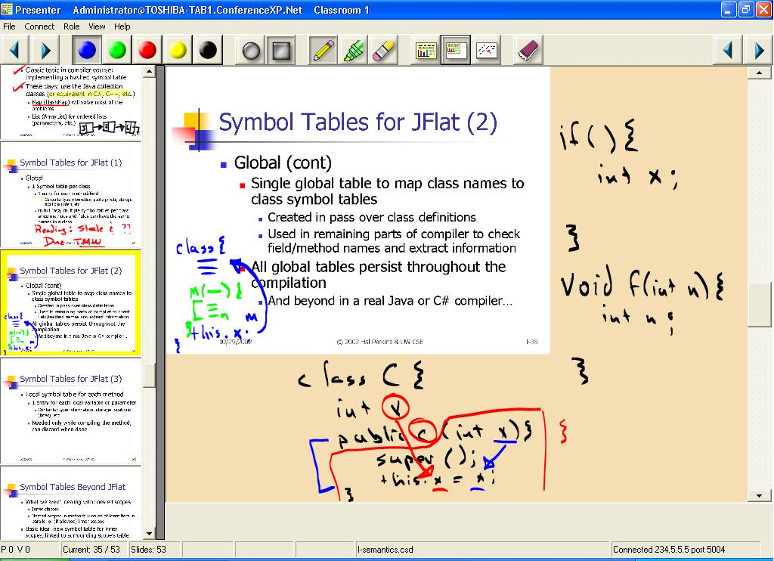
We have developed and deployed a lecture presentation system called Classroom Presenter in which the instructor uses a Tablet PC as a presentation device. The system has been deployed in approximately fifteen large courses at the University of Washington since Autumn 2002 and in one small undergraduate architecture course in Spring 2003 at the University of San Diego. It has been favorably received by students and instructors. In our system, the instructor holds a pen-based computer that is wirelessly networked with another computer driving the classroom projector. The instructor displays slides from the tablet and can write (“ink”) on top of them. Various navigation and control facilities are available. In this work we present an overview of the system and discuss particular uses and advantages of the system in an undergraduate architecture class setting.

Introduction
Presentation technology impacts the structure and delivery of lectures. Different technologies support different instruction styles and provide various mechanisms for engaging an audience. In university classrooms, predominant presentation technologies include blackboards, whiteboards, overhead projectors, and computers with data projectors. Each of these technologies has properties that may make them more or less suitable to specific instructors or course material. Specifically, delivering a lecture directly from a computer has both advantages and disadvantages. Advantages include the ability to structure material in advance, prepare high-quality examples and illustrations, and to share and re-use material[3]. However, these advantages come at the expense of flexibility during presentation – especially in an undergraduate architecture class where we’d like students to experience for themselves the tradeoffs inherent in the microarchitecture design process.
Classroom Presenter (hereafter, Presenter) is a system developed and deployed by the University of Washington as part of the Conference XP conferencing experience project. The immediate goal of Presenter is to provide an improvement to the computer-based lecturing environment – offering, at a minimum, the benefits of prepared slides and extemporaneous writing and diagramming. In the long term, Presenter aims to enhance learning and teaching through new technologies and software for the classroom. The key components of the current system are the use of an instructor Tablet PC (with high-quality inking support), wireless network connectivity, and a data projector.
In this paper we focus on the presentation issues found in an undergraduate Patterson and Hennessey-style architecture course. We show how the interactive nature of inking on empty (or intentionally incomplete) slides allows students to participate in the microarchitecture design process, rather than having it presented to them “fait accompli”. Specifically, we investigate the ability of the Presenter system to support the in-class development and modification of datapath diagrams and active student participation in problem solving. Additionally, we preview future Presenter support for sharing tablet-based in-class group work.
Figure 1. A screenshot of the instructor’s Tablet PC while using Presenter. The slide is minimized to provide extra writing space. The filmstrip is along the left of the figure allowing preview of and navigation among slides. (CSE582, Univ. of Washington, Autumn 2002)
The rest of the paper is organized as follows. In Section 2 we describe the Presenter system and note three key features that arose in its design process. In Section 3 we describe an initial offering of an undergraduate computer architecture class utilizing Presenter for class lecturing in a small classroom setting (10-15 students). In Section 4 we describe upcoming Presenter features that empower additional classroom interaction and group activities in both the small and large classroom environments. Section 5 describes related work and Section 6 concludes.

Presenter System
Figure 2 depicts the basic architecture of the Presenter system. The instructor loads a presentation composed of an ordered deck of slides onto a mobile tablet computer. She can write on the slides with the tablet’s pen and control the presentation—advancing slides, changing pen color, etc.— using controls displayed on the tablet. The tablet wirelessly transmits control information and writing to a computer driving a data projector, synchronously displaying slides and writing to the entire class. In a distance class, a remote site would have its own computer and projector controlled by the tablet via the Internet.
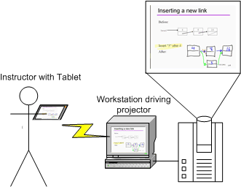

Figure 2. The architecture of Presenter in the classroom. An instructor controls the presentation from a mobile Tablet PC. The tablet is wirelessly connected to a machine driving the display of the presentation on a data projector.

Presenter transmits and displays writing and control information in real-time over an 802.11b wireless network. In-class use of Presenter has been tested with most known brands of Tablet computers currently available (including Acer, Toshiba, HP/Compaq, Fujitsu, NEC, and Motion Computing models). The machine controlling the data projector must either have an internet connection or be connected to the same wireless network as the instructor’s tablet (no live internet connection required). Assuming a classroom has already been outfitted with a computer and data projector, using Presenter would cost about $2000 for the Tablet PC and $150 for a wireless base station. Both of these could be shared across classes, or the tablet could be used as a personal machine by an instructor.
Three key features of Presenter and, we believe, for lecture presentation systems in general, emerged from our in-class experiences with our system. First, Presenter integrates writing directly on top of slides. The instructor can use the tablet pen to write notes or diagrams directly over the slide, as shown in Figure 1. The instructor can also shrink the visible slide and writing, creating new writing space around the slide. The ability to write in the context of the slides maintains the connection between extemporaneous writing and the prepared content. Sustaining this link enhances the slides’ value as a support structure for communication – a “mediating artifact” [16] − in the classroom. Additionally, if the instructor has even more to say, she can jump to a “whiteboard” slide to work an impromptu sample problem or continue discussion beyond the context of the prepared slide.
Second, writing in Presenter is represented with high-quality ink, which renders in real-time and looks and feels natural. This is enabled by the high pen sampling rates and resolution on recent Tablet PCs and Tablet PC software support for smooth curves and pressure-sensitive line thickness. High-quality writing allows full use of the available resolution on the display, increases instructor comfort with writing and eases student comprehension of hand-written text.
Finally, Presenter separates the instructor view of the presentation from the projected display that students see. Actually, Presenter supports three viewing modes: instructor (seen on the “primary” tablet), projector, and student. Instructor and projector modes are described here, while student mode will be further discussed in Section 4.
The instructor uses the instructor view on her tablet while the projector machine ships the display view to the public screen. This separation allows the instructor view to include a wide array of tools—such as pen color and style controls—and information displays—such as the filmstrip pane on the left side of the display, showing miniatures of the slides immediately preceding and following the current slide. Furthermore, with no tether to the data projector, the tablet can go completely wireless, giving the instructor freedom to control her presentation from anywhere in the classroom or even to pass the tablet to a student.
Additionally, Presenter supports “instructor mode objects” − text or drawings visible only on the instructor tablet view and not shown on the projector view. These objects can contain reminders, notes, or hints to the instructor of issues to discuss in relation to the slide or questions to ask the students. These objects can also encapsulate information that the students will be asked to actively derive in-class – in contrast to more traditional static “here’s the resulting answer” treatments. Pictures, graphs, or diagrams can be annotated with circles, lines, or other drawing objects that the instructor can “draw over” in class to highlight important areas or show modifications.
One unique capability of the Presenter system is that it facilitates the creation of an artifact from a given lecture. Inked notes created in class can be saved in conjunction with the slides from the class and viewed at a later time. This has implications for allowing instructors to review, in greater detail, the material and discussions covered in a given class period. Students could also be given access to inked notes from class discussions, at the discretion of the instructor.

Presenter for Undergraduate Architecture

We discuss one semester’s experimentation using Presenter in a small-class undergraduate Patterson and Hennessey-style computer architecture class. We give examples of the various usages of Presenter system components in creating a more interactive lecture while still maintaining the organization and re-use features of an electronic presentation. Many of these examples echo recommended practices of modern pedagogy, e.g., active learning [9] and Classroom Assessment Techniques [2]. A survey of the class found strong student approval of the Tablet PC-based system, despite occasional technical issues involved with beta-testing.
Inking-Over for Emphasis, Notes to Mention
Perhaps the most often used form of interaction enabled by the Presenter system is a simple circling or highlighting of a word or phrase on a slide. This can allow the instructor to visibly drive home an important concept or emphasize a term students should understand. In Figure 3(a) we see a projector view that might result after a discussion of execution time versus throughput. These circles were added at the same time a “verbal clue” was given to the students – showing emphasis or distinguishing from previously discussed concepts. Additionally, instructor-only objects (shown in Figure 3(b) in rounded text boxes) can remind the instructor of additional comments to make or simply encourage the instructor to prompt the class for a verbal response.
Another instructor using Presenter combined inking for emphasis with a simple feature of Presenter to develop a new discussion style. His discussion of a slide would focus on certain features of the material (emphasizing these in ink with highlights, circles, or other marks), next he would erase the ink with the “chalkboard eraser” button in Presenter’s top toolbar, and then he would discuss the slide again from a different perspective and with different markings. The rapid erase feature enabled this new style and tempo of discussion.
Culling Participation from the Class
Next we show an example where the class will be shown two graphs and asked to propose various conclusions that can be drawn. Figure 4(a) shows the instructor view before class discussion, Figure 4(b) shows the instructor view after

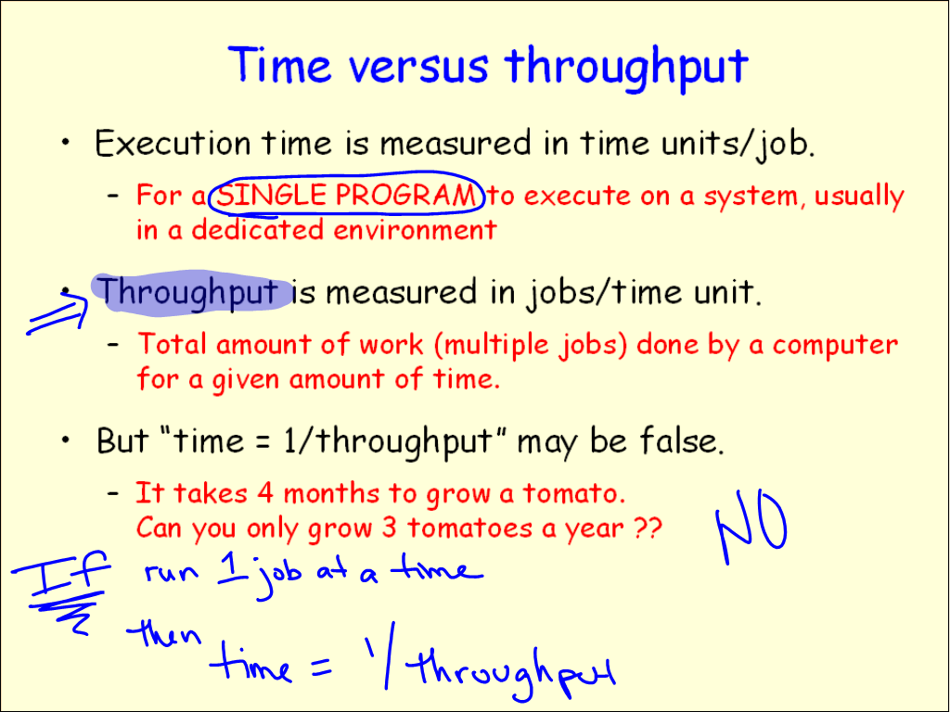
Figure 3(a). Projector view with key points emphasized via circling and highlighting. Additional notes at bottom of screen emphasize what was, hopefully, made clear in verbal lecture.
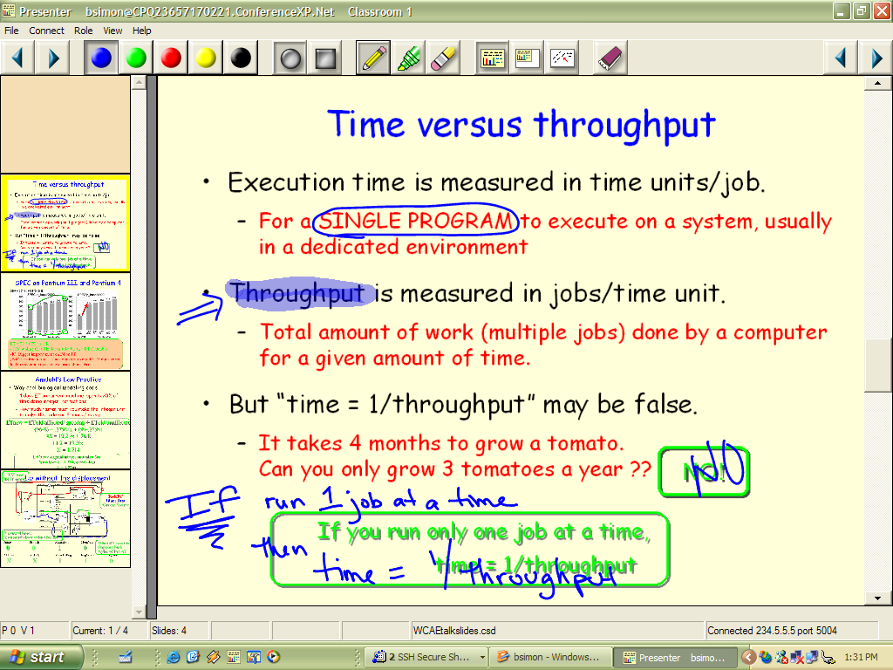
Figure 3(b). Instructor view after discussion. The rounded text boxes are instructor objects, not seen on the projected display. These objects can hold reminders of points to emphasize in class.

class discussion, and Figure 4(c) shows the projector view after discussion.

This slide wraps up a discussion of benchmarking as a manner of evaluating performance. Students are encouraged to recall a previous concept then apply it to the given problem. Specifically, students are asked to explain why the doubling of the clock rate doesn’t produce a doubling of performance (circles on the left graph remind the instructor where to draw student attention). Instructor notes at the bottom of the slide prompt the instructor to write, one more time, the ET = IC * CPI * CT equation and provide a color-coded reminder of the main topics students should bring up.

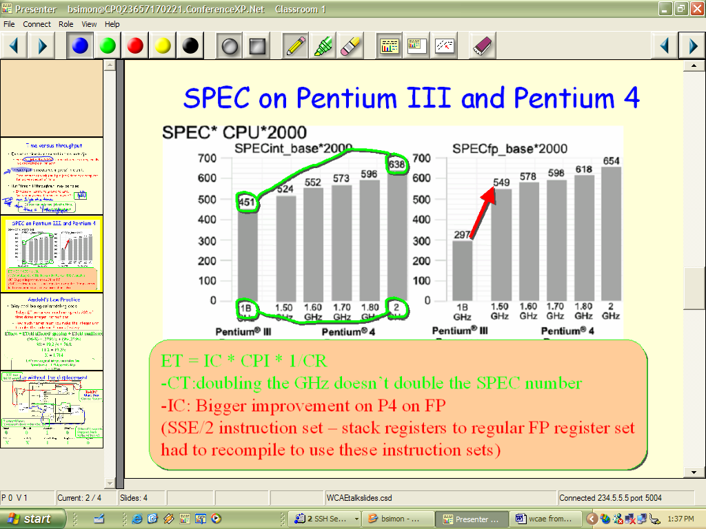
Figure 4(a). Instructor view before discussion. The “hand drawn” circles and lines, arrow, and text box are instructor objects – not seen on projected slide.

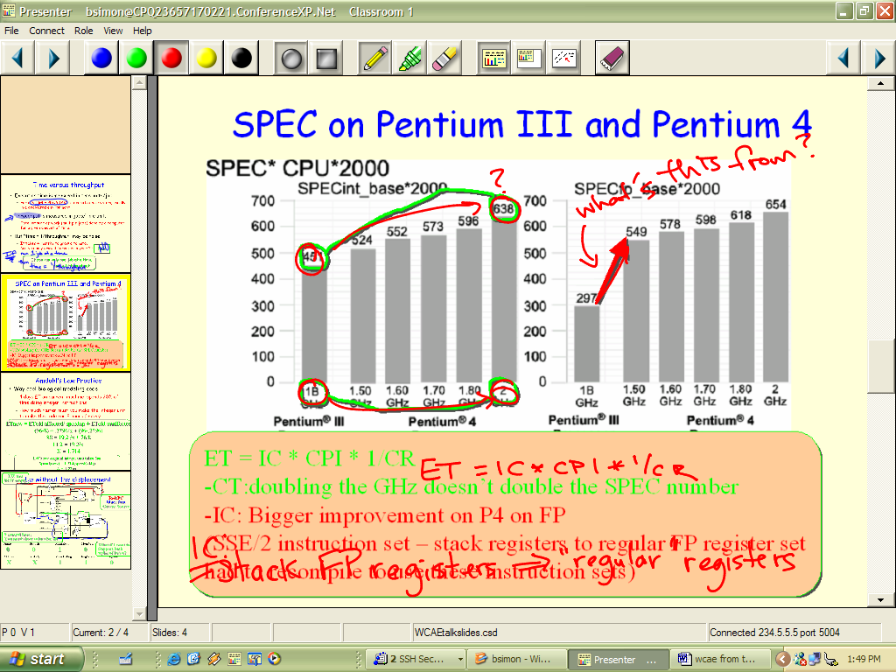
Figure 4(b) Instructor view after discussion. In-class inking has occurred overtop of “instructor object” inking as issues are raised in class. Some “notes” at bottom have been “copied” for students.
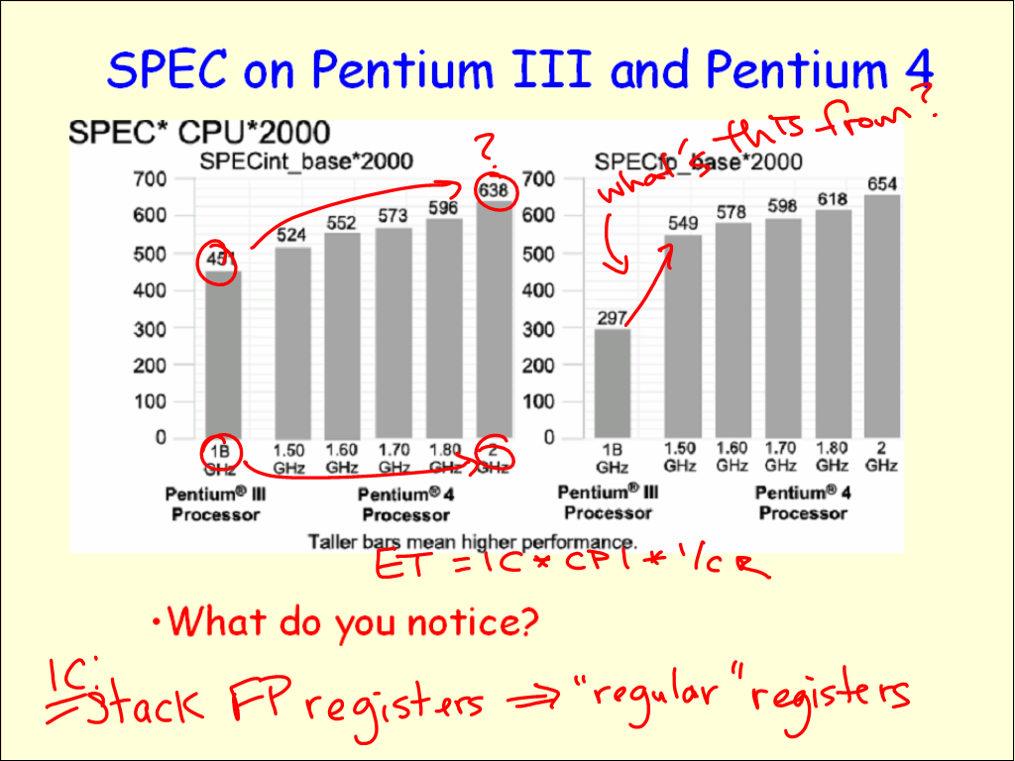
Figure 4(c). Projector view after discussion. This is what the students see.
Note that, in class, the instructor can “draw over” the circles and arrow instructor objects – either at the direction of an astute student, or as a hint to the class if no suggestion is forthcoming. If a student brings up some issue other than those “expected” by the instructor, the instructor is free to explore that topic, ignoring his own notes. If, after that discussion concludes, he wants to return to a “clean” version of the slide to discuss the planned topics, he can erase all ink at once using the chalkboard eraser icon on the top toolbar. If he wants to perform a partial erase of certain words, the pencil eraser erases ink one stroke at a time.
Interactive, But Planned, Problem Solving
Figure 5 shows one example of interactive problem solving where the students can get a first experience with applying Amdahl’s Law. In order to be sure to cover all the “basics”, there are instructor notes to encourage the instructor to fully set up the equation and to relieve him of the need to concentrate on simple math. A separate instructor note shows an additional calculation that can be discussed or omitted as time allows. A scroll bar on the instructor view allows the instructor to “scroll up” the ink (as on an overhead projector) of the Amdahl’s Law solution to provide additional room to solve the speedup equation (alternately, he can shrink the current slide to ¾ size and show additional work around the edges). In Figure 5(b), we see the projector version after the instructor has “scrolled up” some inked notes to solve an additional problem.
Providing Unexpectedly Needed Review
“You all know how to convert from decimal to binary don’t you?” When it becomes clear that one has misjudged the background knowledge of the class, Presenter allows one to easily “break out” of a planned lecture sequence. This can be done either by jumping to a backup slide (perhaps stored at the end of the slide deck and accessed through the filmstrip view) or to a blank “whiteboard” slide to provide a quick review or to recommend a reference for student use.
Summarizing What We’ve Learned
Presenter can add new life to the usual “here’s what’s important from Chapter X” conclusion slides. Simply converting current summary bullets to an instructor object (not seen by students) can force students to take notes as the instructor “overwrites” key topics or allow the class to brainstorm their opinions of the most important material as in the “Empty Outline” Classroom Assessment Technique [2] pp.138-141.
Adding an Instruction to a Single Cycle Datapath
The freedom of instructor mode objects (rather than just instructor mode text) is especially useful when explaining and modifying charts, graphs, or diagrams. The slide shown in Figure 6 was developed as an in-class review of a homework assignment where several students had produced confused answers. They had been asked to modify the
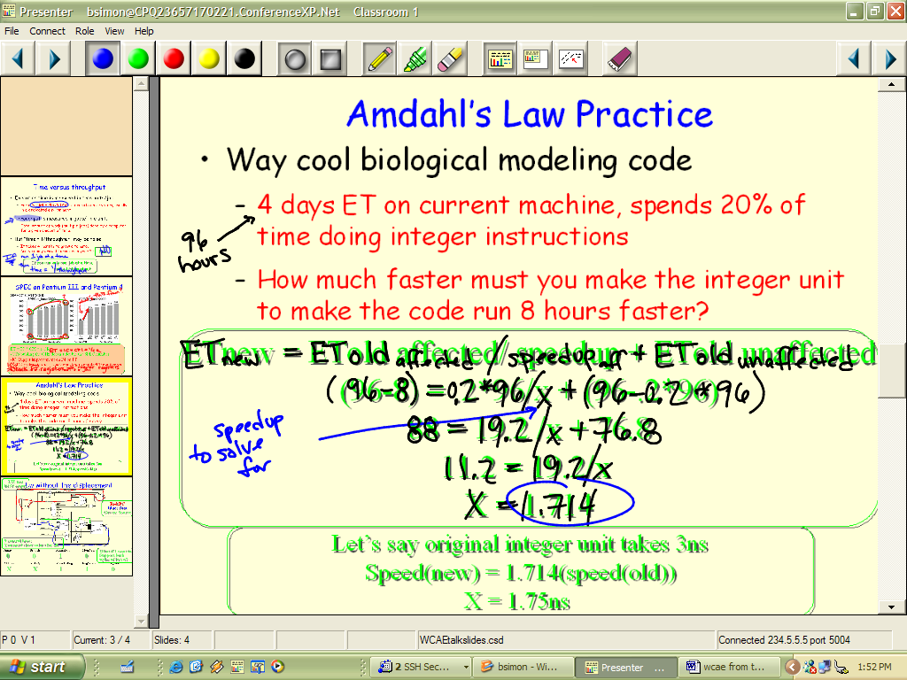
Figure 5(a). Instructor view where a pre-planned practice problem has been solved in-class. Text in bubbles are instructor objects and do not appear on projected slide. Instructor can “trace over” instructor object equations to avoid skipping through solution too quickly. Notes in bottom instructor object bubble can be discussed or skipped as time permits.
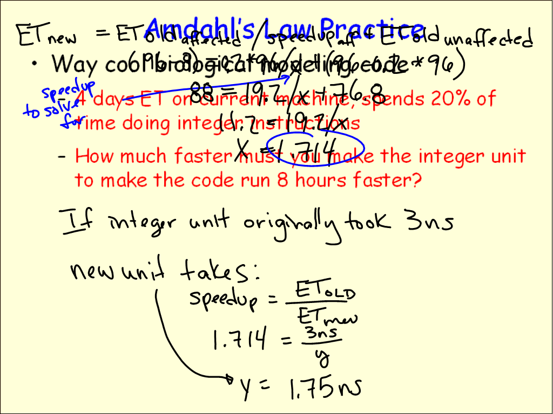
Figure 5(b). Projector view of 5(a) after “scrolling up” first equation work to make room for new discussion. This new ink addresses the bottom instructor object bubble in 5(a).
MIPS single cycle datapath (developed in Patterson and Hennessey, chapter 5) to support only lw and sw instructions

that had no displacement. In Figure 6(a) we see the instructor view before discussion. The datapath has been “drawn over” with instructor object lines in different colors. Notes are scattered around the slide as reminders of the format of the instruction and as a guide to an ordering for discussing the datapath modifications. In class, we see (Figure 6(b)) that the instructor has inked over the instructor objects as discussion of the problem progresses. Figure 6(c) shows the much less cluttered projected version.

Upcoming Features and Future Work

Additional Instructor Control Features
Currently, all instructor notes must fit within the available real estate on the slide, and the built-in notes from PowerPoint are ignored. The on-slide notes offer extra flexibility—shapes, figures, etc. as notes rather than just text; however, off-slide notes would ease space management issues for instructors. In future versions, an optional extra pane will display PowerPoint notes.
Furthermore, instructor notes are currently distinguished from public slide elements by a shadow beneath the note, allowing instructors to quickly determine which slide elements students see and which are invisible to them. However, some instructors prefer other mechanisms such as making instructor object text all one color, or using only the rounded box shape for notes. We plan to support a broader range of mechanisms for distinguishing instructor notes.
Instructor-Only Inking
Future plans for “instructor-only” inking would allow instructors to make private inked notes during class (visible only on the instructor tablet). These notes could reflect anything that pops into mind in class that the instructor wants to remember afterward. Possibilities include comments on the efficacy of certain slides, points of confusion, and possible homework or test problem ideas.
Tablets for Student Interaction in the Small Classroom
While in-class group problem solving is often viewed by students as very instructional, instructors often feel the class time spent on these group activities comes at the cost of lecture presentation time. Specifically, if students are to benefit from the evaluation of other students’ work, then one must ask different groups to present their results to the class in some form (at the board, etc.). This adds yet more time to the group activity.
Future versions of Presenter will support an additional, “student view” that will be wirelessly transmitted to Tablet PCs scattered throughout the class. While not every student may have a tablet, for the purposes of group work, each group (or a subset of groups) can be given a tablet on which to record their work. The instructor tablet will have a method of previewing the various student tablet screens, and selecting one to be projected by the data projector. In this way, a group can “show their work” instantaneously. The group can be asked to describe their work, possibly using additional ink (circling, etc) to emphasize points in the discussion.
Some of the things students will be able do include working on a “blank screen”, solving a problem proposed on a slide, modifying a datapath diagram, or filling in an empty cache.

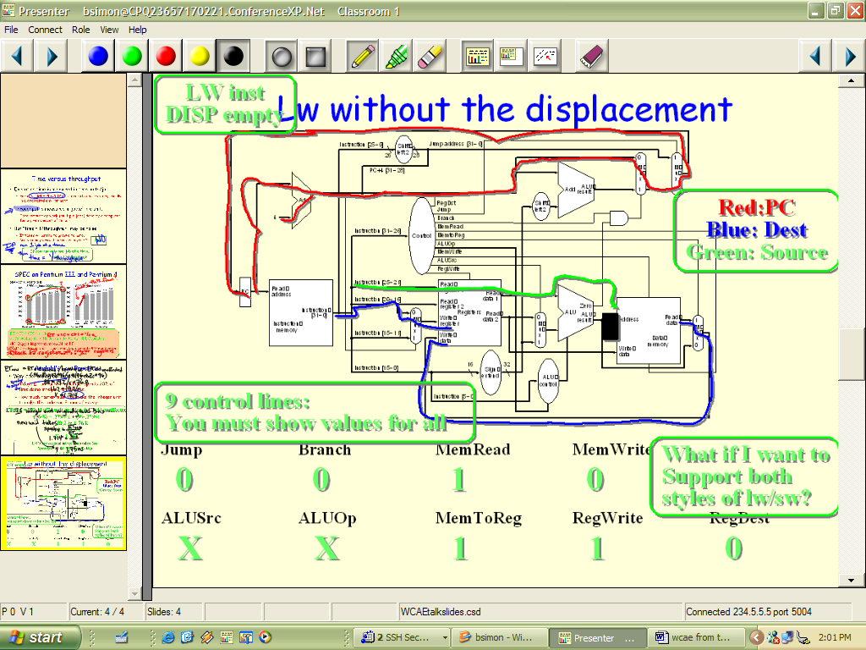
Figure 6(a). Instructor view before discussion. Many instructor objects are present including text boxes, lines drawn over the datapath, and values for control lines.
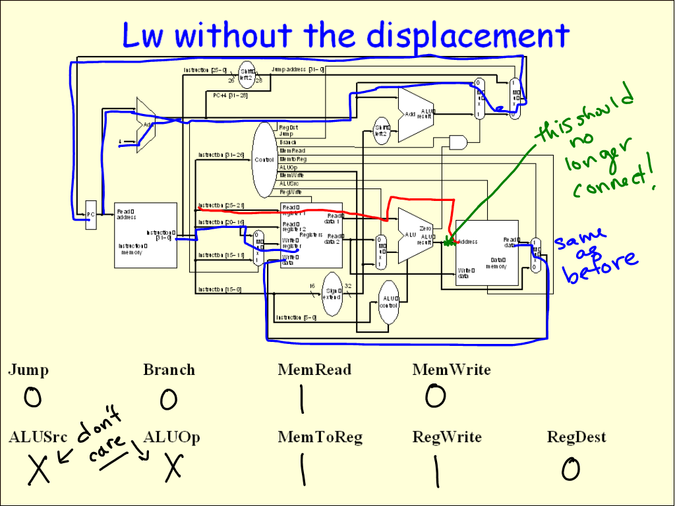
Figure 6(c). Projector view of modifications to support lw without displacement. Pen color changed to show which parts of the datapath had to be altered to accommodate the new instruction.

Wireless Data Projectors
While current implementations require a separate machine to drive the data projector (so as not to tether down the instructor), future versions may discard this requirement through the use of wirelessly enabled data projectors. While still in their infancy, wireless data projectors could set up a connection with the instructor tablet to project only the projector view version of a slide.

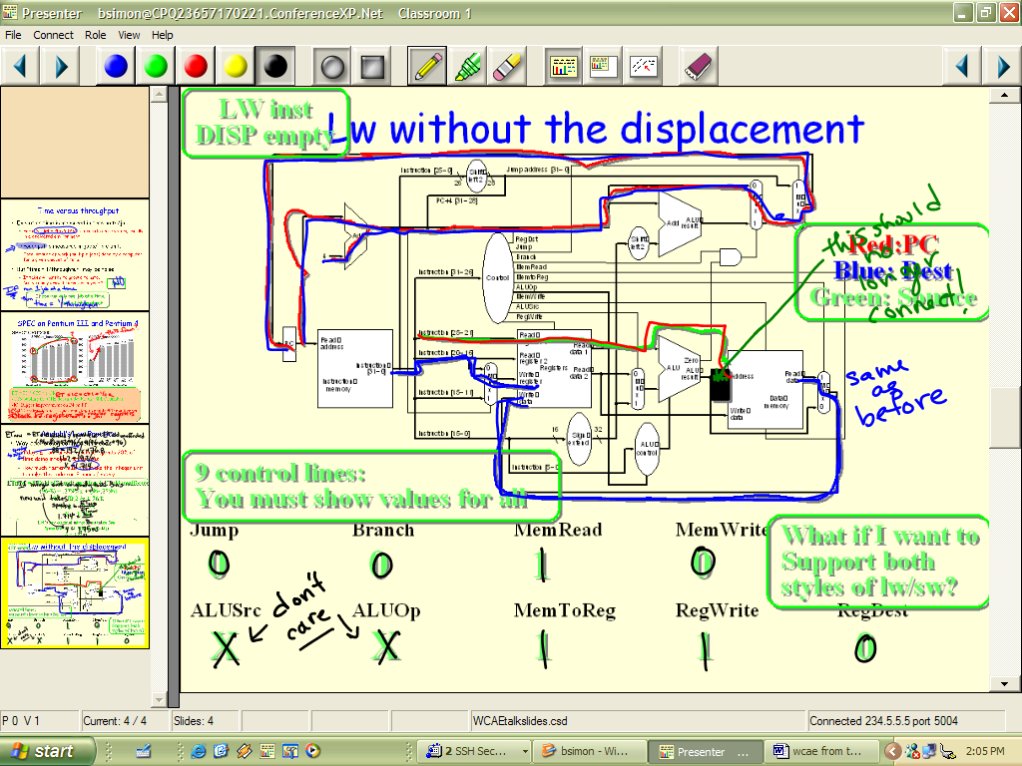
Figure 6(b). Instructor view after discussion. Datapath lines have been “inked over” in the order recommended in an instructor object text note. The class was asked to supply control line values, which could be “checked” against instructor note values.

- Related Work
There have been a number of related efforts to deploy technology in the classroom to enhance learning, and to capture the lecture for later playback. eClassroom (formerly Classroom 2000) [1] is a premier project for incorporating technology in the classroom to facilitate note taking, capture, playback, and presentation. While eClassroom includes some effort to improve presentation facilities for the instructor, our work focuses directly on this aspect. Classroom Presenter also differs from eClassroom in that our goal is to deploy in a general data projector-enabled classroom, as opposed to basing our design on a dedicated facility. The Pebbles system [10] was one of the first projects to explore steering a presentation from wireless devices. Our emphasis on writing as part of presentation relates to the broad literature on pen computing and electronic whiteboards [11]. In this stage of our work we are not attempting a semantic interpretation of the ink, as in the Back of the Envelope project [6]. Work on zoomable interfaces has relevance to our work, both in suggesting alternative ways to view the display surface and the presentation [5].

The importance of actively involving students in classroom activities at regular intervals is supported by studies on student attention spans [2][13]. There has been some educational work attempting to evaluate the use of PowerPoint in university classrooms [7][8][14]. The overall results have been ambiguous with respect to learning outcomes, but the papers have some perceptive comments on the use of PowerPoint and indicate a favorable student response. There has also been an active debate on the lecture style supported by slides with polemics on all sides [15][12][4].

Conclusions

This work describes the Classroom Presenter lecture presentation system developed at the University of Washington. We highlight some of the specific utilities of the system in the context on an undergraduate computer architecture course. The main benefits of Presenter stem from wireless, high-quality inking over slides during lecture combined with a separation of views between instructor and projector. These features have enabled high levels of spontaneity and interactivity in an undergraduate architecture class. Specifically, the ability to use instructor-only visible objects to annotate diagrams and graphs can encourage the instructor to develop designs jointly with the class rather than presenting them as problems already solved.

References

[1]Abowd, G. D. Classroom 2000: an experiment with the instrumentation of a living educational environment. IBM Systems Journal, 38(4), 1999.

[2]Angelo, Thomas A. and Cross, K. Patricia. Classroom Assessment Techniques. Jossey-Bass Publishers, San Francisco, 1993.

[3]Bligh, D. A. What’s the use of lectures? Jossey-Bass Publishers, San Francisco, 2000.
[4]Creed, Tom. PowerPoint No, Cyberspace Yes. The National Teaching & Learning Forum, 1997, http://www.ntlf.com/html/sf/cyberspace.htm
[5]Good, Lance and Bederson, Benjamin B. CounterPoint: Creating Jazzy Interactive Presentations. HCIL Tech Report #2001-03. University of Maryland, College Park, MD 20742, 2001.

[6]Gross, Mark D., and Do, Ellen Yi-Luen. Drawing on the Back of an Envelope: a framework for interacting with application programs by freehand drawing. Computers & Graphics, 24 pp. 835-849, 2000.
[7]Hozl, J. Twelve tips for effective PowerPoint presentations for the technologically challenged. Medical Teacher, 19, 175-179, 1997.
[8] Lowry, R. B. Electronic presentation of lectures -- effect upon student performance. University Chemistry Education, 3 (1), 18-21. 1999.
[9]McConnell, Jeffrey J. Active Learning and Its Use in Computer Science. SIGCSE/SIGCUE Conference on Integrating Technology into Computer Science Education (Barcelona, Spain June 2-5, 1996), also published as SIGCSE Bulletin, Vol. 28 Special Issue, 1996, pp. 52-54.
[10]Myers, Brad A. and Stiel, Brad A. and Gargiulo, Robert. Collaboration using multiple PDAs connected to a PC. In Proceedings of CSCW’98: ACM Conference on Computer-Supported Cooperative Work, pages 285–294, November 1998.
[11]Mynatt, E., Igarashi, T., Edwards, W. K., and LaMarca A. Flatland: new dimensions in office whiteboards. Proceedings of ACM Human Factors in Computing (CHI 99). New Your: ACM, pp 346-353. 1999.
[12]Rocklin, Tom. PowerPoint is Not Evil! National Teaching and Learning Forum Newsletter, 1997. http://www.ntlf.com/html/sf/notevil.htm
[13]Stuart, John and Rutherford, R. J. Medical Student Concentration During Lectures. The Lancet, September 2, 1978, pp. 514-516.
[14]Szabo, Atilla and Hastings, Nigel, Using IT in the undergraduate classroom: should we replace the blackboard with PowerPoint? Computers & Education, 35 175-187, 2000.
[15]Tufte, E., "The Cognitive Style of PowerPoint", www.edwardtufte.com, 2003.
[16]Vygotsky, L.S. Mind in Society. Cambridge, MA: Harvard University Press, 1978.

Appendix: Classroom Presenter Feature List
The Filmstrip. The Filmstrip is a “preview strip” of slides surrounding the currently displayed slide. The filmstrip facilitates non-linear slide navigation order, which can allow faculty to react to the development of ideas and discussion in class.
Filmstrip preview. Another benefit of the filmstrip view is to allow the instructor to make appropriate concluding comments based on the content of the next slide to be displayed. Filmstrip preview makes this more viable by showing an instructor-visible “zoomed in” version of a filmstrip slide when the tablet pen is “waved” over a portion of the filmstrip.
The Toolbar. Back and forward buttons are placed at both ends to allow easy movement one slide in either direction of the current slide. Four inking colors are supported as well as two ink “tips”: a square and a round tip. The next three buttons select “regular pen” inking, highlighting, or stroke-based erasing. The following three buttons control the view: full slide, ¾ size slide, or blank whiteboard (you can jump from the whiteboard back to your current slide by clicking on the “full slide” button). The chalkboard eraser erases all ink on the current slide. An upcoming feature will be “undo” which can undo the last selection (particularly important for the full erase).

ACKNOWLEDGMENTS: We thank the University of Washington CS Education and Educational Technology Group for their support and insights.

