Lecture Presentation from the Tablet PC

Richard Anderson¹, Ruth Anderson², Crystal Hoyer¹, Beth Simon³, Fred Videon¹, Steve Wolfman¹
University of Washington¹ University of Virginia² University of San Diego³
{anderson , crystalhoyer, fred, wolf} ruth@cs.virginia.edu bsimon@sandiego.edu
@cs.washington.edu

Abstract

We have developed and deployed a lecture presentation system called Classroom Presenter in which the instructor uses a Tablet PC as a presentation device. The system has been deployed in courses at the University of Washington, University of Virginia, and the University of San Diego, and has been favorably received by students and instructors. In this paper we present an overview of the system and discuss particular uses and advantages of the system in small and large lectures as well as distance education scenarios. We discuss two system features in greater detail, a facility for supporting multiple versions of slides for instructor notes, and a facility for delivering student feedback in real time to the instructor. We report on in class use of these facilities.

1. Introduction

In this paper we describe our experiences developing and deploying a Tablet PC-based system for presenting lectures. When using the system, the instructor holds a pen-based computer which is wirelessly connected to a second computer driving a classroom projector. The instructor displays slides from the computer, and can write on top of them. Various navigation and control facilities are available. Figure 1 shows the instructor view and Figure 2 shows the projector view. Students may also receive the presentation on personal devices and provide feedback to the instructor.
The problem that motivated our work was how to improve the ability of an instructor to present lecture material from a computer. Although there are significant advantages to computer projection of lectures (e.g. preparation of high quality examples in advance, ease of switching between slides and web content or other applications), many instructors feel limited in their ability to react to the audience in a slides only format, and also believe that their lectures become highly scripted. Our goal was to address these problems in a presentation system suitable for both large lectures and distributed classes.
We conducted a background study which involved observing live and archived classes, and interviewing students and instructors [6]. A major finding of this study was the importance of integrating lecture slides and handwriting.

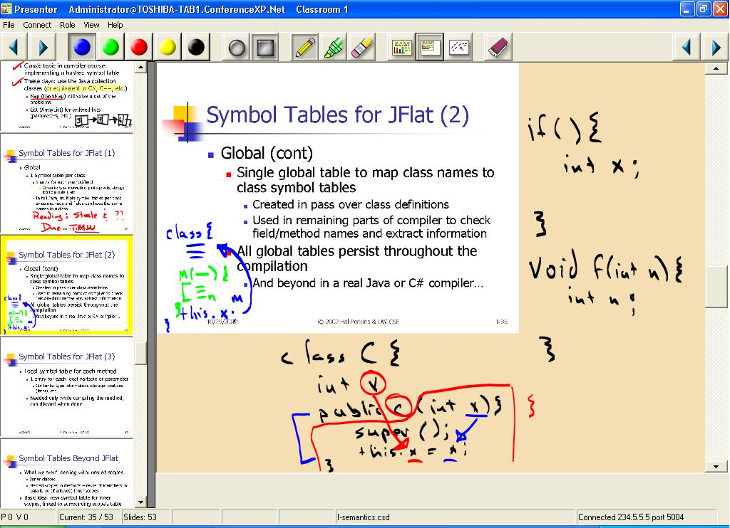
Figure 1. Instructor view showing slide minimized to allow extra writing space. (From CSE 582, Au 2002)
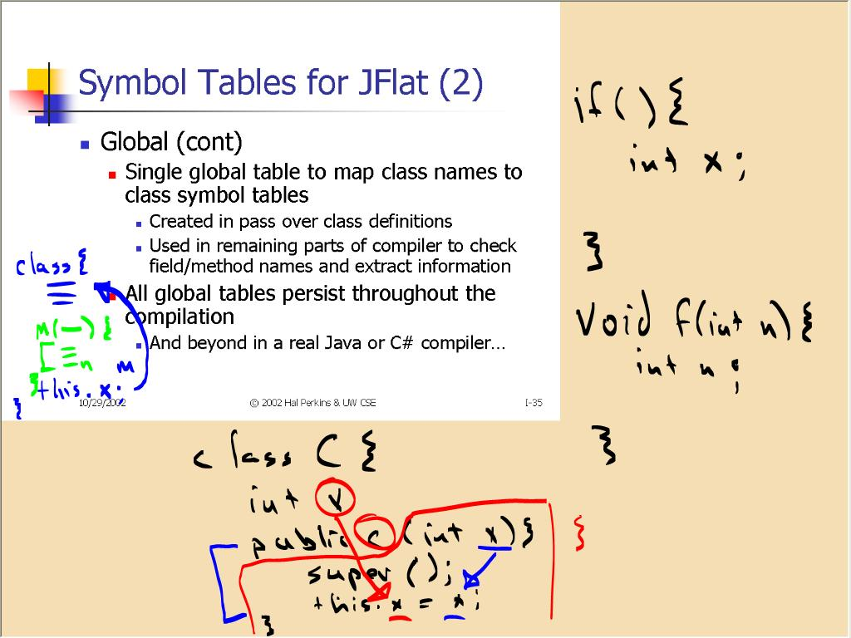
Figure 2. Projector view.

In Section 2 we describe the development and deployment of the system, and in Section 3 we describe key features of the system. Section 4 describes deployment of the system in a distance education scenario. Section 5 gives a specific example of use focusing on instructor-only objects. Section 6 describes initial experiences with integrating mechanisms for student feedback into the system.

2. Development and Deployment

We began developing Classroom Presenter in January 2002 and deployed an early version of the system in a Masters’ level distance learning database course in Spring 2002. In response to feedback from the students and instructor, we modified the system, deploying a more mature version in an introductory programming course in Summer 2002. After a further round of revisions, in Autumn 2002 the system was used in six courses: two introductory programming courses, three senior level courses (algorithms, languages, and software engineering), and a Masters’ level distance learning compilers course. The system was used in the majority of class sessions. Usage of the system has continued at this level in Winter and Spring 2003 and has expanded to use at other universities. We estimate total usage to be over 400 classroom hours.
We studied usage by observing classes, capturing sessions with a logging tool, and conducting a survey of students and instructors. In addition, we received detailed usage notes from some of the instructors. Overall, instructors and students were enthusiastic about the system’s ability to create a more spontaneous and interactive classroom environment. Activities involving handwriting (e.g. drawing diagrams in response to student questions, recording students’ verbal responses, elaborating on slide contents and drawing attention to key concepts) that were previously unavailable in computer-based presentations, have been brought back into the classroom.

3. Key Features of the Presentation System

Based on discussions with numerous faculty members and initial positive experiences with our system, we believe that presenting lectures from a pen based computer will become commonplace within a few years.
We now discuss results from our initial deployments in terms of design choices we made and areas for future work. The most significant implementation choice that we made was to develop the system as a distributed application with a separate computer driving the data projector. This gave the instructor a separate view from the students and also allowed for mobility.

3.1. Use of Ink

All instructors made extensive use of ink. Instructors reported marking on approximately half of their slides. The type of ink usage varied substantially and we are developing a classification of use for future study. The two most important components of the inking system were the high quality, natural inking provided by the Tablet PC, and support of layering of ink that allowed some separation of ink and slides. One piece of evidence we have in support of the value of high quality ink is that the Spring 2002 deployment used an earlier pen based computer, and received a significantly different reception from users. Our implementation treats ink as a separate layer, and supports shrinking the slide to create blank writing space, scrolling the writing layer as on a traditional overhead projector and use of blank slides as whiteboards. Observations and instructor comments indicated that these facilities were very significant to the usability of the system. Figures 1 and 2 show how slide shrinking was used in class. The system also gave flexibility in choice of pens and colors, but instructors rarely changed the pen options.

3.2. Wireless Presentation Device

Several benefits of wireless communication were observed. Two of the instructors carried the tablet while lecturing and others took advantage of the wireless device to improve the position to lecture from. One unanticipated use occurred when an instructor carried the tablet into the audience and had students write directly on it to contribute to the shared display. Students in the course commented on this experience very positively.

3.3. Multiple Views

The distributed implementation allowed a rich UI for the instructor without cluttering the shared display. Different views also made it possible to display information to the instructors (talk notes and slide previews) that were not intended for the students. This feature will be discussed in more detail in Section 5.

3.4. Navigation

In response to early feedback on the system, we introduced a filmstrip view to give the instructor more flexibility in navigation. For some instructors, this was a very valuable facility, and there appeared to be more non-linear navigation than with traditional delivery of computer-based presentations. Navigation between the whiteboard slide and the slide deck was also an important feature. An area for future work is to gain an understanding of navigation facilities. We had not anticipated that navigation would be as important an issue as it appears to be.

3.5. Pen Based UI for Presentation

It is important that the UI for the presentation device does not require much attention to use, since the instructor should be concentrating on the content and the audience, not on the presentation device. The area of the system that underwent the greatest changes throughout our process of iterative development was the UI as we made changes in response to observed difficulties. Changes included widening resize handles, increasing button sizes, turning off the mouse button and disabling jumps on scroll bars. One area of particular concern was the transition between inking areas and control areas so that writing did not inadvertently trigger other actions.

4. Distance Education

We used Classroom Presenter in a distance learning environment for a Masters degree program in Computer Science at University of Washington [1]. The program is designed for technology professionals. Courses typically met in the evenings once a week for three hours. We coordinated the use of Classroom Presenter for this program, interacting with instructors, and observing the use of the software over four academic quarters.

4.1. The Distance Learning Environment

The distance learning courses joined two learning sites: a site on the university campus and a site at Microsoft. The instructor delivered lectures at the local site, while a video image of the instructor and the presentation were displayed at the remote site. Each site was equipped with video conferencing equipment, projectors, cameras and microphones.
In addition to the live video conference, the distance learning courses were archived for asynchronous access. The archives were prepared in Windows Media format, and contained additional information to permit slides and instructor annotations to be synchronized with the audio and video.

4.2. The Original Presentation System

Prior to the introduction of Classroom Presenter, PowerPoint slides served as the primary presentation medium. For extemporaneous writing, the instructor used a Smart Board electronic whiteboard. The whiteboard was connected to the instructor computer where a custom whiteboard application was used to display the current board state. The foreground application on the instructor computer was projected in the local classroom and transmitted to the remote site using Microsoft NetMeeting application sharing. Since the whiteboard application was separate from PowerPoint, the instructor could project and transmit either the whiteboard display or the PowerPoint slides, but not both at once. The system did not permit annotations to be made directly on top of PowerPoint slides.
The presentation archive was prepared using a set of custom tools and scripts. Before each lecture, the PowerPoint slide deck was converted to a set of web accessible images. During the lecture, custom tools ran on the instructor computer capturing whiteboard interactions and slide transition timing information. After each lecture the logged presentation information was synchronized and merged with the Windows Media file. The playback system used a web interface which relied on a custom Java applet to draw the whiteboard image [2].

4.3. Shortcomings of the Original System

Instructors and students who had been involved in distance learning courses were asked about their experiences with the presentation system [6]. A major issue for instructors was the inability to respond in a flexible manner to the students while giving a slide based lecture. Some students value digression which is more difficult when lecturing with PowerPoint slides. Most instructors would have liked to have the ability to highlight and annotate directly on slides. Instructors noted that the ability to view the whiteboard and lecture slides simultaneously would be valuable. Some found the whiteboard size to be limiting, and would have liked the ability to save an image from the whiteboard so that it could be referred to at a later point in the lecture.
Instructors remarked about difficulties with the whiteboard technology. Some were observed repeatedly struggling to write legibly, or having difficulty switching context between the PowerPoint presentation and the whiteboard. The fact that the whiteboard was sensitive to the touch of fingers as well as pens caused trouble for some. Some instructors who experienced difficulties in using the electronic whiteboard abandoned its use midway through the academic term.

4.4. Use of Classroom Presenter in Distance Learning

We replaced the original presentation system with Presenter beginning in Spring quarter 2002, and we have used it in four distance learning courses over four consecutive quarters to date. During the first and fourth quarters, both local and remote sites were equipped with multicast capable networks. This allowed the use of Presenter at both sites. During the second and third quarters, the remote site did not have a multicast capable network, so during these quarters we used Presenter at the local site, and used NetMeeting application sharing to transmit the Presenter display to the remote site. While NetMeeting was a reasonably functional alternative to Presenter’s native RTP transmission, it caused a slight but noticeable degradation in image quality, and more significantly, it increased the latency in the transmission of the presentation.

4.5. Experiences with Presenter

By far the most significant problem we experienced using Presenter during the first and fourth quarters was a direct result of problems with the quality of multicast network connectivity between the two sites. In particular, during the first of the four quarters, the course was affected by frequent interruptions. Some lectures suffered from complete multicast outages, forcing the transmission of the entire presentation with NetMeeting.
Aside from multicast networking issues, Presenter was popular with instructors and students. After the first quarter, surveys and interviews revealed student satisfaction in particular with the writing on slides [6]. Instructors reported that the software was easy to use, and were rarely observed to have problems writing legibly. Usability issues which were observed arose from the proximity of controls to one another. One instructor mistakenly clicked on a menu rather than the toolbar icon as he intended. Another occasionally clicked the scroll bar when he intended to annotate near the edge of the display. Instructors were observed using ink and other Presenter features to varying degrees. Some instructors took time before the first lecture to familiarize themselves with the Tablet PC and with Presenter features, and began using ink, whiteboard, scrolling, and slide resizing right away. Other instructors became familiar with more features only as the quarter progressed. Instructors were observed using Presenter with different lecture styles. One instructor frequently designed slides with significant blank space which he would fill with annotations during class, lecturing in “whiteboard style”. Other instructors used ink mainly to respond to student questions, to support unplanned digressions in the lecture, or to give extra emphasis to text within the slide. Another important suggestion from one instructor was to provide additional mechanisms to support preview and navigation of slides. Observation of her use suggests that these facilities have improved her ability to deliver her lecture in a non-linear fashion.

4.6. Presentation Archiving

Classroom Presenter data was captured for archival use with the data logging feature of the ConferenceXP to Windows Media Gateway [3]. The primary purpose of the Windows Media Gateway is to transcode audio and video from a set of ConferenceXP streams into Windows Media format. An additional feature of the Windows Media Gateway listens for Classroom Presenter data, inserts that data into the Windows Media stream, and optionally stores the data to a XML formatted log file. After each lecture, the log file was placed on a web server, and a URL reference to the log file was included in Windows Media metadata where it would be accessible to Windows Media clients. A custom client application, ConferenceXP WebViewer [4] was designed to support the playback of the presentation synchronized with the Windows Media stream. The WebViewer embedded the Windows Media Player and a slide view control, and maintained state of the slide view as the user navigated through the media. The WebViewer supported a table of contents which was built from markers in the Windows Media file.

5. Instructor Mode

One of our interests in developing this instructional technology is to see how the different mechanisms which are made possible by a distributed, pen based system influence lecture style and instructor-student interaction. One example of this is the use of different slide views for the instructor and students. Classroom Presenter supports “instructor mode objects” − text or drawings visible only on the instructor tablet view and not shown on the projector view. These objects can contain reminders, notes, or hints to the instructor of issues to discuss in relation to the slide or questions to ask the students. These objects can also encapsulate information that the students will be asked to actively derive in-class – in contrast to more traditional static “here’s the resulting answer” treatments. Pictures, graphs, or diagrams can be annotated with circles, lines, or other drawing objects that the instructor can “draw over” in class to highlight important areas or show modifications.
In this Section we discuss one semester’s experimentation using Classroom Presenter’s “instructor mode objects” in a small-class undergraduate computer architecture class. We show the usage of the instructor mode objects in creating a more interactive lecture while still maintaining the organization and re-use features of an electronic presentation.

5.1. Example from a Computer Architecture Class

We describe an example where the class will be shown two graphs and asked to propose various conclusions that can be drawn. Figure 3(a) shows the instructor view after class discussion, and Figure 3(b) shows the projector view after discussion. Instructor-only objects (shown in Figure 3(a) in a rounded text box) can remind the instructor of additional comments to make or simply encourage the instructor to prompt the class for a verbal response.

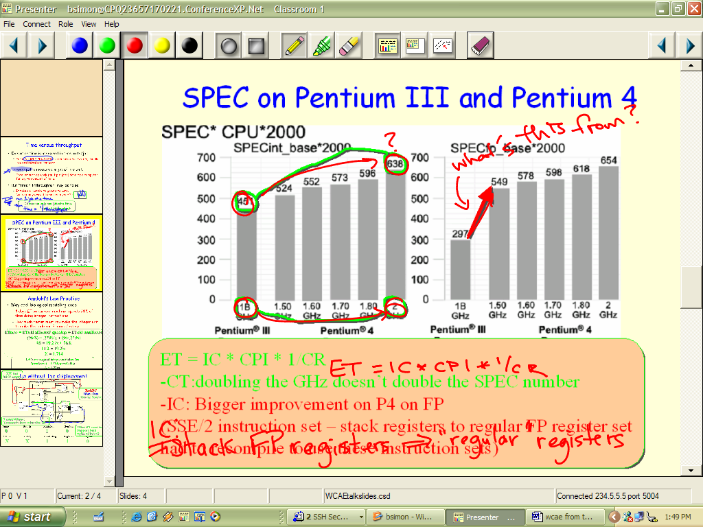
Figure 3(a). Instructor view after discussion. In-class inking has occurred overtop of “instructor object” inking as issues are raised in class. Some “notes” at bottom have been “copied” for students.

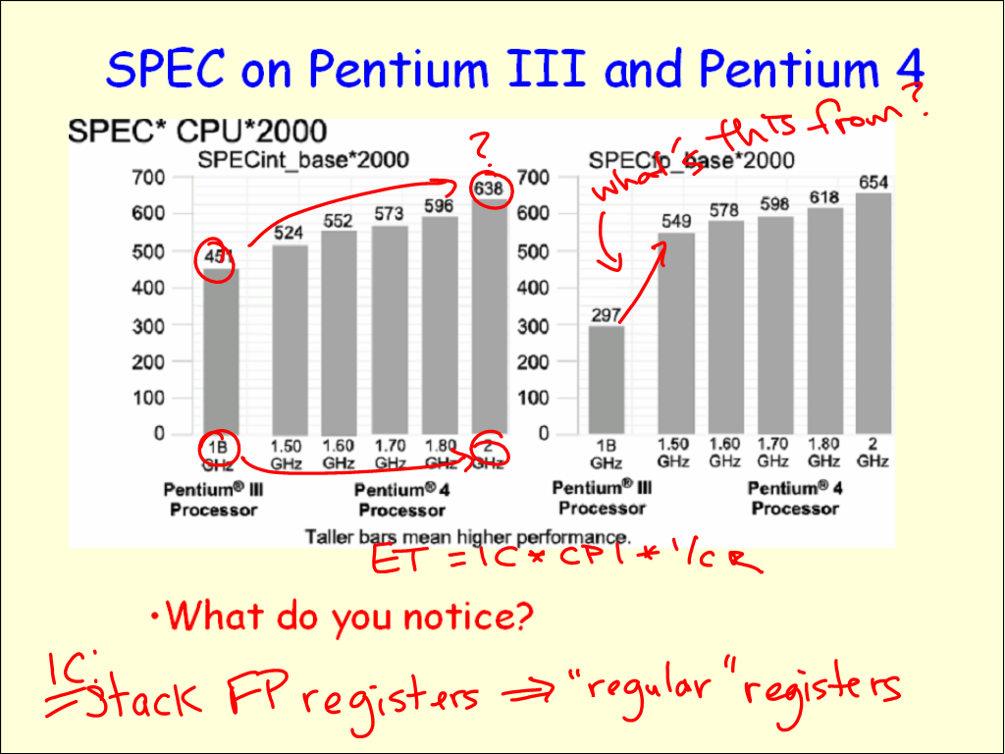
Figure 3(b). Projector view after discussion. This is what the students see.

During class, students are encouraged to recall a previous concept then apply it to the given problem. Specifically, students are asked to explain why the doubling of the clock rate doesn’t produce a doubling of performance (circles on the left graph remind the instructor where to draw student attention). Instructor notes at the bottom of the slide prompt the instructor to write the ET = IC * CPI * CT equation and provide a color-coded reminder of the main topics students should bring up.

Note that, in class, the instructor can “draw over” the circles and arrow instructor objects – either at the direction of an astute student, or as a hint to the class if no suggestion is forthcoming. If a student brings up some issue other than those “expected” by the instructor, the instructor is free to explore that topic, ignoring his own notes. If, after that discussion concludes, he wants to return to a “clean” version of the slide to discuss the planned topics, he can erase all ink at once using the chalkboard eraser icon on the top toolbar. If he wants to perform a partial erase of certain words, the pencil eraser erases ink one stroke at a time.

5.2. Other Uses

Classroom Presenter can add new life to the usual “here’s what’s important from Chapter X” conclusion slides. Simply converting current summary bullets to an instructor object (not seen by students) can force students to take notes as the instructor “overwrites” key topics or allow the class to brainstorm their opinions of the most important material as in the “Empty Outline” Classroom Assessment Technique [7] pp.138-141.
The ability to use instructor-only visible objects to annotate diagrams and graphs can encourage the instructor to develop designs jointly with the class rather than presenting them as problems already solved. The incorporation of these instructor objects into a lecture reminds the instructor of important issues while giving students the opportunity to reach conclusions as a class.

6 Computer–Mediated Feedback

Student-instructor interaction is vital to student learning, but soliciting student feedback in large, university-level lecture classes is challenging. As universities serve more students and face tighter resource constraints, these large lectures are likely to persist, necessitating innovative approaches to large class challenges.
We designed the Classroom Feedback System (CFS) as an integrated part of the presentation system to address this problem. Following design experiment methodology [8], we studied large classes through observations. Based on these observations and existing literature, we identified key challenges to interaction. Next, we studied three successive pen-and-paper and electronic prototypes of CFS in large classes, refining CFS’s design and our list of challenges. Finally, we studied an introductory programming course using the full featured CFS. In this Section we focus on the challenges, CFS’s design, and experimental results from the most recent study.

6.1. Challenges to Interaction in Large Classes

The education community has long discussed the challenges of facilitating student-instructor interaction in large classes [8,9]. Based on literature, observations, and experiments with prototypes of CFS, we have identified several primary factors inhibiting student-initiated interaction in large classes:
Feedback Lag: suppression of questions due to lecture tempo. Students in our pilot study doubted the value of their questions on a topic until the topic was closed, but when lecture moved on, they felt the chance to ask their questions had passed.
Student Apprehension: fear of speaking due to the size or climate of the class. In our pilot study, 6 of the 12 participants reported feeling apprehensive of participating.
Single-speaker Paradigm: model in which only one person (student or instructor) speaks at a time. This model does not scale to broad participation in large classes. In our pilot study, 3 of 12 participants reported class size as a factor limiting participation.

6.2. Designed System

CFS (Figure 4) responds to these challenges. The instructor navigates and writes on a slide-based presentation from a wirelessly connected Tablet PC. Students view the slides on the classroom display and on personal wirelessly networked laptops. Students generate feedback by clicking a location on a slide and selecting from a fixed menu of possible annotations such as MORE EXPLANATION (Figure 5(a)). The student view displays both the current and previously presented slide (to address feedback lag) with the student’s feedback superimposed. The student can remove feedback that has been addressed by clicking it.

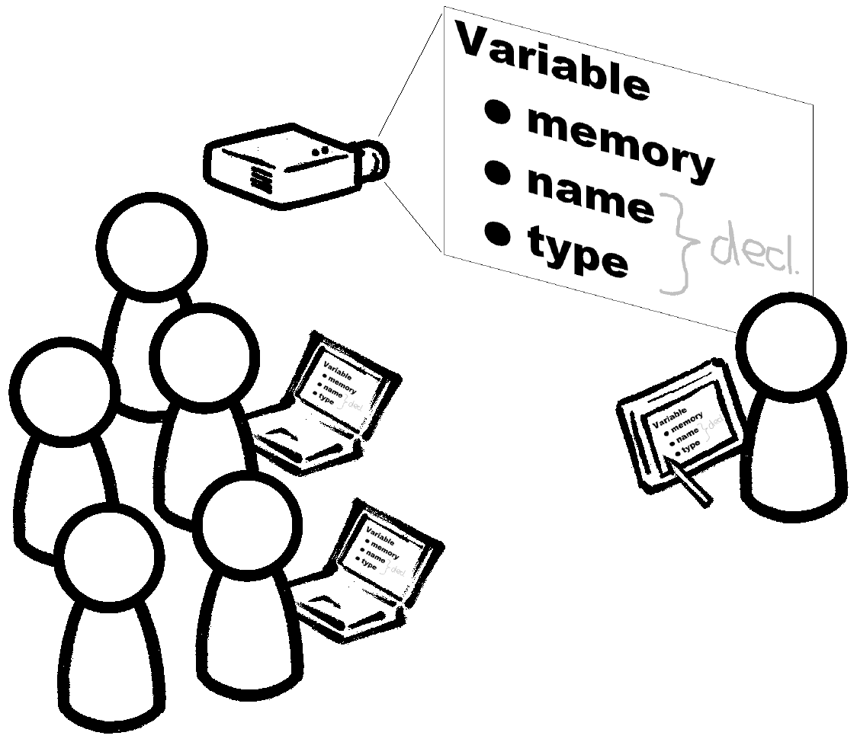
Figure 4: System setup, consisting of instructor and student devices, and a projector for the classroom display.

The instructor controls the presentation from her view (Figure 5(c)). This view shows aggregated student feedback with a shaded dot for each annotation and a highlight for all annotations on a single slide region. The dots show categorical information by color (e.g., red for MORE EXPLANATION) and slide context by location, but student identity is not displayed. The instructor’s filmstrip view of the slide deck (on the left in the figure) summarizes feedback on several surrounding slides.
An episode from the last day of our study illustrates CFS’s use: A student raised her hand but was not seen by the instructor. After a minute, the instructor advanced the slide, and the student abandoned asking her question aloud. Instead, she posted MORE EXPLANATION on the previous slide (Figure 5(a)). The instructor soon noticed the feedback in the filmstrip view (Figure 5(b)) but continued on his current topic for 40 seconds, perhaps waiting for a breaking point. He then returned to the annotated slide (Figure 5(c)) and responded to the feedback. Although the student did not remove her feedback, she indicated in a later survey that the instructor had addressed it.
CFS leverages the increased presence of technology in the classroom to address the challenges from Section 6.1. Networked computers provide an alternative to speech, sidestepping the single-speaker problem. Anonymity—easy to establish in a computer-mediated system—helps address student apprehension. Prepared slides provide a persistent context for feedback, allowing for lagged feedback out of synch with the fleeting context of the spoken lecture.

6.3. In-Class Feedback Experiment

We studied a large, university-level introductory programming class’s use of CFS, focusing on changes in interaction. The course had 120 students and met for three 1-hour lectures weekly for nine weeks. CFS was used during the last three weeks. We configured CFS with three categories: MORE EXPLANATION requests elaboration, EXAMPLE requests an illustrative example, and GOT IT indicates understanding. 12 students participated, each supplied with a laptop. On average, 8 of the 12 checked out their laptops each lecture. (Attendance was spotty as in many large classes.)
We collected a variety of data in order to “triangulate” interesting phenomena: notes during regular meetings with participants; observations by two researchers at each lecture (137 handwritten pages total); all class handouts; replayable logs of CFS use; a long survey from student participants (11 of 12 completed it); a brief, class-wide survey (42 students completed it); publicly available course evaluation data; and, at the end of the study, an audio-recorded interview with the instructor.

6.4. Analysis

CFS promoted interaction (Table 1). There was a substantial, statistically significant increase in student input with the system. Even discounting GOT ITs (which rarely initiated interactions), the change is suggestive of increased interaction, considering that only one in ten students in class used the system.
Non-GOT IT feedback was usually addressed. The instructor felt that ignoring such feedback would be as egregious as ignoring a spoken question. 7 of 11 students in the survey believed the instructor responded to almost all of their feedback. At the same time, CFS did not seem to hinder traditional interactions. As shown in Table 1, the number of student voicings before CFS and during its use were consistent with each other. Students with laptops continued to participate aloud in class.

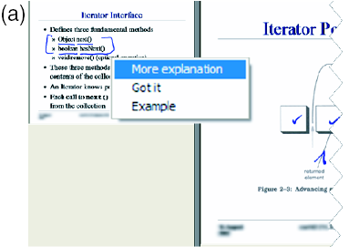

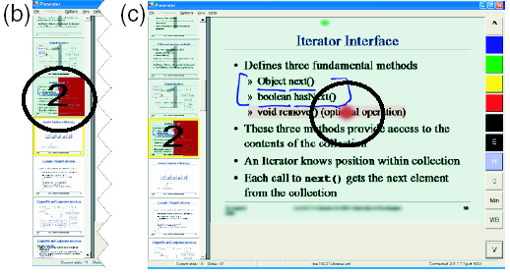
Figure 5. CFS student (a) and instructor (b,c) views. (a): left side of the student view. The student posts MORE EXPLANATION on the last slide presented. (b): left side of the instructor view with an added circle around one thumbnail slide. The new feedback from (a) and one older feedback yield a count of two on the circled thumbnail. (c): instructor view with an added circle around the new feedback. The instructor returned to the slide with new feedback. The new feedback is a dot on “optional” while the old feedback is a dot above the title.

Table 1. Comparison of total student input per class before CFS (first column only, 15 classes) and during its use (7 classes). “Spoken” indicates spoken student comments or questions. “All” is spoken plus CFS feedback. “All except GOT IT” discounts GOT IT annotations. Significance tests were heteroscedastic, two-tailed t-tests. (*: significant at p < .1.)
 | Spoken pre-CFS | Spoken | All | All except GOT IT
# per class | 2.4 | 2.6 | 15.9* | 7.9
p-value | -- | .91 | .04* | .14

The data suggest that CFS addressed the interaction challenges but sometimes with surprising side-effects. Overall, satisfaction with CFS correlated with students’ perception of challenges. All (and only) students who reported challenges to spoken participation (8 of 11) also reported enjoying CFS. Below, we discuss each challenge:
Feedback Lag: CFS alleviated feedback lag for students. 3 of 11 students in our survey felt that unsolicited, spoken questions would interrupt the flow of lecture. All 3 felt CFS addressed the problem. (2 other students felt displaying only one previous slide was not enough for their lagged feedback.)
Two strategies emerged for overcoming feedback lag with CFS. The first was expected: waiting for the instructor to finish discussing a point before annotating it. (See episode in Section 6.2.) Students also created feedback opportunities by annotating points prior to discussion. Many instructors identified this practice as a problem when trying CFS out. However, CFS’s private communication channel and persistent annotations rendered this strategy acceptable and even valuable to our study’s instructor.
Student Apprehension: Students felt apprehensive about speaking in class. 6 of 11 students surveyed cited challenges to spoken participation such as “nervousness” and “larger class size.” Some evidence suggests CFS addressed student apprehension. None of the 6 students reported apprehension with CFS. In one telling case, the instructor was unable to elicit spoken elaboration from a student who gave CFS feedback, apparently because of apprehension at the public spotlight.
Although anonymity addressed apprehension, it also sometimes hindered the instructor’s interpretation of feedback. Without student identities, the instructor could neither evaluate a student’s feedback based on his knowledge of the student nor follow up with the student outside of class. Furthermore, he had trouble understanding sets of related annotations. For example, one student annotated three of a set of six Java classes to indicate which ones confused him. Without knowing that one student made all these annotations, the instructor could not judge how many students were confused nor easily interpret the feedback as expressing a single concept.
Single-speaker Paradigm: CFS allows multiple students to express themselves simultaneously. However, this introduces a new challenge: managing multiple speakers. The instructor felt this challenge sometimes made him appear flustered. He said of one heavy period of feedback (7 annotations by 4 students on one slide) that students probably thought he was having “some sort of brain seizure.” Neither of our observers noticed anything unusual about the lecture during that time, but the instructor’s concerns still indicate a problem which would be exacerbated by more student participants. Better aggregation techniques and more practice with CFS might improve instructors’ comfort with the “multi-speaker paradigm.”

7. Related Work

There have been a number of related efforts to deploy technology in the classroom to enhance learning, and to capture the lecture for later playback. eClassroom (formerly Classroom 2000) [5] is a premier project for incorporating technology in the classroom to facilitate note taking, capture, playback, and presentation. While eClassroom includes some effort to improve presentation facilities for the instructor, our work focuses directly on this aspect. Classroom Presenter also differs from eClassroom in that our goal is to deploy in a general data projector-enabled classroom, as opposed to basing our design on a dedicated facility. Our classroom feedback work relates to other efforts to deploy devices to students in class for supporting interaction, notable projects include ClassTalk [9] and ActiveClass[10]. .

8. Conclusions

We expect that Tablet PC-based presentation will become widespread, and the affordances of electronic ink integrated with slides will have a major impact on the university lecture. We have developed and deployed one such system and are continuing to study its impact in the classroom as well as the technical issues relating to distributed Tablet PC-based presentation systems.
We have described the Classroom Feedback System (CFS), a system for promoting interaction in large classes. Through classroom observations and design and deployment of CFS, we engineered a more interactive learning environment. In the process, we identified key challenges to interaction and grounded these challenges in literature and data from real classes. Analysis of one experiment demonstrated CFS’s success in promoting interaction and revealed interesting interplay with the challenges.

8. Acknowledgements

We thank Microsoft Research for their support during the development and the deployment of Classroom Presenter. We also thank all of the instructors and students who have provided us feedback on the system.

9. References

[1] http://www.cs.washington.edu/masters

[2] http://www.cs.washington.edu/education/dl/tools/

[3]http://www.cs.washington.edu/education/dl/confxp/wmgateway.html

[4]http://www.cs.washington.edu/education/dl/confxp/webviewer.html

[5] Abowd, G., Classroom 2000: An experiment with the instrumentation of a living educational environment. IBM Systems Journal, Volume 38, Number 4, 1999.

[6] Anderson, R. J., Beavers, J., VanDeGrift, T., and Videon, F., Videoconferencing and Presentation Support for Synchronous Distance Learning, to appear, 33rd ASEE/IEEE Frontiers in Education Conference, Boulder, Co. 2003.

[7]Angelo, Thomas A. and Cross, K. Patricia. Classroom Assessment Techniques. Jossey-Bass Publishers, San Francisco, 1993.

[8] Brown, A. L. (1992). Design experiments: Theoretical and methodological challenges in creating complex interventions in classroom settings. The Journal of the Learning Sciences, 2:141–178.

[9] Dufresne, R., Gerace, W., Leonard, W., Mestre, J., and Wenk, L. (1996). Classtalk: A classroom communication system for active learning. Journal of Computing in Higher Education, 7:3–47.

[10] Ratto, M., Shapiro, R. B., Truong, T. M., and Griswold,W. G. (2003). The activeclass project: Experiments in encouraging classroom participation. In Computer Support for Collaborative Learning 2003.

