Experiences with a Tablet PC Based Lecture Presentation System in Computer Science Courses

Richard Anderson
University of Washington
anderson@cs.washington.edu

Steven A. Wolfman
University of Washington
wolf@cs.washington.edu
Ruth Anderson
University of Virginia
ruth@cs.virginia.edu

Tammy VanDeGrift
University of Washington
tammy@cs.washington.edu
Beth Simon
University of San Diego
bsimon@sandiego.edu

Ken Yasuhara
University of Washington
yasuhara@cs.washington.edu

ABSTRACT
Computer science instructors frequently teach using slides displayed with a computer and a data projector. This has many advantages, e.g., ability to present prepared materials and ease of switching the display to a development environment during mid-presentation. However, existing computer-based presentation systems severely limit flexibility in delivery, hindering instructors’ extemporaneous adaptation of their presentations to match their audiences. One major limitation of computer-based systems is lack of support for high-quality handwriting over slides, as with overhead projectors and other manual presentation systems. We developed and deployed Classroom Presenter, a Tablet PC-based presentation system that (1) combines the advantages of existing computer-based and manual presentation systems and (2) builds on these systems, introducing novel affordances. Classroom Presenter has been used in 25 Computer Science courses at three universities. In this paper we describe the system, summarize results from its deployment, and detail several novel uses of the system by instructors in computer science courses.

INTRODUCTION
Our tools affect our teaching, not only increasing our efficiency at classroom tasks [11] but also opening up qualitatively different modes of interaction for the classroom [10]. Our research goal, then, is to design new tools for the classroom to enhance interactions among the participants: maintaining the advantages of existing technology, assuming the advantages of older technologies, and forging new affordances for the classroom.
There are two sides to this approach: improving presentation tools to give more flexibility in delivering the lecture and introducing mechanisms to support interaction between student and instructor devices. In this paper, we concentrate primarily on the former by describing a system that we have developed for delivering a lecture from the Tablet PC and for displaying the instructional materials on multiple machines. The distributed architecture of the system makes it an entry point into interacting with student devices.
A variety of computer-based and manual classroom presentation systems are currently available, each having advantages and disadvantages. Among computer-based systems, the most common is projecting slides using a data projector. Advantages of such systems include the ability to structure material in advance, prepare high quality examples and illustrations, and easily share and reuse material [3]. CS instructors especially benefit from the ability to switch conveniently between slides and web content or a development environment. Computer-based systems are also well-suited for archiving and transmitting presentations, e.g., for distances courses. However, these advantages come at the expense of flexibility during presentation – especially the capacity to adjust the lecture based on audience reaction.
Unlike computer-based presentation systems, many manual systems (including overhead projectors and document cameras) support high quality handwriting over slides, enabling the instructor to augment prepared materials with supplemental text or diagramming. These affordances are particularly useful in CS, where diagramming appears in many levels of instruction: from updating data structures in an introductory course to depicting a distributed algorithm protocol in an advanced theory course.
We have developed and deployed Classroom Presenter, a presentation system that combines the advantages of existing computer-based systems with the flexibility of the handwriting capability offered by manual systems. Running on a Tablet PC [7], a pen-based mobile computer, Presenter allows the instructor to handwrite over computer-projected slides. The slides and ink are then broadcast to other machines for students’ use or to drive a public display. This distributed architecture gives the system a number of advantages that we discuss below.
We first deployed the current system in an introductory programming class in Summer 2002. During the 2002-2003 academic year we deployed the system in 25 courses. The courses represented a broad range of computer science from introductory to graduate level, and from theory to software engineering.
Our primary contributions are the presentation system itself, a working, publicly available, open-source system to enhance interaction in the classroom; evidence from deployments that the system succeeds in the classroom; and an initial understanding of the role Tablet PCs can play in the classroom. We hope that others will adopt our system to improve classroom instruction and build on the ideas embodied in the system to continue advancing computer science instruction.
In the next section of the paper, we give an overview of related work. In Section 3, we describe the system, identifying some of its key features. In Section 4 we talk about the deployment experience, describing the range of courses where Presenter has been used and the different uses instructors have made of Presenter. Finally, in Section 5 we describe in greater detail particular approaches instructors have taken in using Presenter and how it has changed the classroom experience.

RELATED WORK
There has been a history of work in developing technologies to support the delivery of presentations. The two key components of Presenter are integrating slides and writing and having a separation between the instructor’s machine (for instructor use) and the display machine (for student viewing). An early system that integrates slides along with student and instructor writing is Lecturer’s Assistant [5]. Another, notable system which supports writing on slides is ZenPad [4], the presentation component of the Classroom 2000 system. The Pebbles project [8] uses PDAs for steering presentations including stylus based drawing. Other systems have pioneered alternative navigation techniques for presentation including zooming [6] and physical navigation [9]. There is also a recent add-on to PowerPoint which enables some ink functionality, and some instructors have presented directly from Windows Journal.
Our project differs in technology and focus from these. The form factor of PDAs makes the presentation experience very different from a Tablet PC. Tablet and wireless technology has changed radically since earlier projects, which allows Presenter to provide a very different experience for both instructors and students. Our focus on flexibility, interaction, and the needs of CS instructors has also resulted in novel affordances (described below) including embedded instructor notes and integrated support for student interaction.

SYSTEM DESCRIPTION
Presenter is a slide-based presentation system. In its basic deployment, the instructor runs Presenter on a Tablet PC. The Tablet PC has special hardware and software support to make inking as natural as possible. Another copy of the application runs on a second machine which drives the data projector. The two machines communicate via a network connection to synchronize slide and ink data. Figures 1 and 2 show the instructor and the data projector views. The instructor view includes pen and navigation controls, while the projector view shows only the slide. The application also has a student view for use by a viewer who is connected to the presentation by a desktop machine.
Our design for Presenter was informed by studies we undertook prior to building the application. We interviewed instructors and students and conducted field observations. Three key components of our design came out of this process: the presentation device would be a pen-based computer, the application would run between multiple machines, and we would support integration with student devices to allow for interaction during the lecture.
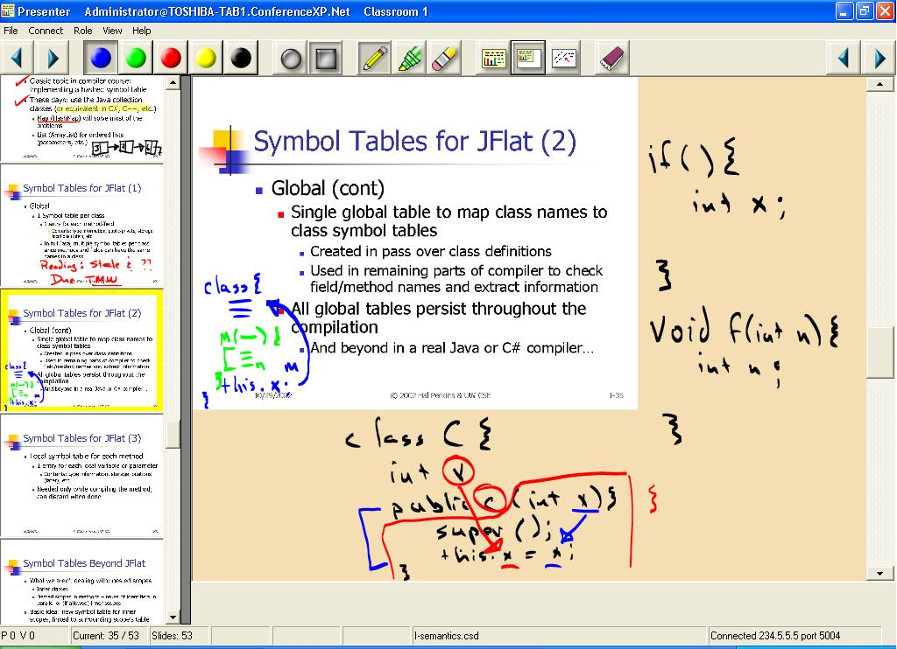
Figure 1. Instructor view with navigation and pen controls. The slide size has been reduced to provide the instructor with extra annotation area. Figures 1 and 2 are from a Master’s level compilers class.

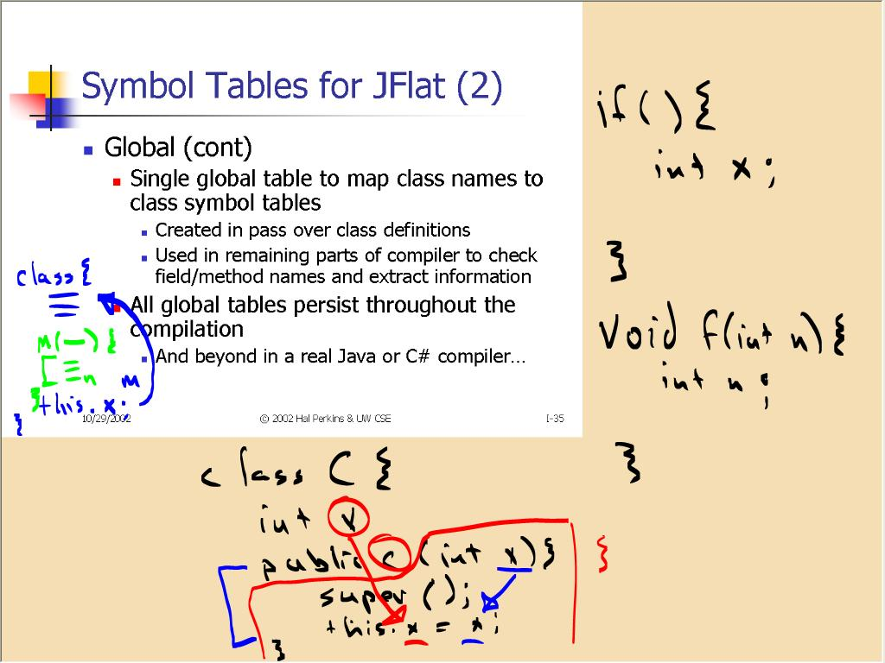
Figure 2. Projector view showing only the slide. The Projector view is synchronized with Figure 1’s instructor view.

Tablet PC based presentation
A key part of our system is the use of the Tablet PC as the instructor device. Tablet PCs enable integration of ink with slides, allowing annotation with natural handwriting. The high quality ink of the Tablet PC completely changes the writing experience from earlier pen computers based on different technologies. In developing the application, we paid attention to the display of ink on all devices, so that remote displays’ ink flows in sync with the instructor’s, communicating the direction and speed of writing.
A substantial amount of effort went into designing the system as a tablet application. This meant using controls optimized for pen manipulation in a mobile environment [7]. We also designed the system with navigation facilities such as the film strip (on the left side in Figure 1) and direct navigation to a whiteboard.

Distributed application
The application is distributed so that each machine shares underlying slide, ink, and navigation data while presenting a view and controls tailored to its users. Machines keep their data in sync through networked communication. Both wired and wireless networking can be used depending on the situation. As a distributed application it is a natural fit for distance learning deployments (which, in fact, was one of the initial use scenarios). Another advantage of the distributed model is untethering the instructor from the data projector, giving the instructor freedom to move about the classroom. One of the first users of the system regularly took the tablet into the audience, TV talk show style, so that students could write their contributions to the slides.
An important advantage of a distributed system for presentation is that it allows different participants to have different views. The instructor view devotes space to controls, previews of upcoming slides, and basic elements of the Windows display like a clock. The public display dedicates all of its space to the current slide. The student view is similarly tailored, for example, showing both the current and previous slide to encourage “late-breaking” questions as the instructor moves through the lecture. Even the display of the slides themselves can differ, allowing, e.g., private instructor notes embedded in the slides or material targeted to students’ archival use of the slides.

Integration with student devices
Presenter was designed so that it could be integrated with student devices in the classroom. In this paper we concentrate on the use of Presenter for delivering lecture materials. However, we are developing support for interaction with student devices. We have already conducted experiments where students can provide real time feedback on slides to the instructor [2]. Presenter has also been integrated with a student note taking system. We are actively developing support for in-class activities, including both spontaneous submission of student ink to the public display and structured active learning exercises built into the presentation. These are being prepared for prototype use.

CLASSROOM DEPLOYMENT
Since Spring 2002, Presenter has been used in 25 different computer science courses, taught by 15 different instructors. Over 1,000 students at three different universities have been in classes where the system has been used in 40-100% (average of 79%) of the course lectures. Classes where Presenter has been used include: eight introductory programming courses, three data structure courses, senior level courses in architecture, digital design, compilers, algorithms (2x), languages (2x), software engineering, and Masters’ level courses in compilers, artificial intelligence, architecture, and transaction processing. Three of the Masters’ level courses were taught as distance learning courses. Class sizes ranged from: 7 to 181 students with an average size of 54 students.
We studied system usage by observing classes, capturing sessions with a logging tool, and conducting surveys of students and instructors. In addition, we received detailed usage notes from some of the instructors. Overall, instructors and students were enthusiastic about the system’s ability to create a more spontaneous and interactive classroom environment.
Table 1 shows the cumulative responses over all surveyed courses of student responses. Students indicated the system had a positive impact on both attention and understanding of the material. For example 57% of the respondents said it increased attention, and 33% said it had no change in attentions. Respondents were on the whole, very encouraging of the system’s future use.
Table 1. Student survey responses. Students were asked about their reactions to the use of Presenter in the classroom. (N = 550)

We surveyed instructors about their reactions to the system. Table 2 shows instructor responses to questions asking about various features to be ranked as “important”, “no opinion” or “not important.” The results coincided with our observations of usage, but had a number of surprises from our initial expectations. Basic pen affordances, (colors, erasing), ranked highly, as did navigation. Many instructors had used the tablet in a stationary mode, so mobility did not rank highly. We were surprised to find that none of the instructors found transparent ink for highlighting to be a useful feature.
Table 2. Instructor survey responses. Instructors were asked to rate individual features of Presenter. (N = 11).
On the whole, instructor reaction to the system was very positive, with one instructor saying "It works great. It didn't take any adaptation. I just talked/discussed and when I needed an example, I just wrote. As easy as using the board,” and another saying ”Being able to diagram and spontaneously work examples, instead of having to use a pre-scripted PowerPoint slide deck - felt like teaching a real class.”
Instructors made substantial use of the facilities of Presenter. Naturally there was a wide variety of use reflecting different lecturing styles and different sub-disciplines. The predominate use was inking, integrated with the slide material, either writing directly on top of the slide or as margin notes. We observed many classes where between 50 and 90 percent of the slides were inked. In the next section we discuss some important usage patterns we observed, but because of space constraints, we do not discuss the full range of novel uses. For example, some instructors passed the tablet around the class to allow student contributions to the shared display, and others used the tablet to collect spontaneous student remarks in collective brainstorming activities. The success of Presenter is that it allowed activities involving handwriting (e.g. drawing diagrams in response to student questions, recording students’ verbal responses, elaborating on slide contents and drawing attention to key concepts) that were previously unavailable in computer-based presentations, to be brought back into the classroom.

EXAMPLES OF USE
Classroom use of Presenter suggests that it can dramatically increase the level of interactivity in lecture. Lecture slides contain less static content, allowing instructors to “fill in” the remainder of important material dynamically in-class, or record and structure student feedback and brainstorming.

Instructor notes
Presenter’s separation of views affords the creation of private instructor notes. These notes can be any PowerPoint object (including ink) and are created and configured through a simple, two-button PowerPoint add-in. Instructors’ private objects automatically appear in the instructor view but not in the student or projector views. (Both views display the same ink.) 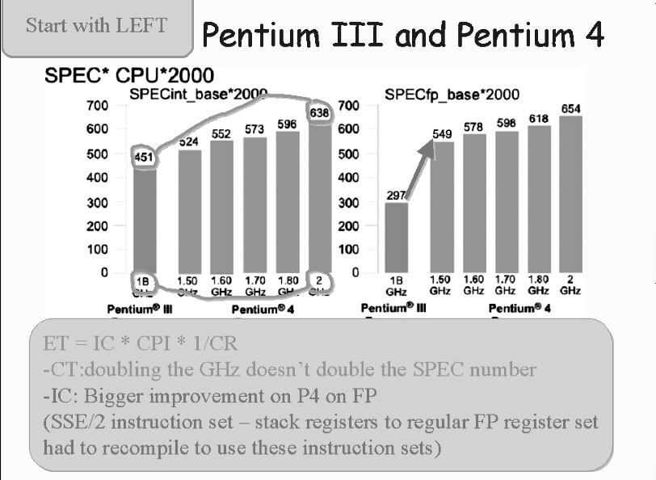
Figure 3(a). Instructor view before discussion. Instructor notes include the two rounded text boxes and the two lines and an arrow on the charts.
Figure 3(a) shows examples of instructor notes as used in an architecture course while Figure 3(b) shows the projector view of the slide after it has been discussed. Instructor notes might, e.g., remind instructors of complex facts and equations, scaffold an instructor’s discussion of a slide, remind the instructor of discussion topics to raise in class, or leave “holes” in the slides to encourage student note-taking.

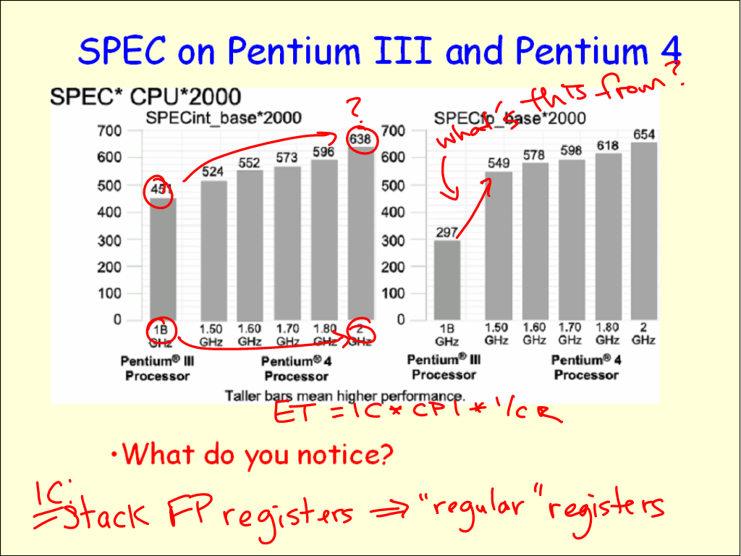
Figure 3(b) Projector view after discussion. Instructor has drawn over graphs during discussion and recorded information relevant to the graphs. Note that the instructor objects are not displayed (although the instructor has drawn some of them in).

Interactive writing
One of the strengths of Presenter is the ability to facilitate interactions between students and instructor. Several instructors noted that using the system to “summarize student comments” or “writing students’ answers to questions I had posed” were among the most valuable uses of handwriting with the system. In our classroom observations we noted numerous examples where the 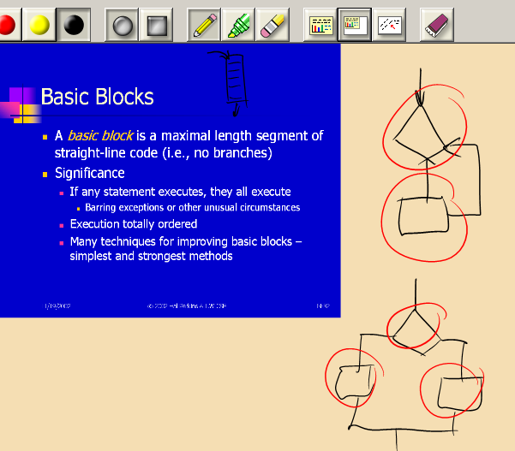Figure 4. Instructor using ink to answer a student question. The instructor returned to this slide when a student asked a question about it. The instructor reduced the slide’s size to allow space for inking within the context of the slide. He used multiple colors to draw attention to portions of the diagram (the circles are red while the remaining ink is black).
instructor used the system to respond to student questions. Often this was done using the whiteboard (a “blank slide” that can be accessed with a single button) or by shrinking the slide to create space in the margins for writing as in Figure 4.

  - Diagrammatic use of ink
One of the strengths of prepared slides is being able to display diagrams. However, when discussing them, it is important to draw attention to detail, such as tracing a datapath in an architectural diagram, or showing active nodes in a state diagram. Instructors have made extensive use inking over diagrams for this purpose. The inking often serves the purpose of an animation, where process is demonstrated with temporal inking. Figure 5 shows a snap shot of a state machine traversal – however the picture fails to convey the dynamic nature of the inking. Continuity in display of ink and directionality of ink is very important.
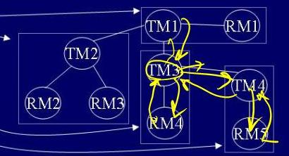
Figure 5 Diagrammatic annotation. The figure shows a portion of a slide with the instructor’s annotation of state machine. Arrows were drawn sequentially to trace a process.

Attention mechanisms
Many instructors would use inking for attention marks. Attention marks draw viewer’s attention to specific content on the slides. Examples of attention marks include checks next to bullet points to show the current topic and underlying the current phrase. We observed a wide range of attention marks used for different purposes during exposition. These included grouping, emphasis, navigation, indication of progress, and identification of key points. It often appeared that instructors had a grammar associated with the marks that were used so that different marks had different meanings. An example of this is an instructor who frequently had examples with sequences. He would underline terms to indicate his progress in discussing the sequence, and circle the key terms, and vertical bars would be used to separate the sequence into groups. The frequent use of attention marks in this case was used to expand the language that was available for discussion. Although it is difficult to quantify the value of ink for attention marks, we believe that specific benefits occurred from their use. Instructors appeared to be more specific in discussing formulas when attention marks were available to identify terms. The use of attention marks also seemed to refocus the audience’s attention back to the slides making the slides more central to the discussion.

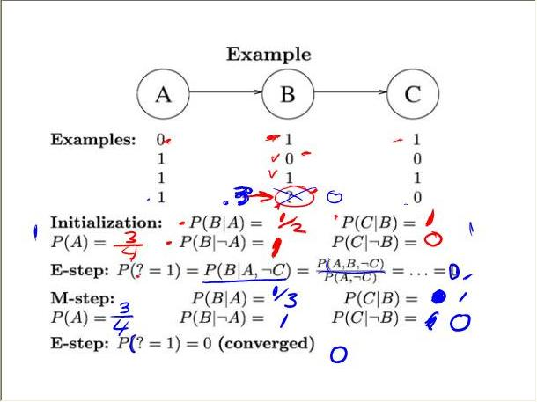
Figure 6 Attentional markings. This slide demonstrates heavy use of ink used to draw attention to portions of the slide. Four distinct marks are used (check, dash, vertical bar, underline) in two different colors.

REFERENCES
- Abowd, G., Classroom 2000: An experiment with the instrumentation of a living educational environment. IBM Systems Journal, Volume 38, Number 4, 1999.
- Anderson, R., Anderson, R., VanDeGrift, T., Wolfman, S., and Yasuhara, K., Promoting Interaction in Large Classes with Computer-Mediated Feedback. CSCL 20003.
- Bligh, D. A. What’s the use of lectures? Jossey-Bass Publishers, San Francisco, 2000.
- Brotherton, J. A., Georgia Tech, College of Computer, Ph.D. Thesis, December 2001.
- Buckalew, C., Porter, A., “The Lecturer’s Assistant”, 25th SIGCSE, pp 193-197. 1994.
- Good, L., and Bederson, B.B. Zoomable User Interfaces as a Medium for Slide Show Presentations, Information Visualization, Palgrave Macmillan, pp. 35-49. 2002
- Jarrett, R., and Su, P., Building Tablet PC Applications, Microsoft Press, 2002.
- Myers, Brad A., Stiel, Herb, and Gargiulo, Robert. Collaboration using multiple PDAs connected to a PC. CSCW'98: 285--294, November 1998.
- Nelson, L., Ichimura, S., Pedersen, E., and Adams, L., Palette: A paper interface for giving presentations, CHI 99, 354-361.
- Ratto, M., Shapiro, R. B., Truong, T. M., and Griswold,W. G. (2003). The activeclass project: Experiments in encouraging classroom participation. In Computer Support for Collaborative Learning 2003.
- Rocklin, T., “Do I Dare? Is it Prudent?”, National Teaching and Learning Forum Newletter, 10, 3, March 2001.

The software is available free for educational and research use from our website.
For the remainder of the paper, we will refer to “Classroom Presenter” just as “Presenter”.

