Classroom Presentation from the Tablet PC

Richard J. Anderson* Ruth Anderson† Tammy VanDeGrift* Steven A. Wolfman* Ken Yasuhara*

*Computer Science & Engineering, U. of Washington
Seattle, WA 98195-2350
{anderson,tammy,wolf,yasuhara}@cs.washington.edu
†Computer Science, U. of Virginia
Charlottesville, VA 22904-4740
ruth@cs.virginia.edu

ABSTRACT
We have developed and deployed a lecture presentation system in which the instructor uses a Tablet PC as a presentation device. The system was deployed in six university courses in Autumn 2002 and has been favorably received by students and instructors. In our system, the instructor holds a pen-based computer that is wirelessly networked with another computer driving the classroom projector. The instructor displays slides from the tablet and can write on top of them. Various navigation and control facilities are available.
Categories and Subject Descriptors: K.3.1 [Computers and Education]: Computer Uses in Education.
General Terms: Human Factors.

BACKGROUND
Figure 1. Instructor view with slide minimized. The filmstrip is along the left of the figure. (CSE582, Autumn 2002)
Our goal was to improve the instructor’s ability to present lectures from a computer. Although there are significant advantages to computer projection of lectures (e.g. preparation of high quality examples in advance, ease of switching between slides and web content or other applications), many instructors feel that computer projection limits their ability to react to the audience. Our goal was to address these problems in a presentation system suitable for both large lectures and distributed (e.g. distance learning) classes.
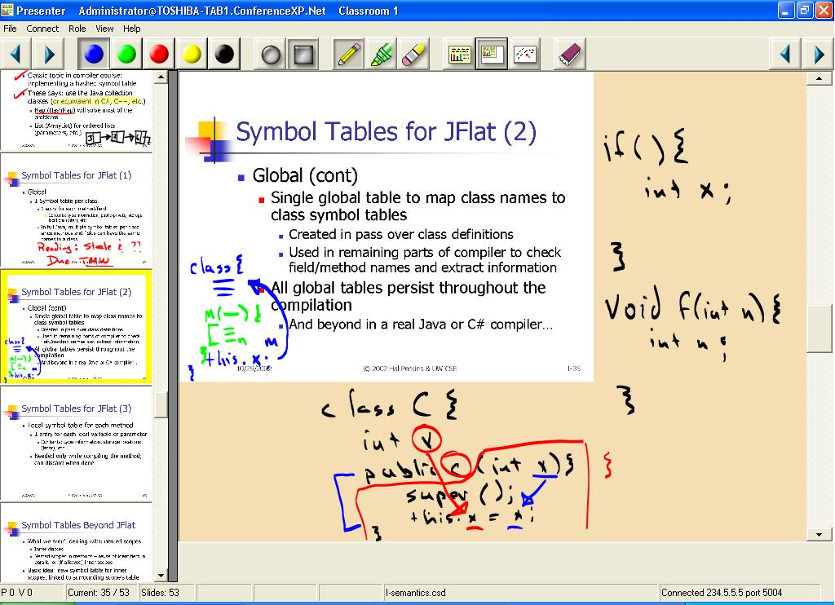
As a background study, we observed several classes and interviewed students and instructors. A major finding was the importance of integrating lecture slides and handwriting. We developed our system based on these findings by iteratively deploying the system in real classes (10 instructors in 15 courses with over 1400 students to date) and refining the design. We studied usage by observing classes, logging system activity, and conducting surveys of students and instructors. In addition, we received detailed usage notes from instructors.

DISCUSSION
Overall, instructors and students were enthusiastic about the system’s ability to create a more spontaneous, interactive classroom environment. Our system supports handwriting activities (e.g. drawing diagrams, recording student responses, elaborating on slides and drawing attention to key points) that are unavailable in computer-based presentations
All instructors wrote extensively over slides. Ink usage varied substantially, and we are developing a classification of usage patterns for future study. The most important components of the inking system were high quality, natural inking provided by the Tablet PC and layered separation of ink and slides. Our system treats ink as a separate layer and supports shrinking the slide to create additional writing space (Figure 1), scrolling the writing layer as on an overhead projector, and use of blank slides as whiteboards. Observations and instructor comments indicated these facilities enhanced system usability. Our system also allows a choice of pen style (e.g. marker, highlighter) and colors.
We observed several benefits of wireless communication. Two instructors carried the tablet while lecturing, and others took advantage of the wireless device to improve the position to lecture from. In one unanticipated use, an instructor carried the tablet into the audience and had students write directly on it, allowing their contribution to be displayed to the classroom. Students commented on this experience very positively.
Copyright is held by the author/owner(s).
ITiCSE’03, June 30–July 2, 2003, Thessaloniki, Greece
ACM 1-58813-672-2/03/0006.
The distributed implementation allowed a rich UI for the instructor without cluttering the classroom display. Separate instructor and classroom views also made it possible to display information to the instructors (e.g. presentation notes and slide previews) that was not intended for the students.
In response to early feedback, we introduced a filmstrip view to give the instructor more flexibility in navigation. For some instructors, this was a very valuable facility, and there appeared to be more non-linear navigation than with traditional computer-based presentations. The ability to quickly switch between slides and a whiteboard mode was also an important feature. An area for future work is to improve navigation facilities. We had not anticipated that navigation would be as important an issue as it appears to be.
ACKNOWLEDGMENTS: Development commenced at Microsoft Research. We thank the MSR Learning Science and Technology Group for their contributions. We also thank the system’s users, especially Alon Halevy, a good-natured initial user.

