A Study of Digital Ink in Lecture Presentation

Richard J. Anderson, Crystal Hoyer,
Steven A. Wolfman
Dept. of Computer Science and Engineering
University of Washington
Seattle, WA, 98195, USA
{anderson, clhoyer, wolf}@cs.washington.edu
Ruth Anderson
Dept. of Computer Science
University of Virginia
Charlottesville, VA, 22904, USA

ruth@cs.virginia.edu

ABSTRACT
Permission to make digital or hard copies of all or part of this work for personal or classroom use is granted without fee provided that copies are not made or distributed for profit or commercial advantage and that copies bear this notice and the full citation on the first page. To copy otherwise, or republish, to post on servers or to redistribute to lists, requires prior specific permission and/or a fee.
CHI 2004, April 24–29, 2004, Vienna, Austria.
Copyright 2004 ACM 1-58113-702-8/04/0004…$5.00.

Digital inking systems are becoming increasingly popular across a variety of domains. In particular, many systems now allow instructors to write on digital surfaces in the classroom. Yet, our understanding of how people actually use writing in these systems is limited. In this paper, we report on classroom use of writing in one such system, in which the instructor annotates projected slides using a Tablet PC. Through a detailed analysis of lecture archives, we identify key use patterns. In particular, we categorize a major use of ink as analogous to physical gestures and present a framework for analyzing this ink; we explore the relationship between the ephemeral meaning of many annotations and their persistent representation; and we observe that instructors make conservative use of the system’s features. Finally, we discuss implications of our study to the design of future digital inking systems.

Categories and Subject Descriptors
H.5.2 [Information Interfaces and Presentation]: User Interfaces—evaluation/methodology, interaction styles

General Terms
Human factors

Keywords
Classroom presentation, digital ink, distance learning, penbased user interface, educational technology

INTRODUCTION
Digital inking systems — i.e., computer applications that accept pen based written input — promise infinite malleability and detailed archiving of ink. Ink can change colors; it can be moved and resized; it can be transformed into typeset text. Inking systems can record time, pressure, context, and other information for every stroke drawn. To effectively explore this vast space of rendering and archiving possibilities, it is critical to understand how digital ink is actually used in practical contexts.
One promising context for digital ink is the university classroom, where instructors increasingly rely on digital projection of slides. Although digital slide projection is controversial [9], it has advantages, including the ability to structure material in advance, prepare high quality examples and illustrations, easily share and reuse material [5], and facilitate distance learning. However, many instructors feel these advantages come at a price in the lack of flexibility to adjust the lecture based on student reaction and to work through examples in real-time.
A natural response is to integrate digital ink and slides, giving instructors the flexibility to adjust prepared material. Advances in digitizing technologies have facilitated efforts to do this. We developed one such system, Classroom Presenter, which allows the instructor to write on slides with Tablet PC digital ink and project the results to the class [2].
In this paper we present results on how instructors used digital ink in Classroom Presenter and discuss ramifications for future systems. We identify three themes of interest: the frequent use of ink in a manner analogous to physical gestures, the tension between the ephemeral meaning of ink and its persistent representation on the display, and parsimonious use of system features by instructors. A natural application of our observations is to improve systems for digital inking in presentations and related applications.
In the next sections we survey related work and describe Classroom Presenter and its deployment history. We then detail the core study courses. Next, we analyze ink use in the context of the three themes described above. We conclude with implications for future research and design.

RELATED WORK
Digital ink technologies have evolved over time and include cameras, touch sensitive whiteboards, PDAs, Tablet PCs, and digital pens. Systems using these technologies support note taking and sharing [10], real-time distributed conversation [13] and meetings [17,20], and classroom presentation and capture [1,15]. (See [6] for a broader survey.)
Several recent systems parallel Classroom Presenter’s functionality, integrating ink with prepared slides for lecturing. Some commercial systems [18,19] integrate ink and projected material on a modified whiteboard. Others support presentation to remote audiences [8,21]. Lecturer’s Assistant is one early research system that integrated slides with student and instructor writing in the classroom [7]. Similar systems exist for PDAs [16], tablets, and whiteboards [4]. PowerPoint and Windows Journal can also be used to project and annotate material from the Tablet PC.
Classroom Presenter differs from these systems in several ways (e.g., in enabling technology and deployment requirements); however, the critical point for this paper is that all of these systems integrate digital ink into presentations. We believe that a deep analysis of inking in Classroom Presenter will inform the design of such systems in the future.
We are not aware of any classroom ink analysis of the sort we describe in this paper. The largest archive of digital ink in the classroom is the ink/slide/audio/video recordings of over 80 classes collected by eClass [1]. Although Brotherton [6] analyzed these recorded classes, he focused on automated capture and access and its impact on students and instructors, not on patterns of ink use.

SYSTEM DESCRIPTION
Classroom Presenter (henceforth, “Presenter”), is the slide based presentation system used in this study. The instructor runs Presenter on a Tablet PC which communicates with a second machine driving a data projector. Figure 1 shows the instructor interface. The instructor has controls for manipulating both the slides and the ink. The data projector would display only the slide image and the ink. Ink on the projected display tracks the instructor’s ink in real time.
Presenter’s primary controls are in seven groups across the top of Figure 1. The first and last groups advance and backup the current slide. Groups two and three control the pen’s color and the shape of its tip. Group four controls the pen mode: regular ink, highlighter (transparent ink with a large pen tip), and erase mode. Erasures are by stroke — i.e., the ink created by one continuous contact between pen and screen. Group five controls annotation space: creation of extra annotation space on the slide and navigation to a separate white board. The lone button in group six is page erase, which erases all the ink on the slide.

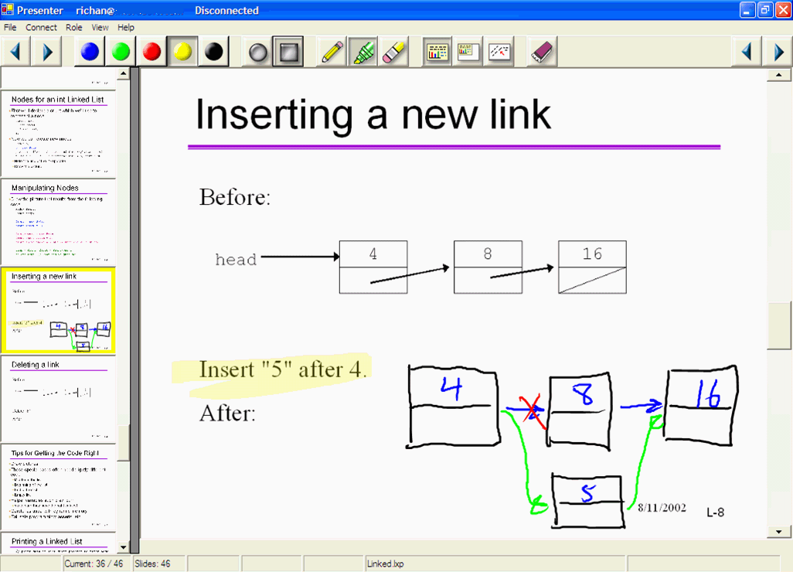

Figure 1 Presenter’s instructor interface with pen controls (top), slide navigation (left), and current slide (right).PRESENTER DEPLOYMENT
Between Spring 2002 and Summer 2003, Presenter was used in 21 computer science courses at three universities, taught by 15 different instructors. Over 1,000 students attended these classes. The deployments included classes from a dozen students to hundreds; courses from introductory to Master’s-level and across the breadth of computer science; instructors who walked with the Tablet PC; and others who lectured from a fixed podium. We studied use by observing classes, logging interface actions, and conducting surveys of students and instructors. In addition, we received detailed usage notes from some of the instructors.
Overall, instructors and students were enthusiastic about Presenter’s impact on their courses. In a survey of 479 students from these courses1, 55% of the respondents said it increased their attention to lecture, compared to 10% who said it decreased their attention. 69% of students said they would encourage other instructors who currently use PowerPoint slides on the computer to use Presenter, while 8% would discourage Presenter. Most instructors that we surveyed also believed that Presenter improved their students’ learning experience while none believed it detracted.

STUDY COURSES
For this study, we focused on three courses offered in the evening Master’s program in our department.2 These were the only Presenter based courses video conferenced between two sites; therefore, they were also the only ones for which full audio, video, and inking archives were created. This provided a rich source of data. We were able to watch Presenter’s use with corresponding audio and video and analyze logs of Presenter commands and ink strokes.
We recognize that the focus on just three courses at one institution limits the scope of our results. However, this focus on a small number of courses also enabled us to gain a deep understanding of the style and context of each course; furthermore, the results we report here coincide in tone with our less extensive observations of the many other Presenter deployments described above.
Table 1 Recorded lecture material for study.
*Some class sessions ran short for Profs. B and C.
 | Lectures | Time | Full logs | Topic
Prof A. | 4 | 6 hrs | No | Compilers
Prof B. | 8 | 20 hrs* | Yes | AI
Prof C. | 10 | 23 hrs* | Yes | Databases
Table 1 summarizes the archived course data used for this study. (Henceforth, we refer to the courses and instructors by the labels displayed in Table 1.) Full audio and video archives were available for all three courses. Ink capture and replay was under development during Prof. A’s course; so, we have logs for only four of the lectures late in the term from that course, and even these logs are limited. We excluded the final two lectures of Prof. B’s course from the study because they were student presentations. Prof. A’s course met twice weekly for one and a half hours a session. The other two courses met once weekly for three hours.
The instructors lectured from a podium and used Presenter to display PowerPoint slides. Profs. A and B were free to approach the nearby wall display of the slides although their Tablet PCs were fixed in place. Prof. C, who taught from a different site, was confined to the podium to support unstaffed video capture. In all three cases, slides, ink, and audio and video signals were synchronously broadcast to a remote site. Profs. B and C had taught similar courses with similar physical constraints in the past using lecture slides (but not Presenter). Prof. A had taught his course before but without the use of slides. The lecture slides were “content heavy”, and were primarily from slide decks that had been designed for projection without inking.
All three instructors used ink extensively throughout their courses. Figure 2 shows the per lecture ink use by Profs. B and C. While use varied across the term for both instructors, no distinct trend emerged. We were unable to extract data for Prof. A, but our observations suggest that he used ink at least as extensively as Profs. B and C. Another measure of ink use is the percent of slides containing ink marks: 39%, 64%, and 66% for Profs. A, B, and C respectively.

Figure 2 Number of strokes per lecture for Profs. B and C.STUDY RESULTS
In this section, we discuss three themes that arose in our analysis: uses of ink, which we call attentional marks, that are analogous to physical gestures; the tension between ephemeral meaning of ink and its persistent representation; and instructors’ parsimonious use of system features.

Attentional Marks
We define attentional marks to be ink annotations which provide linkage between spoken context and the shared display. These marks serve a variety of purposes including resolving deictic references (as with physical pointing gestures), grouping related slide elements, and emphasizing important points. Attentional marks were often arrows, circles, or underlines but also included boxes, overbars, ticks, check marks, tracings, brackets, and dots. Figure 3 shows several examples of attentional marks. Figure 4 shows a particularly effective attentional mark, the exclamation point, which simultaneously drew attention to a topic, linked items, and stressed the importance of the items.
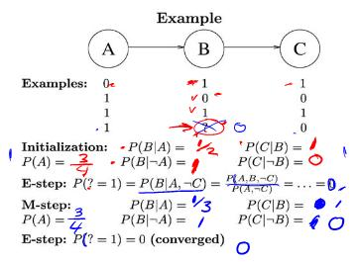
Figure 3 A slide from Prof B’s course heavily annotated with attentional marks including circles, underlines, checks, ticks, and tracing of slide contents. For example, the two check marks and an arrow near the middle of the slide are attentional marks.
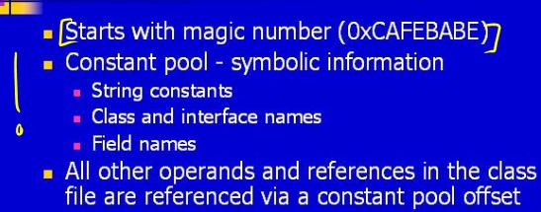
Figure 4 A slide from Prof. A's course with attentional marks.Instructors generally used attentional marks analogously to physical hand gestures. McNeill [14] identifies the following linkages between gestures and speech: gestures occur only during speech; gestures and speech are semantically and pragmatically co-expressive; and gestures and speech are synchronous. We found that attentional marks share these same linkages with speech, supporting a view that attentional marks are analogous to physical gestures.
McNeill further characterizes hand gestures by their contrast with language, identifying the following differences: gestures are “global-synthetic” and “non-combinatoric”, i.e., they convey meaning in their totality of form, not from the structured composition of independently defined elements; gestures lack a “standard of form”, i.e., there is no “correct” way to make a gesture; and gestures lack “duality of patterning”, i.e., the arbitrary association of sound with meaning. Attentional marks mostly share these differences. Attentional marks, like those in Figures 3 and 4, express intent with form: visually connecting, isolating, or emphasizing elements of the slide. Attentional marks also lack any defined grammar or “standard of form”. One contrast with hand gestures is occasional duality of patterning in attentional marks. The conventionally shaped checks in Figure 3 and the exclamation point in Figure 4 are good examples.
McNeill also classifies hand gestures into iconics, metaphorics, beats, cohesives and deictics. Iconics and metaphorics are gestures with associated meaning. Iconics are direct representations while metaphorics are abstract. Beats track the progress of the narrative. Cohesives link temporally separated portions of the discourse, and deictics are pointing gestures which provide reference.
This classification covers most attentional marks we observed, with all five types represented. The exclamation mark in Figure 4 is primarily iconic since it has a commonly understood symbolic meaning independent of context. The circles in Figure 5 are metaphoric since they are abstract representations whose meaning was constructed in context. Figure 9 below shows cohesives and deictics. The bracket connecting two bullets is a cohesive, indicating the connection between these points. The check marks are deictics clarifying which bullets the instructor referred to during discussion. Beats are difficult to identify, but marks that otherwise seem to be idle doodling or retracing of existing ink may function as beat gestures. In practice, some strokes, like the exclamation mark in Figure 4, function in multiple categories, as do many hand gestures. The close fit with McNeill’s classification is further evidence that attentional marks are analogous to physical gestures.
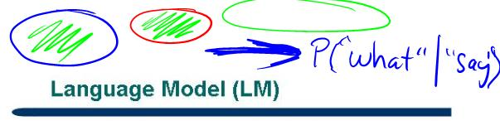
Figure 5 Circles drawn by Prof. B. The circles are in three different colors to illustrate different concepts.In a sense, the parallel between attentional marks and hand gestures is a self-fulfilling prophecy, predicated on our focus on a certain class of marks that parallels McNeill's focus on a certain class of hand gestures. What makes this parallel important is the surprising frequency of attentional marks and the interesting practices and conflicts that arise from transferring the form of fleeting physical gestures to a medium with persistent representation. The remainder of this section establishes the importance and frequency of attentional marks. The next section explores the conflict between ephemeral meaning and persistent ink representation of attentional marks in light of McNeill's framework.
Both instructors and students saw attentional marks as critical elements of Presenter. Nine out of ten instructors we surveyed (including Profs. A, B, and C) indicated that they frequently drew attention to points on slides with ink. 414 out of 479 students across the classes surveyed felt that these attention-directing marks contributed to their learning.
To measure the extent of attentional marking, we coded all ink use in two recorded study lectures, one each from Profs. B and C. (No Prof. A lecture was used because of problems with the logs.) The lectures, Prof. B’s sixth and Prof. C’s eighth, were selected arbitrarily but seem representative in terms of quantity of strokes as can be seen in Figure 2.
To code the lectures, two researchers independently broke the inking into coherent episodes — i.e., atomic meaningful groupings of ink strokes — and classified each episode in one of four categories: attentional mark, textual writing, diagramming, and other unusual marks. Where the researchers’ segmentation of ink strokes into episodes differed, they agreed on a consensus segmentation and reclassified resulting episodes. (These resegmentations usually involved trivial splitting or merging of episodes which did not affect codes.) The researchers then resolved differences in classification by agreeing on a consensus code for each episode. The two researchers’ initial coding agreed on 91% of episodes (92% for B and 91% for C). The resulting data are shown in Table 2. Coding was per episode, but we maintained stroke counts for each episode since writing episodes usually include many more strokes than attentional marking episodes. (Writing a single word may take a dozen strokes while drawing a circle or check takes only one.)
Table 2 Segmented episodes and ink strokes in each coded category for Prof. B’s lecture, Prof. C’s, and the two combined.
(Because of rounding, not all columns sum to 100%.)
 | % of episodes |  |  | % of strokes
 | B | C | B+C | B | C | B+C
Attentional | 77 | 74 | 76 | 49 | 53 | 51
Diagram | 8 | 8 | 8 | 9 | 7 | 8
Writing | 14 | 16 | 15 | 41 | 38 | 40
Other | 2 | 2 | 2 | 1 | 2 | 1
The coding confirmed that attentional marks occurred frequently, accounting for three-quarters of inking episodes and half of all ink strokes. We expect this pattern would hold for the other lectures by Profs B and C. Our observations suggest that Prof. A would have a higher proportion of diagrams and writing, although he also made substantial use of attentional marks.

Ephemerality and Persistence
The prevalence of attentional marks highlights the tension between the persistent representation of ink on the display and its often ephemeral meaning. Ink is represented persistently in that it remains visible until explicitly erased or hidden by a slide transition. In contrast, spoken words and physical gestures have no persistent, external representation. They must be perceived when they occur, or they are lost. (Even in an archive, a spoken word or physical gesture is only available during its moment of the replay [14].)
Because ink is represented persistently, it outlasts its spoken context. Yet, much of this preserved ink (including most attentional marks) is difficult to comprehend without its context. In this sense, ink’s meaning is ephemeral. Figures 6 and 7 illustrate this point. In Figure 6, the instructor circled two points in a numbered list, apparently distinguishing these from the others. A natural assumption is that these points are particularly important; however, Prof. C’s spoken commentary identifies these as points that he will not discuss. Figure 7 shows a complex diagram traced atop existing slide content. Most of the information provided by the ink comes from spoken context and the order and relative timing that nodes were traced and arrows drawn, but the static image does not show this information.
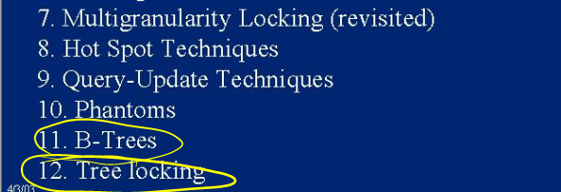
Figure 6 A slide from Prof. C's course with attentional marks used to point out content that will be ignored.
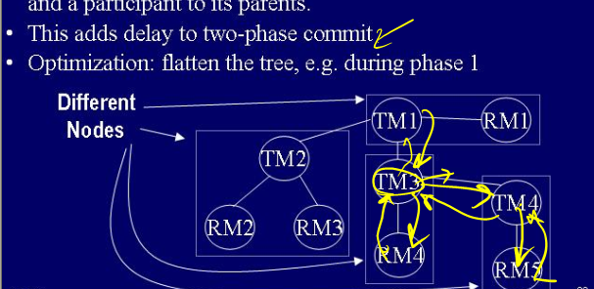
Figure 7 A slide from Prof. C's course with ink showing how communication among nodes “adds delay to two-phase commit.”For attentional marks in particular, we can examine the length of time that meaning persists in light of McNeill’s framework for physical gestures [14] described above. Iconic marks are likely to last the longest since they have inherent meaning. The meaning of a metaphoric gesture is less likely to outlive the spoken context which grounds its abstract representation. Cohesives may provide lasting evidence of connections (although Figure 9 has both positive and negative examples of this, described below). Beats’ and deictics’ meaning will persist only briefly, since their primary function involves fleeting spoken utterances.

Patterns of use that convey ephemeral information
Several uses of Presenter highlight its ability to convey ephemeral information. Annotations including written text are one example. The written phrase P(“what”|“say”) in Figure 5 clarifies the diagram’s context (a calculation of conditional probability) for students and allows the instructor to draw on well-understood symbolic notation that is more easily grasped when read than when only heard. Figure 3’s numerical values are examples where the location of written text provides added value. This location information would be fleeting if the instructor pointed and spoke rather than writing. Written labels on diagrams functioned similarly. While text annotations often rendered spoken information more persistent, it was still difficult to ascertain the full meaning of the text without spoken context.
Instructors made creative use of Presenter to convey ephemeral information about diagrams and processes. Prof. C often drew multiple examples on the same slide, making extensive use of page erase to separate examples. Figure 8 shows a few of the examples drawn on a slide that was erased six times. These erasures distinguished the examples from each other but also limited their lifetimes. Other instructors used color to distinguish between ideas or phases in a process. Figure 5 shows how Prof. B used colors to distinguish concepts in a diagram.
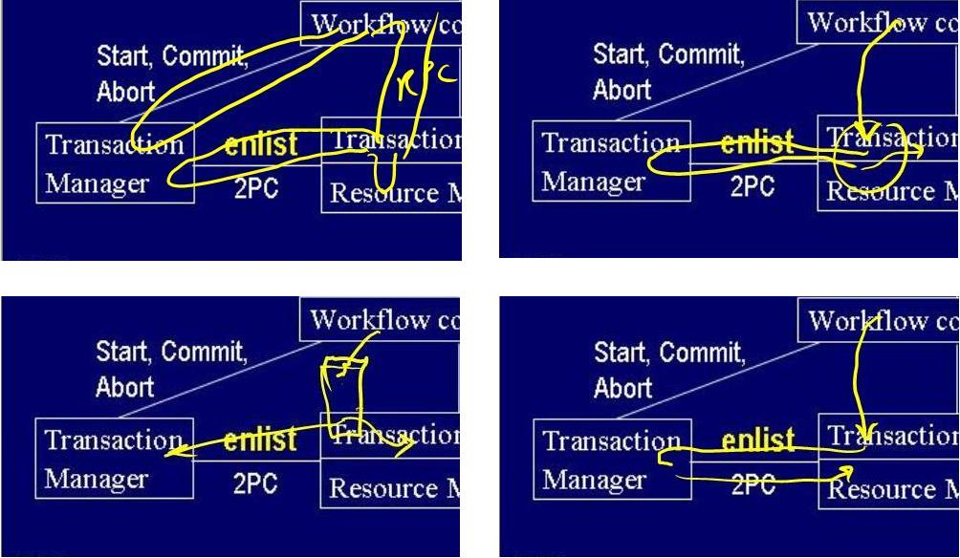
Figure 8 A slide from Prof C’s lecture that he erased multiple times to show several different examples.
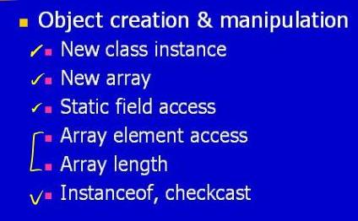
Figure 9 A slide from Prof A’s course with attentional marks. The top two check marks were temporally grouped.Presenter’s real-time rendering also conveys some ephemeral information. For example, the loop in the top left diagram in Figure 8 was drawn from the “Workflow” box at the top of the slide, down to the “Transaction Manager” box at the left, and then back to the top. While the instructor could have added directional arrows to make the information more persistent, he chose instead to rely on real-time rendering to express this progression. This ephemeral information is not captured in the static ink, but the fact that the stroke was rendered in progressive stages did convey the information as it was presented. Several instructors commented that real-time rendering was important to them.

Breakdowns in persistent representation
We observed several common and instructive breakdowns in the expression of ephemeral information as persistent ink. These breakdowns occurred because Presenter’s ink rendering did not distinguish overlapping strokes or display strokes’ age or drawing order.
Along with many digital ink applications, Presenter renders ink in a single color which is constant across the area of the stroke and as the stroke is rendered over time. This style of rendering makes it difficult to distinguish newly drawn ink from existing, overlapping ink. Figure 10 shows an example of this. In Figure 10(a), Prof. B draws attention to a formula on the slide with an underline. Then, he discusses individual parts of the formula. Figure 10(b) shows the formula with three new underlines under these parts. Unfortunately, the new marks, especially the rightmost, are difficult to distinguish from the underlining of the entire formula.
(a) | 
(b) | 
Figure 10 Two snapshots of a slide from Prof. B’s course with ink annotations breaking down a formula of interest. Note the underline under the rightmost “p_{o}log₂p_{o}” term in (b).
This is not strictly a case of ephemeral information uncaptured in the static representation. Indeed, even as the instructor drew the final underline in Figure 10(b), it was largely invisible on the public display. (The instructor, on the other hand, can track new ink by the location of her pen.) However, even if, e.g., an animated cursor on the public display tracked the instructor’s pen [11], the static slide image would still lack this ephemeral information and therefore give no persistent indication of stroke boundaries.
Figure 10(b) also lacks information about the order that strokes were drawn. There is no way to tell from the static image whether the instructor began the discussion with the parts or the whole or in which order he discussed the parts. Figure 7 above illustrates a similar problem.
Instructors used temporal grouping of attentional marks to create cohesives between conceptually related slide elements. Figure 9 shows a typical example. The instructor discussed the first two bullets as a single conceptual unit. He indicated this conceptual link by marking the first two bullets with checks in rapid sequence. He later indicated that the fourth and fifth bullets were conceptually linked with a bracket mark. Prof. A used two cohesive gestures in this example, one spatial (the bracket) and one temporal (the checks on the first two bullets). Both ephemerally linked the topics, but only the spatial mark retains this information in its persistent representation.
Figure 11 shows a slide in Prof. B’s course which illustrates all the breakdowns described above: stroke overlap, ordering, and temporal grouping. The heavy arrows on the left of the diagram were retraced to illustrate successive passes through the diagram, but homogenous ink rendering makes it impossible to tell how many times each arrow was traced. The four unlabeled nodes toward the bottom were drawn in a surprising order, but this is not represented in the static image. (The leftmost unlabeled node was drawn first, followed by the other three from bottom to top.) Finally, the underline on the left was temporally grouped with the left edge extending from the “A₂” node, but this connection is absent from the static image. Although single slides with all these breakdowns were rare, the individual breakdowns were common in the courses we observed.

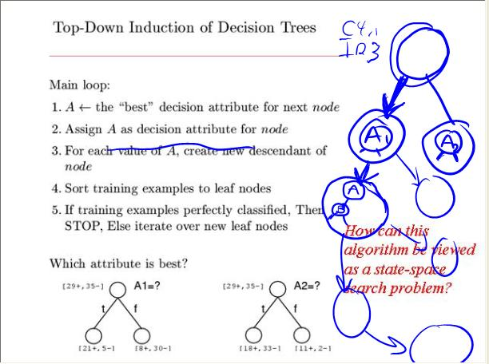

Figure 11 A slide from Prof B’s course illustrating breakdowns in persistent representation of ephemeral information.Parsimonious Use of System Features
Instructors were strikingly restrained in their use of Presenter’s features. Table 3 below gives some basic information for instructors’ use of features. The information for Profs. B and C are from the logged data, and Prof. A is from observation of the lectures recorded with ink.
Table 3 Use of Presenter features in number per hour of lecture.
 | Prof. A | Prof. B | Prof. C
Slides | 36.7 | 30.9 | 17.3
Highlighter use | 0.0 | 0.0 | 0.0
Color change | 11.8 | 6.2 | 1.0
Page erase | 0.0 | 2.1 | 19.0
Stroke erase | 1.3 | 0.2 | 0.2

We had anticipated that the instructors would use the highlighter to draw attention to slide content. We were interested to observe that this feature received no use. (Instructors replaced highlighting with attentional marks such as underlines.) We attribute the lack of use to the extra effort highlighting required: switching to highlighter mode, changing colors, and returning to the pen mode when done.
Use of color varied among instructors. Most instructors in our survey of 10 instructors self-reported at least occasional use of multiple pen colors and viewed the feature as important. In contrast, Profs. B and C rated color change as an unimportant feature. In practice, Prof. B made moderate use, changing pen colors 6.2 times per hour of lecture. Prof. C changed pen color only once per hour of lecture.
Ensuring color contrast accounted for most color changes: either contrasting with existing ink or with the slide background. Profs. A and B used multiple contrasting ink colors to visually distinguish distinct concepts. Figure 5 shows an example where Prof. B changed color to distinguish concepts in a diagram. All three instructors also changed colors to ensure contrast with the slide background.
This pattern of color changes supports the notion that instructors made parsimonious use of the UI. The critical point is that instructors did not follow what might seem a more natural pattern: choosing a preferred color for common use and consistently returning to that color after changes. Instead, when an instructor changed color to contrast with existing ink, she would then almost always continue to use that color even when the current example was finished. Following this pattern requires one fewer UI actions than returning to a preferred color.
Another surprise for us was the way instructors erased ink from slides. Two erasing mechanisms were available: erasing a stroke at a time by using the pen in erase mode, or erasing all the ink on a slide by using the page erase button.
Page erases were much more frequent than stroke erases. Both Profs. B and C used page erase far more often than stroke erase. Prof. C used page erase more than once per slide on average, erasing some slides up to 10 times. His predominant use of page erase was to clear the ink context (as described above), although there were cases where he used page erase to clear mistakes. In several cases Prof. C used page erase to clear a diagram after making a mistake and then reconstructed the diagram from scratch. Examining the cases when Prof. C used the stroke eraser rather than the page eraser gives insight into his use of page erase. In these cases, the erase activity was very intentional. One observed case was when a moderate sized diagram had to be corrected, and redrawing it would have been a challenge. Another was when Prof. C used marks in a diagram to indicate a resource was being reserved, and then used the eraser to show that the resource had been released. Perhaps the most interesting example occurred when Prof. C wrote a word as a correction which later turned out to be incorrect itself. In this case, Prof. C used the stroke eraser to give extra emphasis to the word’s erasure.
The use of page erase is consistent with the hypothesis that instructors use Presenter in a manner that minimizes operations. In this case, the page erase is a single click operation while stroke erase requires a click to activate the eraser and a click to return to the pen, in addition to the actual erase operations. In most cases, the ease of using page erase makes up for its lack of precision.

IMPLICATIONS OF THE STUDY
The observations we describe in the previous section lead naturally to design directions for future digital ink presentation systems and related applications. We focus in our design discussions on the themes of attentional marking and ephemerality vs. persistence. However, system designers should bear in mind the lesson of parsimony: busy and focused instructors may well respond to new features, new buttons, or new mode changes by ignoring them. The best designs may be those that work smoothly without effort or thought on the instructor’s part.
Our observations suggest that designers of digital ink presentation systems should try to understand which ephemeral information is important to their systems and consider how to capture that ephemeral information in a persistent ink representation. Successfully capturing this ephemeral information will ease the task of understanding presentations, extending the window of opportunity for participants to perceive, connect, and construct meaning from the many available streams of information. Furthermore, simple, static archives of ink will be more valuable resources if they encode this critical ephemeral information.
Instructors’ practice of reifying gestures into ink based attentional marks is one method we have already described for extending the window of opportunity for understanding ephemeral information. These attentional marks help participants who might have missed a physical gesture. Some types also remain comprehensible well after their spoken context. Interaction histories [12], as with telepointer traces [11], are a promising approach to persisting ephemeral information without explicit action on the part of instructors.
While we believe our results are of use to designers of digital inking systems in general, the Tablet PC form factor, Presenter’s architecture, and other details of our study have certainly shaped our results. An important future direction from this work will be to perform similar studies but change some critical parameters. Possibilities include work with digital whiteboards where physical pointing and attentional marks are closely conflated or with a digital ink system that allows truly ephemeral, digital gestures (like telepointer traces [11]). Studies of fully co-located classes may uncover somewhat different ink use patterns.
Our work also supports the “holistic” approach to classroom capture (espoused, e.g., by eClass [1]) in which video, audio, and many other information streams are correlated for playback. We had initially envisioned that ink archives from presentations would add significant value to the bare slides. However, the prevalence of ephemeral attentional marks, unlabelled diagrams, and fragmentary text makes spoken context critical for understanding these annotations.
Digital ink has the potential to encode much more than the simple location of ink strokes. Future designers can make ink representations that respond to any of the breakdowns we discussed above. Ink strokes might indicate the direction they were drawn or their boundaries with other strokes through non-homogenous coloring across their area. Ink strokes that change color with time (like physical ink drying) could encode the age and temporal grouping of strokes. Ink might brighten conspicuously when first drawn to more clearly convey the current focus of attention.

CONCLUSIONS
In this paper, we analyzed a set of rich data on use of digital ink in presentations. We identified three major themes in the data: (1) establishing that a substantial amount of ink in these presentations acted analogously to physical gestures, (2) exploring the tension between the ephemeral meaning of many ink annotations and their persistent representation as it plays out with our ink rendering, and (3) observing that instructors tend to make parsimonious use of Presenter’s features. We also extrapolated from these observations to design recommendations for future digital ink presentation systems. We believe that these results and recommendations establish fertile ground for more ambitious rendering and control in digital ink systems and broader future studies of the themes we identified.

ACKNOWLEDGMENTS
We thank those who provided assistance and feedback. Thanks especially to the instructors, students, and support staff of the study courses, the Microsoft Research Learning Sciences & Technology group, the University of Washington Computer Science & Engineering Education & Educational Technology research group, and the blind reviewers. This work was supported by the National Science Foundation (DUE-0229908), Microsoft Research, and an HP University Mobile Technology Grant.

REFERENCES
- Abowd, G. Classroom 2000: An experiment with the instrumentation of a living educational environment. IBM Systems Journal, 38:4, 1999, pp. 508–530.
- Anderson, R., Anderson, R., Simon, B., Wolfman, S., VanDeGrift, T. & Yasuhara, K. Experiences with a Tablet PC based lecture presentation system in Computer Science courses. Proc. SIGCSE ’04.
- Barreau, D. & Nardi, B. Finding and reminding: file organization from the desktop. SIGCHI Bulletin, 27:3, 1995, pp. 39–43.
- Berque, D., Johnson, D. & Jovanovic, L. Teaching theory of computation using pen-based computers and an electronic whiteboard. Proc. ITiCSE ’01, pp. 169–172.
- Bligh, D. What’s the Use of Lectures? Jossey-Bass Publishers, San Francisco, 2000.
- Brotherton, J. Enriching Everyday Activities through the Automated Capture and Access of Live Experiences. Ph.D. Thesis, Georgia Tech, 2001.
- Buckalew, C. & Porter, A. The Lecturer’s Assistant. Proc. SIGCSE ’94, pp. 193–197.
- Centra Symposium. http://www.centra.com/products/
- Creed, T. PowerPoint, no! Cyberspace, yes. The National Teaching & Learning Forum, 6:4, 1997, pp. 1–4.
- Davis, R., Landay, J., Chen, V., Huang, J., Lee, R., Li, F., Lin, J., Morrey, C., Schleimer, B., Price, M. & Schilit, B. NotePals: lightweight note sharing by the group, for the group. Proc. CHI ’99, pp. 338–345.
- Gutwin, C. & Penner, P. Improving interpretation of remote gestures with telepointer traces. Proc. CSCW ’02, pp. 49–57.
- Hill, W., Hollan, J., Wroblewski, D. & McCandless, T. Edit wear and read wear. Proc. CHI ’92, pp. 3–9.
- Iles, A., Glaser, D., Kam, M. & Canny, J. Learning via distributed dialogue: Livenotes and handheld wireless technology. Proc. CSCL ’02, pp. 408–417.
- McNeill, D. Hand and Mind: What Gestures Reveal about Thought. The University of Chicago Press, 1992.
- Müller, R. & Ottmann, T. The “Authoring on the Fly” system for automated recording and replay of (tele)presentations. Multimedia Systems Journal, 8:3, 2000, pp. 158–176.
- Myers, B. Using handhelds and PCs together. CACM, 44:11, 2001, pp. 34–41.
- Pedersen, E., McCall, K., Moran, T. & Halasz, F. Tivoli: an electronic whiteboard for informal workgroup meetings. Proc InterCHI ’93, pp. 391–398.
- SimplyLiveWorks. http://www.wearesimply.com/
- SMART Technologies. http://www.smarttech.com/
- Stefik, M., Foster, G., Bobrow, D., Kahn, K., Lanning, S. & Suchman, L. Beyond the chalkboard: Computer support for collaboration and problem solving in meetings. CACM, 30:1, 1987, pp. 32–47.
- WebEx Training Center. http://www.webec.com/

1 Surveys of classes taught by Presenter researchers (including their students) are excluded from results in this paper.
2 None of the study instructors were involved in Presenter, HCI, or education research.
All examples in this paper are from the third week or later of each class, allowing time for instructors to develop proficiency with Presenter and a stable use pattern.
Conversely, designers should beware of allowing information whose value (and not just representation) is ephemeral to outlive its “shelf life” and crowd out more important working information. [3]

