**Key Request**

 Issuing keys is now done on-line: https://www.keydesk.ubc.ca/

Login with CWL account

 To create a new record, click on New Key Request.

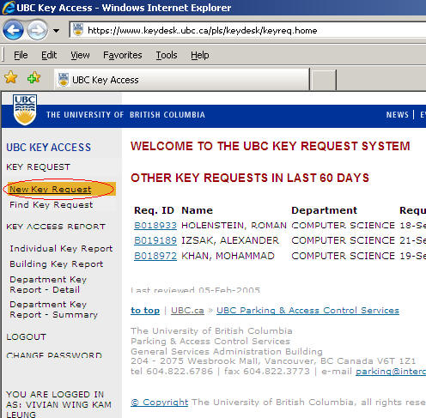

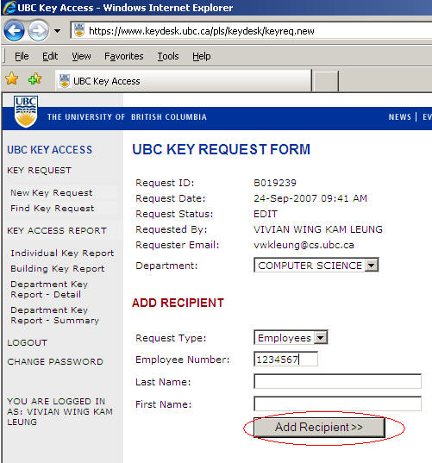 Type in the recipient information and then click Add Recipient before going to the next stage

Choose the key, click Add Key

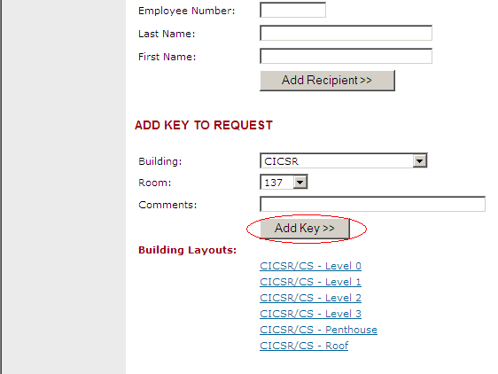

Click Approve and Submit button