Urgency Analysis of Voicemail Messages

Rolf Biehn
rolfbiehn@yahoo.ca

Abstract
Voicemail is a prevalent form of communication often used in business and personal life. Several techniques exist for classifying the urgency of voicemail such as prosodic analysis (Konstantinos et al., 2005 [2]) or caller formality(Jing Huang et al, 2001[3]), however they have traditionally not focused on temporal and co-occurrence information that can be extracted relatively easily from the transcripts. This paper will analyze urgency classification of voice mail using naïve Bayesian classifiers that use co- occurrence and temporal information.

Introduction
Urgency Analysis is useful in many different Natural Language Processing domains. The obvious first use is in classifying the importance of a voicemail or e-mail messages and spam filtering. It can also be important in sentence generation to ensure the urgency is consistent with the intended urgency. Summarization can utilize urgency analysis to discriminate important information from less important information. It is hoped a simple method to evaluate voicemail transcripts can also be directly applied to these domains; however, this paper will strictly focus on voicemail urgency analysis. In the following sections, the performance of 3 naïve Bayesian classifiers will be evaluated. The classifiers will use annotated information, co-occurrence information and temporal information to perform the urgency analysis.

Corpus
The corpus used was “IBM Voicemail Corpus-Part II” distributed by The Linguist Data Consortium [9]. Although this corpus provides both audio recordings and written transcripts, only the written transcripts were used. Proper nouns are prefixed with an exclamation point (i.e. “!Monday”). Numbers are written as words (i.e. “twenty-one”).
A random subset of the written transcripts was chosen and manually annotated with additional information.

Annotation
Annotation was done by two annotators with the help of a GUI(see figure1). The following information was manually added via the GUI:
DateCallMade: The date the call was made. If this information is not inferable from the text, the annotator chose a reasonable date.
DateReceived: The date the message was received. This number is generated by the GUI program based on DateCallMade. Annotators had the option of changing this date if it was deemed inappropriate.
Requester: The class the originator of the request belongs to; one of {“unknown”, “family”, “stranger”, “coworker”, “superior”}.
Summary: A short summary of the message.
SummaryDate: The earliest Calendar date mentioned in the summary. This field is strictly for verification purposes -- it is not used by the classifiers.
Urgency: A number from 1 to 5 based on how urgent the message is judged to be considering all of the available data. 1 is the lowest priority, 5 is the highest priority. 5 is roughly the top 20% urgent of all messages, 4 is roughly the top 21%-40%, etc. “Priority” and “Urgency” are used inter-changeably throughout this report. U1 refers to Urgency 1; U2 refers to Urgency 2, and so on.

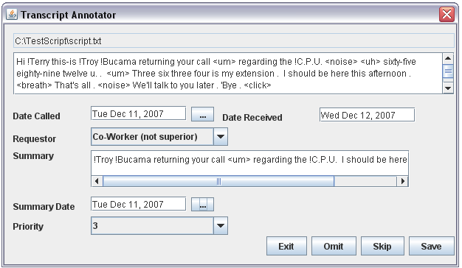
Annotators were given an option of omitting records if the record was deemed inadmissible. Approximately 6 records were omitted.
Figure 1. A Screen-shot of the GUI Used to Annotate the Transcripts

Annotation Challenges
Several challenges were faced with annotation. Establishing the superior relation based on the context of the message is difficult. An integrated voicemail system, such as a voicemail system integrated with a Blackberry® would be capable of easily determining this information via an address book. Urgency often depends on unknown information, e.g., “Hi it’s Mr. Smith, please give me a call”. It is unclear if Mr. Smith is an important client or if we are expecting a call from Mr. Smith. The Requestor could also be a “co-worker” and a “friend” simultaneously. There is also a notion that if it was really important, the caller would find another way of contacting the Receiver. The priority can vary greatly depending on these parameters. Annotators were asked to analysis these issues on a case-by-case basis; make a reasonable decision and then evaluate the urgency accordingly.
The Summary Date can often be ambiguous. Examples are “next week” and “next month”. These types of dates were not annotated. Implicit dates such as “ASAP” and “before you leave” were also not annotated.
The Summary was frequently difficult to determine. Annotators were asked to summarize the important points of the text as concisely as possible using the original transcript’s text as much as possible.

Annotation Agreement
A set of 30 identical transcripts, with preselected DateCallMade, DateReceived, and Requestor fields was randomly chosen from the corpus. This set will hereon in be referred to as the overlap set. The overlap set was given to both annotators during the annotation process. At the end of the annotation process, both annotators were asked to re-evaluate the overlap set. A short-hand notation of ANNXTY will be used to refer to Annotator X, Try Y. For example, ANN1T1 refers to Annotator 1’s annotation from the first evaluation. ANN2T2 refers to Annotator 2’s annotation from the second evaluation and so on. A score was given to each classification by evaluating |transcript1Urgency – transcript2Urgency| for each transcript.
ANN1T2, ANN1T2 and ANN2T2 were compared to a baseline of ANN1T1. ANN1T1 does not contain any U5 transcripts. A fairly high degree of agreement was seen between ANN1T1 and ANN1T2 suggesting a fairly good degree of consistency. However, ANN1 and ANN2 disagreed by a fairly large amount. When ANN2T1 was used as a baseline, ANN2T2 do not agree very well. In-fact, ANN1T2 agrees more highly with ANN2T1 than ANN2T2. This suggests a high degree of subjectivity in urgency analysis and a modest degree of inter-annotator agreement.

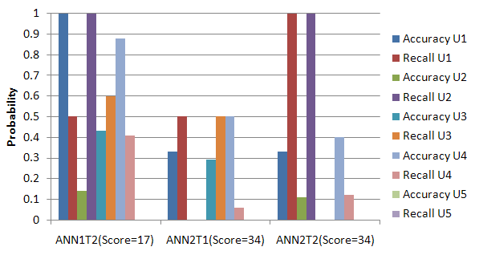

Figure 2. Annotator Agreement using ANN1T1 as a baseline.
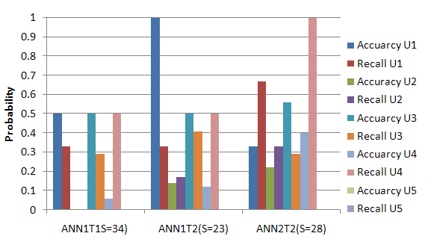
Figure 3. Annotator Agreement Using ANN2T1 as a Baseline

Annotation Results
A total of 718 transcripts were annotated (598 + an overlap of 120 transcripts). Only 30 unique transcripts from the overlap were used in the final evaluation. The overall distribution of transcripts are [U1, U2, U3, U4, U5] = [.11,.19,.31,.27,.12]. There is a heavy concentration of transcripts with Urgency 3 and Urgency 4 which has a significant effect on all of the classifiers.

Classifiers
All 3 of the classifiers used were naïve Bayes classifiers. The probabilities were always smoothed using Laplace (add-one) smoothing. Two types of evaluation functions were used to evaluate the classifiers, absolute and simple. The calculation for an absolute evaluator is {Absolute(predicted, actual)= |predicted – actual|}. The calculation for the simple evaluator is {Simple(predicted, actual) = 0 if (actual == predicted), 1 if (actual <> predicted)}
All classifiers choose the urgency which minimizes their expected score. The process is described in Equation 1.

eval(actual, predicted) = evaluation function
Fv =feature vector
MIN1<=i<=5{∑1<=j<=5(P(U[j]|F_{v})*eval(j,i)))}
= MIN{P(1|Fv)*eval(1,1)+P(2|Fv)*eval(2,1) + P(3|Fv)*eval(3,1)+P(4|Fv)*eval(4,1)+ P(5|Fv)*eval(5,1), P(1|Fv)*eval(1,2) + P(2|Fv)*eval(2,2) + P(3|Fv)*eval(3,2) + P(4|Fv)*eval(4,2) + P(5|Fv)*eval(5,2), etc… }

For Bayesian classifiers P(U[j]|Fv) can lose precision due to many decimal multiplications so do the multiplication in log-space and remove expressions that evaluate to 0.
=MIN{10^{log(P(2|Fv)*eval(1,2))} + 10^{log(P(3|Fv)*eval(1,3))} + 10^{log(P(4|Fv)*eval(1,4))} + 10^{log(P(5|Fv)*eval(1,5))},
10^{log(P(1|Fv)*eval(2,1))} + 10^{log(P(3|Fv)*eval(2,3))} + 10^{log(P(4|Fv)*eval(2,4))} + 10^{log(P(5|Fv)*eval(2,5))}, etc..}

Unfortunately log(P(j|Fv)*eval(i,j)) can become very negative, especially for the co-occurrence classifier, which means 10^ log(P(j|Fv)*eval(i,j)) = 0. So multiply everything by α if a possible precision loss is detected.
=MIN{10^{log(P(2|Fv)*eval(1,2)*α)} + 10^{log(P(3|Fv)*eval(1,3)*α)} + 10^{log(P(4|Fv)*eval(1,4)*α)} + 10^{log(P(5|Fv)*eval(1,5)*α)},
10^{log(P(1|Fv)*eval(2,1)*α)} + 10^{log(P(3|Fv)*eval(2,3)*α)} + 10^{log(P(4|Fv)*eval(2,4) *α)} + 10^{log(P(5|Fv)*eval(2,5) *α)}, etc…}

Choose α to be a value that ensures at least one expression can be properly evaluated. i.e. (MAX{log(P(j|Fv)*eval(i,j)) } + log(α) )> -10)

Equation 1: Equation used for calculating the urgency with the minimum expected score

Baseline Classifier
The baseline classifier uses Requestor and DateDiff as its feature vector. DateDiff is defined as #days(DateReceived – DateCallMade) . The overall distribution of Requestor and DateDiff are shown in Figure 4 and Figure 5 respectively.

COWORKER[.06,.17,.35,.28,.14], N=360
UNKNOWN[0.16,.22,.27,.28,.08], N=120
FAMILY[.20,.20,.28,.27,.05], N=98
SUPERIOR[.06,0,.19,.38,.38], N=16
STRANGER[.15,.29,.24,.21,.12], N=34

Figure4. Requestor Distribution[U1,U2,U3,U4,U5]

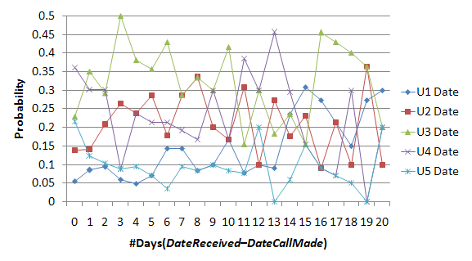
Figure 5. DateDiff Distribution

Co-Occurrence Classifier
The underlying theory behind the Co-Occurrence Classifier outperforming the baseline is that certain words are likely to be more highly correlated with certain urgencies (such as “immediately”, “meeting”, and “sometime”). The Summary text was pre-processed using the Stanford Part-Of-Speech Tagger [10]. The approach used was the same as the approach used in Word Sense Disambiguation in (Daniel Jurafsky et al., 2007[1]). The entire Summary annotation was used, and no data was filtered. Negation was not considered, for example, “not urgent” would be processed as two separate words, “not” and “urgent”. Clearly there is potential with this approach as some clear distribution patterns were observed with certain words. Requestor and DateDiff are also used as part of the feature vector for this Classifier (see figure 6).

"meeting/NN" [0,0,0.21,0.63,0.16], N=19
"!Wednesday/NNP" [0,0.12,0,0.88,0], N=8
"installed/VBN" [0,0,0,0.17,0.83], N=6
"asked/VBN" [0,0,0,0.20,0.80], N=5
"she/PRP" [0,0.78,0.11,0.11,0], N=9

Figure 6. Select Co-Occurrence Distributions [U1, U2, U3, U4, U5].

Temporal Classifier
The theory for the temporal classifier is that if a date is mentioned it may be associated with importance. An absolute calendar date was extracted from the Summary and then converted to the number of days relative to DateReceived.

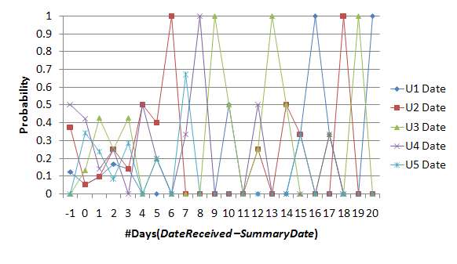
Figure 7 Temporal Dates Distribution

Temporal Analysis
Temporal analysis is the problem of mapping a temporal expression onto a specific calendar date. There are essential 3 classes of temporal expressions: Absolute temporal expressions (“July 1st, 2007”), relative temporal expression (“next Thursday”) and Durations (“for one hour”). An anchor date is necessary to resolve relative temporal expressions. The program to extract the date information from the Summary field was TempEx created by MITRE [11]. TempEx is a two phase Perl implementation. In the first phase, temporal expressions are identified. In the second phase, an anchor date is passed in and dates are resolved as much as possible. The anchor date used for the second phase was DateCallMade. Although this may not be the perfect choice for all situations, it is expected that most dates mentioned in the transcript will be relative to DateCallMade. TempEx requires that all input be POS tagged. The output of TempEx is a tagged temporal expression described by (Ferro et al, [7]). Examples of resolved tagged dates :

<TIMEX2 TYPE="DATE" VAL="20071202"><lex pos=NN>tomorrow</lex></TIMEX2>

<TIMEX2 TYPE="DATE" VAL="20071208TMO"><lex pos=DT>this</lex> <lex pos=NN>morning</lex></TIMEX2>

<TIMEX2 TYPE="DATE" VAL="PRESENT_REF"><lex pos=NN>today</lex></TIMEX2>

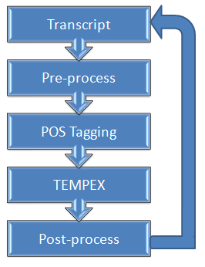
Figure 8: Temporal Extraction Process

Temporal extraction followed a 4 stage process illustrated in Figure 8. In the first stage the Summary field is read from the transcript and pre-processed. The pre-processing step involves the removal of all “!”s from date information, (i.e. “!Friday” becomes “Friday”) and replacing written numeric expressions with their cardinal representation (i.e. “twenty-one” becomes “21”). This data is then tagged by the Alembic POS tagger[12]. The POS tagged data is sent to be processed by TempEx. Finally, the output from TempEx is processed by a Post-processor which identifies tagged expressions, performs some analysis to resolve certain tags (i.e. “PRESENT_REF” becomes DateCallMade), chooses the earliest date and writes the chosen date back into the Transcript as a calendar date. This date is called the TempEx date. The temporal classifier reads this day and converts it to a day relative to DateReceived and uses it as a feature.
Agreement was verified by comparing the TempEx date and a baseline which was the SummaryDate previously annotated by the annotators. It was observed that both the TempEx date and baseline dates agreed 56 times. TempEx and the baseline detected a date but did not agree on the same date 9 times. TempEx detected a date but the baseline did not have a date 57 times. Most of the discrepancy in these cases can be explained by annotator error. The baseline detected a date and TempEx was unable to detect a date 81 times. Several reasons for the disagreement occurred. Some examples are ordinal dates (“on the thirteenth”), absolute times ("at four") and elapsed times such ("call you in five minutes"). In many cases, TempEx recognized these phrases as temporal expressions in the first stage; however, it did not resolve these dates properly in the second phase. A modification to the post-processing algorithm could allow these dates to be resolved by using certain heuristics, however time did not allow for this. The overall accuracy of temporal extraction was 77%.

Figure 9: Baseline and TempEx Agreement

Evaluation
The classifiers were tested by verifying against the overlap transcripts and by performing 10-Fold evaluation.

Overlap Evaluation
The overlap transcripts were evaluated. Training was performed on all of the annotated transcripts except for the overlap transcripts. Evaluation was done using Absolute Score and a baseline of ANN1T1 and a baseline of ANN2T1.
When using a baseline of ANN1T1, the best score and overall recall/accuracy rates were realized by ANN1T2. The co-occurrence classifier preformed second best and the temporal classifier and baseline classifiers were tied for a close 3rd. The reason for the high degree of recall of Urgency 3 for the temporal and baseline classifiers is both of these classifiers simply chose “3” for every urgency. There are two reasons for this. First, the absolute evaluation function favours choosing zero. Even if all the probabilities were equal, a good classifier will always choose the priority in the middle to minimize the expected score. Second, the distribution of the transcript scores heavily favouring priorities 3 and 4. The classifiers do not have sufficient confidence to choose a different value. As it can be observed, choosing 3 all the time results in a score better than human annotators.

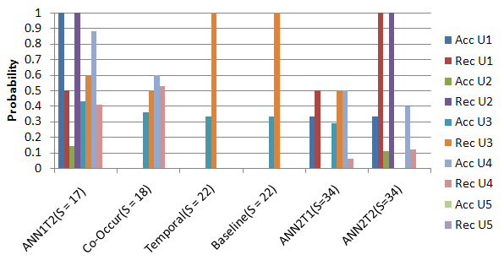
Figure 10. Overlap Evaluation

10-Fold Evaluation
The classifiers were also analyzed using 10-Fold Evaluation. In this process, all of the transcripts were divided into 10 equal parts. 9 parts of the transcripts were used to train the classifier and the remaining part was used for testing. This process was repeated 9 more times using a different part for testing data every time. See Appendix A for the resulting Confusion Matrices. Figure 11 and Figure 12 show the results from the experiment.

Baseline Evaluation
Similar to the results observed from the overlap evaluation, the baseline classifier always chose 3. However, if the evaluation function used in classification is changed from Absolute to Simple the effect is the classifier will choose the urgency it thinks is the most likely. After changing the evaluator, the base-line chose a mix of priority 2s and priority 3s.

Co-Occurrence Evaluation
The performance of Co-Occurrence varied wildly. Sometimes it would perform well and sometimes it would perform much worse than the baseline. On the whole it was not able to perform better than the base line.

Temporal Evaluation
The temporal classifier consistently out-performed the baseline by a slight margin using both the absolute evaluator and the simple evaluator.

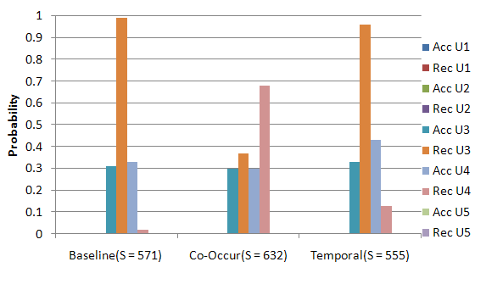
Figure 11. 10-Fold Absolute Evaluation

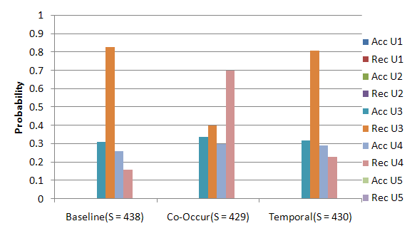
Figure 12. 10-Fold Simple Evaluation

Adjustments to Co-Occurrence Classifier
The high volatility of the Co-Occurrence classifier was investigated. It was observed that words with very few supporting instances in the training data were having a detrimental effect on the results. It was also observed that words with very high entropy were skewing the choice towards U3. To address these issues, some of the words gathered during training were filtered. Words that appeared in less than 1% of all the transcripts were removed. Only the words with the lowest 10% of entropies were kept. These numbers were determined through experimentation to be reasonable numbers. After applying these filters, the behavior of the Co-Occurrence classifier stabilized more, and it was able to outperform the baseline on average. A second 10-fold evaluation was performed and the results are shown in Figure 13.

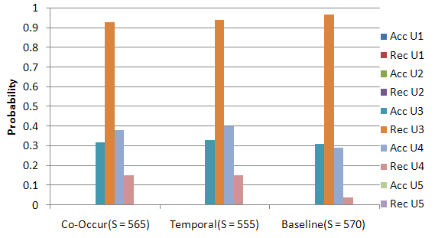
Figure 13.10-Fold Absolute Adjusted Evaluation

Conclusions
In conclusion, the transcripts were weighted heavily in the middle and it affected classification greatly. There was a modest consistency in annotation. The selected features likely give some information on the urgency of the message; however, the classifier does not exploit these features properly. The Co-Occurrence classifier performs poorly, but can be improved by filtering certain information. The Temporal classifier consistently performed slightly better than the base line.

Future Work
In future many improvements can be made. Clearly temporal extraction can be improved. A larger set of annotated data may show more patterns in the data. Further investigation is needed to determine the affect of different features, smoothing algorithms and classifier/feature weights. In general, an algorithm for classifying not just a voicemail transcript, but a sentence’s urgency, would be a great asset to Natural Language Processing.

References
[1] Daniel Jurafsky, James H. Martin. 2007. Speech and Language Processing: An Introduction to Natural Language Processing, Computational Linguistics, and Speech Recognition. <http://www.cs.colorado.edu/%7Emartin/slp2.html>

[2] Konstantinos Koumpis, Steve Renals, 2005. Summarization of voicemail messages using lexical and prosodic features.
<http://portal.acm.org/citation.cfm?id=1075390&dl=ACM&coll=&CFID=15151515&CFTOKEN=6184618>

[3] Jing Huang, Geoffrey Zweig, Mukund Padmanabhan, 2001. Information extraction from voicemail. <http://portal.acm.org/citation.cfm?id=1073051&dl=ACM&coll=&CFID=15151515&CFTOKEN=6184618>

[4] Martin Jansche, Steven P. Abney, 2002 . Information extraction from voicemail transcripts.
<http://portal.acm.org/citation.cfm?id=1118734&dl=ACM&coll=&CFID=15151515&CFTOKEN=6184618>

[5] Meredith Ringel, Julia Hirschberg, 2002. Automated Message Prioritization: Making Voicemail Retrieval More Efficient. <http://hci.stanford.edu/publications/2002/urgency.PDF>

[6] Meredith Ringel, Julia Hirschberg, 2002. Automatic Voicemail Summarization for Mobile Messaging. <http://www.dcs.shef.ac.uk/~costis/pubs/pdf/koumpis_phd.pdf>

[7] Lisa Ferro, Robyn Kozierok, Laurie Gerber, Beth Sundheim. Annotating Temporal Information – From Theory to Practice. <http://timex2.mitre.org/articles/HLT2002-timex2.pdf>

[8]Frank Schilder, 2004. Extracting meaning from temporal nouns and temporal prepositions
<http://portal.acm.org/citation.cfm?id=1017071&coll=&dl=ACM&CFID=15151515&CFTOKEN=6184618>

[9] The Linguist Data Consortium <http://www.ldc.upenn.edu/>
[10] Stanford Log-linear Part-Of-Speech Tagger
<http://nlp.stanford.edu/software/tagger.shtml>
[11] TempEx Temporal Tagger
<http://timex2.mitre.org/>
[12] Alembic POS tagger
<http://www.mitre.org/tech/alembic-workbench/>

Appendix A – Confusion Matrix Results from 10-Fold evaluation

