Design and In-Situ Evaluation of a Mixed-initiative Approach to Organizing Emails
1st Author Name  Affiliation  Address  e-mail address  Optional phone number | 2nd Author Name  Affiliation  Address  e-mail address  Optional phone number | 3rd Author Name  Affiliation  Address  e-mail address  Optional phone number

ABSTRACT
Paste the appropriate copyright/license statement here. ACM now supports three different publication options:
- ACM copyright: ACM holds the copyright on the work. This is the historical approach.
- License: The author(s) retain copyright, but ACM receives an exclusive publication license.
- Open Access: The author(s) wish to pay for the work to be open access. The additional fee must be paid to ACM.
This text field is large enough to hold the appropriate release statement assuming it is single-spaced in TimesNewRoman 8 point font. Please do not change or modify the size of this text box.

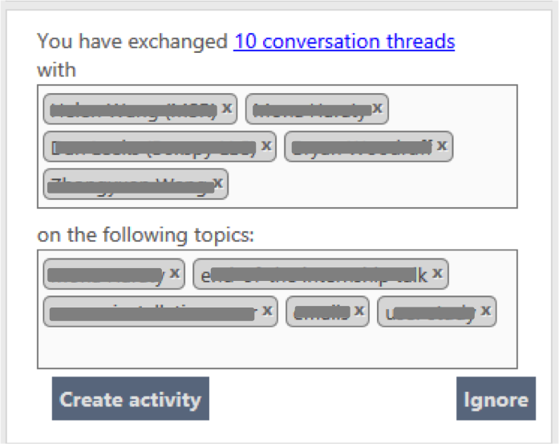
Figure 1: A suggested organizing construct (activity) that helps bootstrapping organizing email conversations. Topics and contacts are masked for anonymity.

Organizing personal information by foldering or tagging has proved to be effective for finding, remembering, and understanding information. However, past studies have shown that the cost of creating sufficient organizations is too high for some users. Mixed-initiative approaches could potentially reduce the burden of manual organization—by suggesting organizations of information to users who could then modify the suggested organizations and create their desired ones. However, we know little about how would organizing information using a mixed-initiative approach influence the number and the type of organizations created (e.g., their importance), users’ investment in their organizations, and how well users recall them. We investigated this by extending an activity-based computing system—which enables organizing different types of information regardless of type into activities—to suggest activities to users based on their email conversations. We conducted an in-situ experiment with 34 participants to study their activity-creation behaviors. We show that using a mixed-initiative approach to organizing emails into activities makes it easier to create activities; leads to creating activities that otherwise would have not been created. However, it reduces users’ further investment in organizing.

Author Keywords
System-suggested organization; semi-automatic; Personal Information Management; Clustering; activity-based computing.

ACM Classification Keywords
H.5.m. Information interfaces and presentation (e.g., HCI)

INTRODUCTION
We benefit from organizing our information: it helps us to re-access our information and to understand and make sense of it better [11]. Even improvements to desktop search tools have not removed the need to active organization for retrieval; many people prefer relocating their documents by browsing to keyword search [1,2,3]. But the act of manually organizing information and maintaining the resulting organizations is time-consuming. Automatic and mixed-initiative—where both user and system are involved in organizing—approaches to organizing information can potentially remove the burden of manually organizing large amounts of information. Past work on email clustering has shown that users are very intolerant of inaccuracy of fully automated methods though, and instead they prefer mixed-initiative methods [14].
There has been very little research comparing the effect of using mixed-initiative methods with manual methods for organizing information. Although several previous work have shown that using a mixed initiative approach The question is whether mixed-initiative approaches to organizing could reduce the burden of manual organization? How would organizing information using a mixed-initiative approach influence the number and the type of organizations created (e.g., their importance), users’ investment in their organizations, and how well users recall them? Would users create more organizations because it is easier? Would users forget about some of the organizations they create, if created in a mixed-initiative way?
To understand these, we designed and implemented a mixed-initiative approach to organizing information—mostly focusing on organizing emails. We extended an activity-based computing system called Somex—which enables organizing different types of information regardless of type into activities—to suggest activities to users by clustering their email conversations. We conducted an in-situ experiment with 34 knowledge workers from a large industrial research laboratory to see how would creating an activity manually compare with creating an activity with a mixed-initiative approach, where system suggests an activity and a user modifies/fine-tunes it to create one.
Our results showed some benefits of our mixed-initiative approach to organizing emails: 1) most of our participants (73%) found it easier to create activities using the mixed-initiative approach compared to the manual method, 2) suggested activities reminded many participants of some of their activities that they would have otherwise not remembered. We found that creating activity with the mixed-initiative approach did not seem to affect the number of activities created, their importance, and their recall. Although most participants (70%) preferred to see the suggested activities before creating on their own, a few participants had strong preference for seeing the suggestions only after they created activities on their own.
The remaining sections of this paper are organized as follows: first, we report on the related work; then, we briefly describe the activity-based system (Somex) that we extended, the clustering algorithm we implemented, and how system-suggested organizations (activities) were presented to users; next, we describe our evaluation methodology; finally, we report and discuss the results of our study.

Related Work
Two methods of organizing information include placing them into folders (foldering) or tagging them with labels. A comparison of the two methods revealed that each of the methods have advantages and disadvantages and a good organization mechanism goes beyond either of them to combine the advantages of both [3]. Past studies have shown that the cost of creating sufficient organization is too high for some users [5,15]. Below, we report on some of the attempts toward introducing more automation to organizing information.
To help users with organizing emails, Whittaker et al. experimented with a fully automated approach by clustering contacts based on frequency and reciprocity in email conversations [14]. However, due to the poor results of the clustering and users’ feedback, they decided to take the manual approach and support users by showing them information about each of the contacts such as recency and frequency of communication and allowing manual spatial arrangement of contacts to indicate their relationships.
SwiftFile and BuzzTrack are two systems that have employed mixed-initiative approach to helping users organize their email messages. SwiftFile [13] suggests three folders that are most likely to be related to a message and users can organize an email by choosing one of the selected folders. Although SwiftFile and other similar systems help with deciding about which folder to choose, users still have to create the folders manually. In another study, Dredze et al have investigated use of several algorithms for classifying emails into activities in activity-based systems [6]. Although this group of work help with reducing the burden of organizing emails into folders, they rarely address the burden of creating folders in the first place.
BuzzTrack facilitates information organization by overlaying its suggested topic and labels on each conversation in the inbox and reduces the cost of tagging by just requiring the user to change the incorrect labels and topics [4]. Several studies have explored mixed-initiative clustering methods for organizing a corpus of documents or emails into folders for various purposes. For example, Huang and Mitchell’s algorithm that have shown significant improvements when user feedback has been incorporated [10]. However, we know little about the nature of users’ efforts, how willing are they to collaborate with a system in organizing their information, and what type of organizations they will create. Generating summary keywords have been employed for several reasons including coping with email overload by having the gist of each email message in just a few words [7].
There is a body of work on visualizing summary of emails by showing some email meta-data such as contacts, keywords, and attachments for understanding archives and better retrieval of emails (e.g., [8,9,12]). Their goal has often been to facilitate understanding of emails, reminiscing, and facilitating retrieval rather than bootstrapping the act of organizing emails. Our approach is similar to that of this group of work in presenting summary of email conversations to users.
We build on this body of work and extend it by comparing a mixed-initiative approach with the manual approach of foldering to organizing emails to investigate the effect of organizing method on the number and type of organizations created, their importance, and their recall. Our work sheds lights into users’ preferences on different approaches to organization, as well as how tolerant of system’s inaccuracy would users be when they are working with a system to organize their emails into activities.

Mixed-initiative approach to organizing
We implemented a mixed-initiative approach to organizing information in an activity-based system—Somex—that enables organization of digital artifacts into organizing constructs called activities. In this Section, we first provide some background by briefly describing Somex. Next, we describe our mixed-initiative approach, where Somex suggests an activity to users who can then modify the suggestion and create an activity. Specifically, we describe our clustering algorithm that we used for inferring activities from user email conversations, and how we presented suggested activities to users.

Overview of Somex: an activity-based system
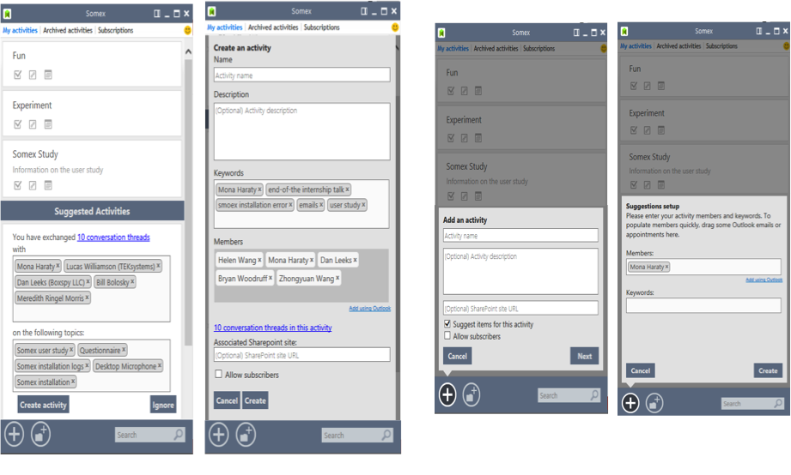
Figure 2: activity creation in Somex: from left to right (1) the main view of Somex when suggested activities are displayed. Activities are listed before the suggested activities (only one suggested activity is displayed in this screenshot) (2) activity creation window when creating activity from suggestions, (3, 4) activity creation windows when creating activity without suggestion. Members and keywords are added to an activity in Somex to enable Somex to suggest relevant artifacts (e.g., emails) to an activity.
Somex is a standalone application, designed to address the problem of project fragmentation by enabling users to organize their information regardless of its type, using organizing constructs called activity. To create an activity in Somex, users should specify its name, people who are involved in it, and keywords representing it (Figure x); the latter two are provided to enable Somex suggest relevant email messages to an activity and thus making it easier to populate an activity. To organize an information artifact—which can be an email, a file, a web page, a task, an appointment, or a contact—into an activity, users can drag and drop the artifact to the activity. In addition, for each activity, Somex provides a list of suggested conversations that could potentially belong to the activity; to include the suggested conversations into an activity, users should accept the suggestion (Fig x). Somex is a collaborative system in that people can share their activities with others by adding them as team members to an activity. Since, this part of the system is not directly relevant to the research presented in this paper, we do not describe it in detail.

Identifying potential activities from email conversations
[to MUX reader: please skip this section as I’m waiting to hear back from a collaborator about it]
There is a sizable body of research on improving the accuracy of email or document clustering algorithms. Our intention here is not to compare our clustering algorithm with the existing algorithms, but to simply describe it.
To cluster emails into potential activities, we first extract the keywords in email messages. [A brief explanation of keyword extraction: if KEX is published, just a reference to it would suffice]. Then, for each of the extracted keywords, we construct the following features:
People feature—a vector of size N, where N is the total number of people (contact) in one’s mailbox. The k-th dimension stands for how many times the k-th person are related with the keyword.
Date feature—a binary vector of size N, where N is the total time span (in date). The k-th dimension stands for whether the keyword appears in that day’s mail.
Mail feature—a binary vector of size N, where N is the total time span (in date). The k-th dimension stands for whether the keyword appears in that day’s mail.
Forward/reply feature—a binary feature, if the mail is titled “FW:XXX” or “RE:XXX”, the feature value is 1, otherwise it’s 0. Next, a K-means like clustering algorithm is run on the keywords, where the cosine distance between the two keywords are calculated. If the cosine distances of all the first three features (people, date, mail) of two keywords are larger than a threshold [describing how we chose this threshold], the keywords will be merged and their features will be summed up. Once a keyword has been merged, it will not be compared to other keywords.
[from here I was kind of lost in the OneNote description: how will the keywords be eventually grouped as a cluster?]
Below, we describe how the clustering results were presented to users as potential activities.

Presenting system-suggested activities to users
In the Somex main view, users can see their activities listed followed by the system suggested activities that were separated from their activities with a bar (Fig 2). Each suggested activity is represented as a useful piece of information about one’s email exchanges over a time period; taking the form of “You have exchanged 10 conversation threads with Bob, John, Sarah on the topics of Somex, CHI, submission” (Fig 1, 2). Users have the options of ignoring a suggested activity, which would remove it, or using it to create an activity. All the elements of suggested activities are modifiable, i.e. users can remove any irrelevant keyword, member, or conversation that does not belong to the activity that they want to create and add more keywords or members to the suggestion.
The input to the clustering algorithm was the most recent 500 email conversations of users, from their inbox and any other email folders selected in the initial set-up of Somex. The resulting clusters (suggested activities) were shown to users in batches of five suggested activities with a “show more suggested activities” button for users who wanted to see more.

Methodology
The goal of our evaluation was to compare the two approaches to organizing email conversations into activities—manual vs. mixed-initiative. More specifically, we aimed to compare the activities created manually with the ones created using system suggestions in terms of their importance and how well people recall them. For example, we were concerned that people might not recall the activities they create using system-suggestions or that people might end up in creating activities that are less important to them, just because they were suggested to them. Finally, we were interested in knowing how would people compare the two approaches to organizing their emails. To address all these questions, we conducted an in-situ experiment with 34 participants. The experiments were done at the participants’ offices on their own computers, and the sessions were 35 to 70 minutes long. Below, we describe the experiment procedure, the experiment design, the participants, and the data collection and analysis.

Experiment Procedure
The experiments started with installing Somex on the participants’ machines and a quick demo of Somex, describing all its features and the experiment’s tasks and steps. The experiment comprised of five steps: First, participants performed the main experiment task, which was creating activities and populating each activity with some relevant artifacts from their emails, bookmarks, files, tasks, or appointments. Participants were asked to think of their activities in life, to list the activities, and to include the followings in each activity: people that are involved in the activity, keywords that are related to the activity so that Somex could use them to suggest relevant artifacts to the activity, and some relevant artifacts such as emails, bookmarks, files, tasks, or appointments. They were told that for the purpose of the experiment the priority is given to creating as many activities as possible rather than populating each activity with large number of artifacts. The first step was performed differently across the two conditions, which we describe after reporting the other steps. Second, we asked the participants to talk about their current practices for organizing their emails, files, and bookmarks. The goal of the second step was twofold: to distract participants from the activities they created since we wanted to assess their recall, and to get a better sense of our participants organizing practices. Third, participants filled out a short online questionnaire on the usefulness of the suggested activities. Forth, they were asked to recall the name of the activities they created and to write them down on a piece of paper.. Fifth, we asked them to give us some meta-data about their activities; they rated the importance of each activity on a scale of 1-4 (1: unimportant, 2: slightly important, 3: important, 4: very important), they reported whether each activity was work-related or personal, and finally how likely will they keep populating each of the activities they created. The goal of the last question was to give us a sense of the type of activities created.

Experiment Design
We designed an experiment with two conditions, which differed only in the first step as described earlier. Participants in the first condition were told that they had ten minutes or until they were done to create as many activities as they were currently involved in, and to populate their activities with at least one artifact such as an email, a task, an appointment, a bookmark, or a file. When done, the experimenter turned on the suggested activities, and did a quick demo of the second method of creating activity—which was using system suggested activities. Participants then were told to have a look at the suggested activities to see if they wanted to create more activities or revise their existing activities and let the experiment know when done.
In the second condition, suggested activities were displayed from the beginning of the experiment and the participants were told that there are two methods for creating an activity; the first method is to create on their own, and the second method is to create an activity using system-suggested activities, and that it is their choice which method to use to perform their task of creating activity and populating them with artifacts. Participants in the second condition were told that they have 20 minutes or until they were done. Thus, the difference between the two conditions were in the time of showing the suggested activities; level-1: once they were done creating activities on their own, level-2: from the beginning, before creating any activities on their own. In both conditions, participants were told to think aloud while performing their task of creating activities and populating them.

Participants
35 participants (11 female) were recruited through snowball sampling. All were knowledge workers in a large industrial research laboratory, and were full time employees who have worked at the company for more than 4 months, with the exception of one participant (P19) who was an intern; 18 were researchers, 8 were developers/engineers, 5 were managers, 2 were admins. We included the criteria of having worked for more than 4 months in our call for participation to attract participants whose email inbox is old enough to represent a set of diverse activities that they have been involved in. Participants’ age ranged from 24 to 54. We excluded the data of one participant from our analysis, due to some technical difficulty on her machine (Outlook could not run on her machine) and that she created fake activities such as ‘test 1’.

Data collection and analysis
We collected usage log data, post-questionnaire responses, meta-data about the created activities, and notes of participants’ actions and what they said while performing their tasks. To investigate the effect of activity-creating method (manual vs. mixed-initiative) on recalling activity, we ran a logistic regression analysis including the following explanatory variables: activity-creating method (binary: manual vs. mixed-initiative), condition (categorical), activity importance (ordinal), activity type (binary: work-related, personal), likelihood of populating activity in the future (ordinal). To investigate the effect of approach on the number of activities created, we ran a Poisson regression analysis with the same predictors as the aforementioned analysis. In the following Section, we report the results of our statistical analyses of the data collected.

Results
We first describe how participants created and populated their activities. Then, we report on some descriptive statistics on the number of activities created, the amount of time spent on creating activities in each condition, the characteristics of activities (their size, importance, type: work-related or personal). Next, we present the results of investigating the differences across the two approaches to organizing emails—manual vs. mixed-initiative. Finally, we report the results of the post-questionnaire, i.e., how participants compared the two approaches to organization.

Characteristics of activities created in each condition
Participants across the two conditions created a total of 214 activities, 94 using the suggestions and 120 manually. Most suggested activities that were turned into an activity were modified (78/94); 17% (16/94) of the suggested activities were turned into an activity without any modification. In all the modified suggested activities, contacts were modified; participants either added more contacts or removed some irrelevant ones. But the conversation threads included in the suggested activities were modified in only 8 (10%) of them; participants could modify the conversations by removing the irrelevant ones. But, because the process of going through the list of conversations and finding the irrelevant ones was relatively time-consuming—compared to scanning the included contacts and keywords—often when a suggested activity had included a set of irrelevant conversations, it was ignored altogether. The keywords were modified in 46 (59%) of the modified suggested activities.
Number of activities created and time spent (C1): When participants did not see any suggested activity—first phase of the first condition—they spent 7 to 23 minutes with a mean of 14.18 minutes to create 1 to 11 activities with a mean of 4 activities on their own. After they were done with creating their activities and populating them, they were presented with suggested activities where they spent another 3 to 12 minutes with an average of 6.5 minutes to create 1 to 8 activities using the suggestions with a mean of 2.8 (see Table 1 for a summary). Overall, 94% (100/106) of the activities created in this condition were work related.
Table 1: summary of the number activities created (left of the table) and the time spent on creating them (right of the table) across the two conditions, using the two methods of manual and mixed-initiative.
 |  | Number of activities created (count) |  |  |  |  | Time spent on creating activities (minutes)
Cond | Method | Min | Max | Mean | Total/method | Total/Cond. | Min | Max | Mean
C1 | Manual | 1 | 11 | 4 | 64 | 106 | 7 | 23 | 14.18
 | Mixed- | 1 | 8 | 2.8 | 42 | 106 | 3 | 12 | 6.5
C2 | Manual | 1 | 9 | 3.7 | 56 | 108 | 9.5 | 35 | 20.37
C2 | Mixed- | 1 | 8 | 3.3 | 52
Total |  |  |  |  |  | 214

Number of activities created and time spent (C2): When presented with the suggested activities from the beginning (condition 2), participants spent 9.5 to 35 minutes with a mean of 20.37 minutes on creating 4 to 10 activities with a mean of 6 and populating them. When separating activities that were created using the suggestions from the ones created on own, on average 3.7 activities were created on their own and 3.3 using the suggestions (see Table 1 for a summary). Overall, 86% (93/108) of the activities were work-related and the remaining were personal/social.
Was there any difference in the size of the activities created across the two conditions? Participants in the first condition populated their activities with 0 to 105 artifacts with a mean of 32.4 artifacts. The size of the activities in the second condition ranged from 0 to 149 artifacts with a mean of 27.6. The artifacts in both conditions were mostly email conversations. A closer look at Figure 3 shows that the activities that were created in the first condition seem to be more populated. A Poisson regression analysis confirmed this observation; we found significant effect of condition, importance, and approach to creating activity on the number of artifacts in activities. Participants in the second condition populated their activities with 13% less artifacts compared to the participants in the first condition (P<0.001). Activities that were rated as more important were populated with 5% more artifacts compared to the less important activities (P<0.001). Activities that were created manually were 5.3 times more populated than the ones created using the suggestions (P<0.001).
Observations of the participants’ activity creation in C2: The activity creation of the 18 participants in the second condition—where participants had both options of creating activities on their own and using system suggestions from the beginning—seemed to fall into four distinct patterns: 8/18 participants started with using suggested activities and created all or all but one of their activities using the suggestions (P7, P6, P3, P22, P18, P16, P12, P29); 5/18 participants started creating activities on their own and none or only one of their activities were created using the suggestions (P31, P24, P20, P1); 3/18 participants created their first activity using the suggestions, but the rest on their own (P14, P21, P33); 2/18 started creating activities on their own but alternated between the two methods (P9, P23).

Manual vs. mixed-initiative
Do people create more activities when presented with suggestions? To address this question, we compared the number of activities that participants created in the first 10 minutes of their task across the two conditions. We chose to look at the first 10 minutes, because participants in the first condition did not see any suggested activities at least for the first 10 minutes of their task. Participants in the first condition created an average of 3.2 activities on their own within their first 10 minutes, while the participants in the second condition created an average of 4.2 activities; but the difference was not significant (P=0.14).
Does activity-creating method influence recalling activities? Overall, only 45 out of 214 created activities were not recalled; 27 of which were created using suggested activities and 18 were created manually; 32/45 were rated as important; and 41/45 were work-related. A logistic regression analysis showed a significant interaction effect of the method of creating an activity and condition on recalling activity (P=0.002); activities that were created from suggestions in the first condition were 77% less likely to be recalled compared to the activities that were created from suggestions in the second condition. One possible explanation for this is that the activities that were created using suggestions in the first condition, were generally not on top of mind because they were created only after participants were done with creating activity manually.
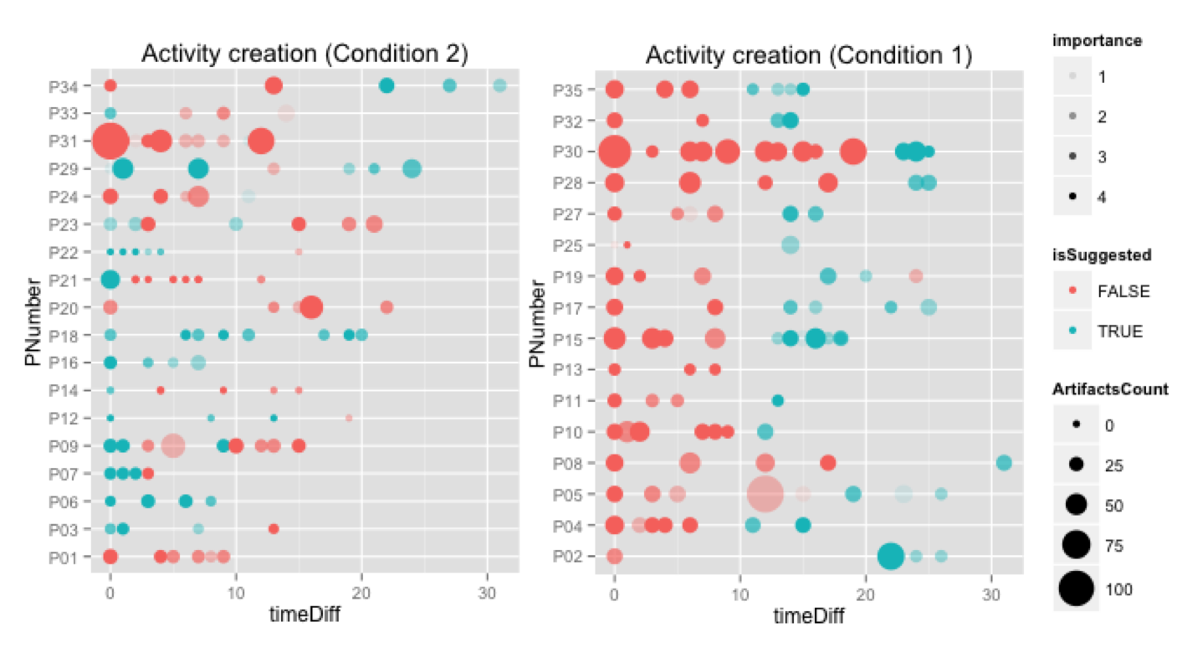
Figure 3: Activity creation over time: each dot represent an activity created; blue dots are activities created using suggestions and red dots are activities created manually; size of the dots represents the number of artifacts that were added to an activity during the experiment; color opacity represents importance of the activities to participants (the higher opacity represents higher importance); the horizontal axis is the time from when the first activity was created (a) Condition 2, where the participants saw the suggested activities from the beginning, (b) Condition 1, where the participants saw the suggested activities after they were done with manually creating activities.

How people compared creating activities with and without suggestions
Was it easier to create activity with suggestions? 73% (25/34) of the participants strongly agreed or agreed that using suggested activities made it easier for them to create activities. For some participants, our clustering algorithm performed very well; for example, P18 who created all his 8 activities using suggestions said: “I really liked the suggestions […] I already use OneNote for organizing my activities. This made me wish OneNote had suggestions”. However, when the clustering did not perform very well, modifying a suggested activity was time-consuming and thus making it more difficult to create an activity from a non-accurate suggestion. P35 who disagreed with suggestions facilitating activity creation commented: “The suggestions were mostly not helpful, so seemed like a bit of a waste of time to weed through them”. Similarly, P34 who started with manually creating activities, although he had the suggestions from the beginning said: “suggestions seemed really random and missed obvious keywords that should have linked the items together”. P22, who created all but one of his activities using suggestions was indifferent and commented: “there's a lot of overlap in my categories, so it was simpler to create manually”.
In addition, not all the suggested activities seemed to be worthy of creating an activity, though; for example, P5 said: “Some of the suggestions were very helpful, many others identified communication threads that I didn't want (or need) to represent by Somex activities”. To summarize, the factors that seemed to make it difficult to create activities using suggestions were inaccuracy of the clustering algorithm (e.g., unrepresentative keywords), overlapping suggested activities, a suggested activity combining multiple activities, or multiple suggestions for a single activity.
Was it easier to populate activities when created from suggestions? 20/34 strongly agreed or agreed with suggested activities facilitating populating activities. Similar to activity creation, whether or not using suggestions facilitated activity population depended on how well the conversations in a suggested activity were relevant to each other. For some participants who had many folders to organize their emails, even a set of relevant conversations in a suggested activity did not make it easier to populate the activity. For example, P5 who identified himself as an aggressive filer populated two of his activities with going to the corresponding email folders and selecting and dragging all the conversations (149) to his activity. He commented: “Some of the suggestions did track down messages spread across e-mail folders. However, I do typically aggressively file my e-mail away in folders, so the benefit of its suggestions were somewhat diminished”.
Preference about when to see suggested activities: To see whether participants had any preference as to when to see system suggested activities, we asked them if they preferred to see the suggested activities before creating activities on their own; overall, 24/34 participants preferred that. Almost all the participants in the second condition (16/18), who saw the suggestions from the beginning, preferred their condition except for P31 and P34 (no opinion); P31 said: “I prefer to first make my own set of activities then have the suggestions maybe help populate those activities or find something I missed, but I think I'd rather not have suggestions till I've made more activities as a base set. though I can see someone wanting to use suggestions as the bootstrapping for the entire thing”. Some participants preferred seeing the suggestions first, because they could avoid the manual work of creating an activity: “I had a good idea of which activities I wanted to create, but I wanted to find the matching suggestion for them, so I didn't have to do the manual work of creating it. So, I would prefer to see the suggested activities first. Also, one of the suggestions was for an activity I wouldn't have necessarily thought to create on my own” [P23]—who alternated between creating activities with and without suggestions. For others, “they were useful to jog my memory re activities” [p14].
Among the participants in the first condition—who saw suggested activities after creating activities on their own—4 preferred their own condition; for example, P5 and P28—similar to P31—said: “I probably would have preferred to take a first pass myself at creating activities, but would then want to adjust/augment them with Somex's suggestions” [P5], “I would prefer to create activities on my own, to stay consistent with my normal tracking process” [P28]. But 8/16 thought that if they had seen the suggested activities first, “it would help getting started” [P8] or “it saves time” [P15]. This was consistent with some of the comments that participants in the second condition made (see above).
Did suggested activities remind participants of their activities that would have otherwise not remembered? The keywords and the contacts in the suggested activities reminded 23/34 participants of some of their activities: “There were some transient activities I was previously engaged in or am in engaged in now that were suggested -- I had forgotten all about them!”[P5], “it did show me many activities I otherwise wouldn't have remembered, but I didn't see some suggestions that I was expecting to see” [P23]. The reminding feature of suggested activities, however, can be related to several factors such as the number of activities that an individual is currently involved in and whether a suggested activity represented an old, recent, or an ongoing activity. For example, P15 did not find any of the suggestions reminding him of any activity that he had forgotten: “the suggested activities were all close in time, so I remembered them”. P27 did not find the keywords helpful, because our keyword extraction did not work great for him: “Most of the keywords were not something I would have associated with an activity”. Similarly, P3 did not find any value in the keywords, but found the contacts useful.

Discussions
One of the questions that we wanted to address with this research was: How would activity-creation method influence the number and the type of activities created (e.g., their importance)? We expected to see an increase in the number of activities created when people were presented with suggested activities. But when we compared the number of activities created within the first 10 minutes of the experiment—when the participants in the first condition were not yet presented with suggestions—we found no significant increase for the number of activities created in the second condition. Our expectation was based on our assumption that creating activities with suggestions would be faster because suggested activities are already filled with some relevant contacts, keywords, and conversations. But this assumption heavily relied on the quality of the suggestions, i.e. the accuracy of our clustering algorithm, which varied significantly across the participants as shown in their comments. This is consistent with the literature about the usefulness of automation being dependent on the accuracy of clustering which is still a challenge.
We were also concerned that less important activities that were created using suggestions might be less likely to be recalled due to less investment on creating them. We did not identify any interaction effect of importance and activity-creating method on recalling of activities. This could be due to the limitation of the way we assessed recall: asking the participants to recall the name of the activities they created after a 10-minute distractor task. A 10-minute distraction might not have been long enough to test this hypothesis properly. However, the fact that 45/214 activities were still not recalled suggests this might not have been a serious limitation of our study design. One thing that might have confounded recall was that some participants had email folders that directly matched the activities they created.
Another question that we wanted to address was whether a mixed-initiative approach—such as ours—to creating activities could potentially reduce the burden of manual method. We found that 73% of the participants found it easier to create activities with suggestions, when the suggestions were accurate. Based on the participants’ comments, some of the factors that seemed to make it difficult to create activities using suggestions were inaccuracy of the clustering algorithm (e.g., unrepresentative keywords), overlapping suggested activities, a suggested activity combining multiple activities, or multiple suggestions for a single activity. Therefore, other than improving the accuracy of the algorithm, we think that the following features could greatly benefit the usefulness of a mixed-initiative approach: 1) allow merging multiple suggested activities into a new or an existing activity, 2) allow splitting a suggested activity into several activities, 3) making the mixed-initiative approach more adaptive to the changes users make to a suggested activity—for example in our case that a suggested activity included contacts, keywords, and conversations, modifying contacts or keywords in a suggested activity should modify the included conversations accordingly. In addition, since it was easy to create an activity using system-suggestions, a few participants forgot that they already have created the activity and they created duplicate activities. One of the participants who did so said: “I should be careful not to duplicate activities that already exist”[P21]. To avoid users creating duplicate organizations, when users are creating activities, system should remind them of other similar activities that they have created by detecting the overlap between them.
Finally, we wanted to see if activity-creation method would affect users’ investment in their activities—as measured by the number of artifacts added to the activities. We found that participants were more invested in the activities they created manually: activities that were created manually had 5.3 times more artifacts than the ones created using the suggestions. In addition, we found that seeing system-suggested activities before creating activities manually reduced the number of artifacts that participants organized into their activities by 13%. One possible explanation for these results is that making it easier to create activities might have affected users’ expectations regarding the amount of effort they are required to put into organizing. Another explanation is that they might have felt higher level of ownership on the activities that they created on their own which had led them to invest more in them.
Creating rules to organize emails into folders was another approach that our participants reported as one of their organizing practices, but it was mostly used for avoiding the messages sent to distribution lists from populating their inbox. We think that a mixed-initiative approach can benefit from combining with a rule-creation approach, where users could define their own rules as to what might represent an activity, for example, when considering email conversations. We found that for some of our participants, all the emails with a single person meant a single activity, but for others, a common group of people could mean several activities.
One of the limitations of our approach was that we only clustered the recent 500 email messages in a participant’s inbox for the performance issues. For some busy participants that used to receive a large number of emails per day, that could only mean the conversations spread across two weeks which is not a long enough time to extract longer-term activities.

Conclusion and future work
We designed and implemented a mixed-initiative approach to organizing emails—where we suggest activities based on clustering users’ messages in their inbox to facilitate creation of activities for organizing emails for users who could then modify the suggestions to create activities. Our study is the first step toward evaluating the effect of using mixed-initiative approaches to organizing information on personal information management behaviours such as organizing, recalling, and maintaining. Our results showed some benefits of our mixed-initiative approach to organizing emails: 1) most of our participants (73%) found it easier to create activities using the mixed-initiative approach compared to the manual method, 2) suggested activities reminded many participants of some of their activities that they would have otherwise not remembered. We found that creating activity with the mixed-initiative approach did not seem to affect the number of activities created, their importance, and their recall; but this could have been due to the limitations of our study described above. Although most participants (70%) preferred to see the suggested activities before creating on their own, a few participants had strong preference for seeing the suggestions only after they created activities on their own. We found that the activity-creating method affected users’ further investment in organizing emails into the created activities. Further research is needed to investigate the longer-term effect of using these approaches on people’s information organization behaviours. We discussed the ways in which we could improve our mixed-initiative approach that we hope had shed light on the future mixed-initiative approaches to organization.

REFERENCEs
1. Barreau, D. and Nardi, B.A. Finding and reminding: file organization from the desktop. ACM SIGCHI Bulletin 27, (1995), 39–43.
2. Bergman, O., Beyth-Marom, R., Nachmias, R., Gradovitch, N., and Whittaker, S. Improved Search Engines and Navigation Preference in Personal Information Management. ACM Trans. Inf. Syst. 26, 4 (2008), 20:1–20:24.
3. Civan, A., Jones, W., Klasnja, P., and Bruce, H. Better to organize personal information by folders or by tags?: The devil is in the details. Proceedings of the American Society for Information Science and Technology 45, 1 (2008), 1–13.
4. Cselle, G., Albrecht, K., and Wattenhofer, R. BuzzTrack: Topic Detection and Tracking in Email. Proceedings of the 12th International Conference on Intelligent User Interfaces, ACM (2007), 190–197.
5. Cutrell, E., Robbins, D., Dumais, S., and Sarin, R. Fast, Flexible Filtering with Phlat. Proceedings of the SIGCHI Conference on Human Factors in Computing Systems, ACM (2006), 261–270.
6. Dredze, M., Lau, T., and Kushmerick, N. Automatically Classifying Emails into Activities. Proceedings of the 11th International Conference on Intelligent User Interfaces, ACM (2006), 70–77.
7. Dredze, M., Wallach, H.M., Puller, D., and Pereira, F. Generating Summary Keywords for Emails Using Topics. Proceedings of the 13th International Conference on Intelligent User Interfaces, ACM (2008), 199–206.
8. Dumais, S., Cutrell, E., Cadiz, J., Jancke, G., Sarin, R., and Robbins, D.C. Stuff I’Ve Seen: A System for Personal Information Retrieval and Re-use. Proceedings of the 26th Annual International ACM SIGIR Conference on Research and Development in Informaion Retrieval, ACM (2003), 72–79.
9. Hangal, S., Lam, M.S., and Heer, J. MUSE: Reviving Memories Using Email Archives. Proceedings of the 24th Annual ACM Symposium on User Interface Software and Technology, ACM (2011), 75–84.
10. Huang, Y. and Mitchell, T.M. Text Clustering with Extended User Feedback. Proceedings of the 29th Annual International ACM SIGIR Conference on Research and Development in Information Retrieval, ACM (2006), 413–420.
11. Jones, W.P. and Teevan, J. Personal information management. University of Washington Press, 2007.
12. Ringel, M., Cutrell, E., Dumais, S., and Horvitz, E. Milestones in time: The value of landmarks in retrieving information from personal stores. Proc. Interact, (2003), 184–191.
13. Segal, R.B. and Kephart, J.O. Swiftfile: An intelligent assistant for organizing e-mail. AAAI 2000 Spring Symposium on Adaptive User Interfaces, Stanford, CA, (2000).
14. Whittaker, S., Jones, Q., Nardi, B., et al. ContactMap: Organizing Communication in a Social Desktop. ACM Trans. Comput.-Hum. Interact. 11, 4 (2004), 445–471.

The columns on the last page should be of approximately equal length.
Remove these two lines from your final version.

