Quick Reference Sheet for the FMS Applications:
FMS Live and FMS nQuery (Formerly known as the FMIS on the Web)

Please note that as of July 23rd, 2004 the Web-based FMS Live and FMS nQuery can be accessed through the Management Systems Portal using the:
- Alternate PeopleSoft Login http://login.msp.ubc.ca, or
- MyUBC http://my.ubc.ca

Before you attempt to log on to the FMS applications, please make sure that you have a CWL account and authorization to access to the FMS application(s). To formally apply for the access to FMS application(s), please download the application forms from the EnableIT website, http://enableit.ubc.ca/overview.cfm?page=1640#8000 , and fax them to the Systems Administrator, c/o FMS Support, Finance Department, at 604-822-2417.

LOGIN INSTRUCTIONS

Please follow the following instructions to access the Web-based FMS applications, that is, FMS Live and FMS nQuery, using the PeopleSoft Login.
1. Open your web browser and go to http://login.msp.ubc.ca

On the PeopleSoft login page that will appear, you will be asked to enter your CWL ID and password. Please note that you must have your Campus Wide Login (CWL) account to access the Web-based system.
For instructions on signing up for the CWL account, please go to http://enableit.ubc.ca/cwl_instructions.cfm. If you cannot remember your login information, please contact fms.support@finance.ubc.ca.
2. Enter your CWL login and password and press the “Login” button. The following screen
will now appear with the main Management Systems Portal page, and the links to the
applications to which you have access.
Note: You will not be able to see the Management Systems Portal with the applications, if
your access has not been authorized.
FMS nQuery (Formerly known as FMIS on the Web)

Click on the FMS nQuery link, (as per the screenshot below), to access the following main functionalities:
- Accounts Payable
- General Ledger (Ledger Summary)
- Payroll
- Purchasing
- Security
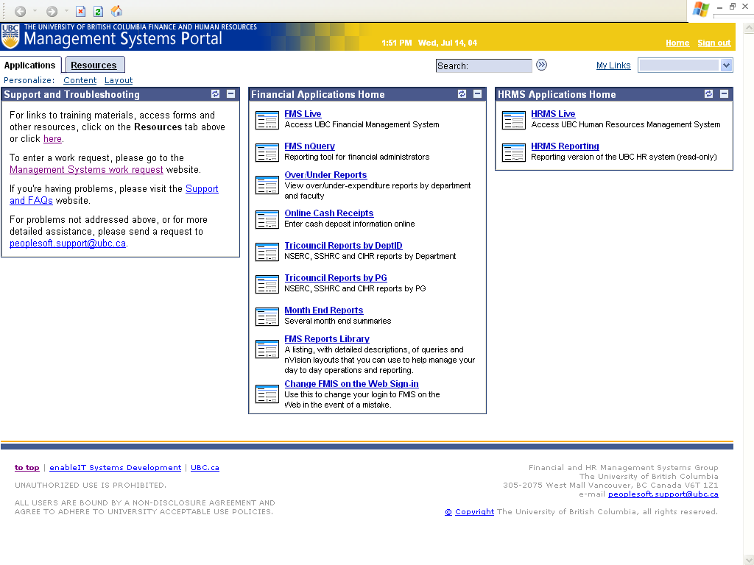
Click here to access FMS nQuery

The FMS nQuery will now appear (as per the screenshot below):

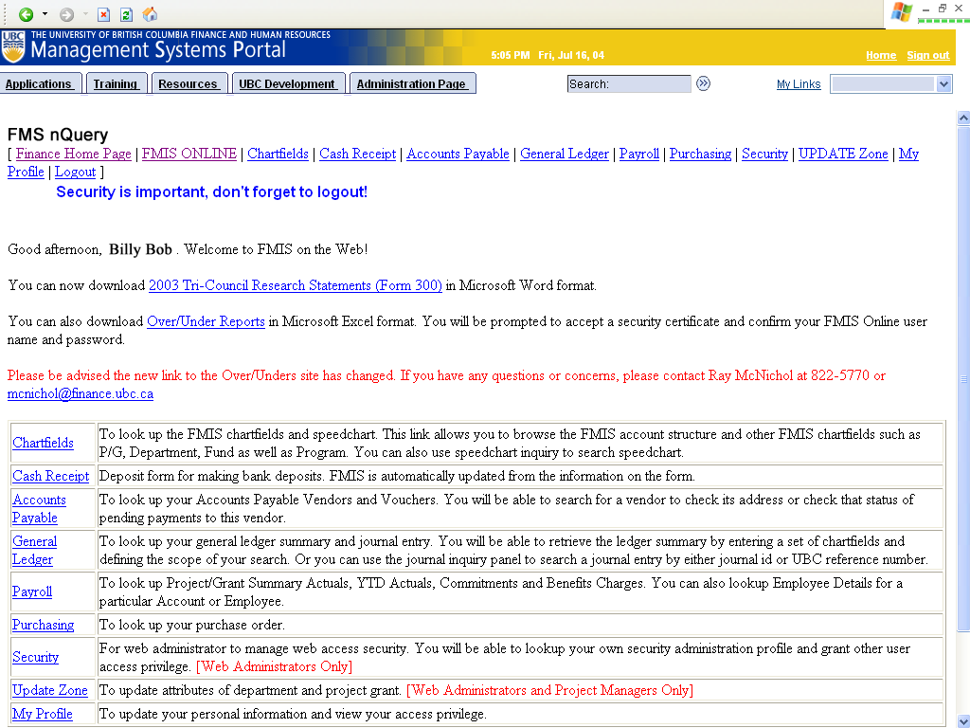
If you require FMS nQuery training please contact us at enableit-program@finance.ubc.ca.
FMS LIVE

Click on the FMS Live link to access the application (as per the screenshot below):

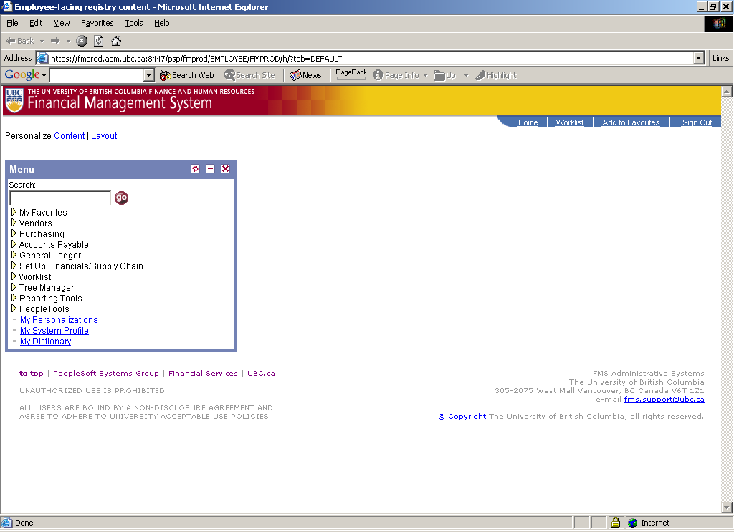

In FMS Live you will be able to access the following major financial modules:
- Purchasing (pCard Users)
- Accounts Payable
- General Ledger
- Reporting

TRAINING GUIDES

The following training guides are available for your convenience:
- AP Training V8.4 PeopleSoft - Campus users
An overview of the major features of PeopleSoft Accounts Payable 8.4. It will focus on voucher entry functionality and certain inquiries that will assist you in checking the payment status of the vouchers entered into the system.
- General Ledger Journal Training
How to complete Journal Transactions
- PO Part I – Requests For Quote Training
What is a Request For Quote. How to create a Request For Quote.
- PO Part II – Purchase Contracts Training
How to create Purchase Contracts for Multi-Year Purchase Agreements
- PO Part III – Purchase Order Training
How to source requisitions and create Purchase Orders
- PO Part IV – PO Reconciliation Workbench Training
How to close, cancel and review PO information using the PO Reconciliation Workbench
- PR Part I – Distributed Users Purchase Requisition Training
How to create Purchase Requisitions on-line for users outside of Supply Management
- PR Part I – Internal Users Purchase Requisitions Training
How to create Purchase Requisitions on-line for Supply Management users only
- PR Part II – Requisition Reconciliation Workbench Training
How to review Purchase Requisition information and find activity information
- Purchase Card Training
This document details the basics of using and administering your PCard.
- Reporting - Query Tool
This document details the basics of searching for and running a Query within PeopleSoft.
- Reporting - PS/nVision
This document details the basics of creating and searching for a Report Request, creating and searching for a Scope, and running a report using PS/nVision.
- Reporting - PS/nVision Supplementary Documentation
This document details the steps involved in running your nVision report to Excel.
CONTACT INFO
Should you experience any problems at any time, or need training in the specific areas of the FMS Live, or wish to communicate your suggestions and specific needs, please contact us at EnableIT-program@finance.ubc.ca.

Thank you for your attention

